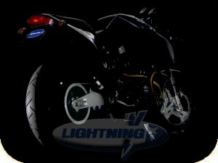


“The Truth is out there"...

Best of BadWeb and ATC

Since buying my 99 X1, I've spent a lot of time hanging out at the American Thunderbike Club¹ Forum and the Bad Weather Biker's BBS².

After awhile, I started to save interesting tidbits for possible future use. As my list grew, I decided to create a web page with this info so others like myself may find information.

So, here it is... the "Readers Digest" of X1 discussions from both forums. I don't claim it's absolutely complete... I just saved what was of interest to me. And I've edited out the chatty stuff (95% less "sass mouth"!).

Plus, please beware these are personal opinions, not proven facts.

But, in all my years of biking, I find these "campfire bull sessions" to be very enlightening.

NOTE!!! Any references to "I", "me", etc. are from the original poster of the information and does not refer to the editor of this page, unless the poster was in fact me. Got that?

- Engine - Exhaust
- Drive train - Suspension
- Surging and stalling problems - Wheels & Brakes
- Fuel Injection - Misc
- Electrical - Recalls
- Oil & Filters - Links
- Breathers

¹) http://www.americanthunderbike.org/
²) http://www.badweatherbikers.com/

Engine

100 Cubic Inch Long Block (http://www.sscycle.com)
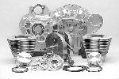
S&S-Cycle manufactures several engine components for Buells. This includes everything
from cases to heads and flywheels. The most interesting product for Buells is a 100 cubic
inch long block.
This engine is simply awesome in a Buell chassis... it won the open class dyno
shootout at Hal's HD during the Buell Homecoming in Milwaukee summer 2000.

Available through Zipper's Performance¹, or visit S&S Cycle².

¹) http://www.zippersperformance.com ²) http://www.sscycle.com

Headwork (Cycle-rama) (http://www.cycle-rama.com)

Contact Wes at Cycle-rama³. Done a lot of high performance head work and lists the dyno charts on his web site.

³) http://www.cycle-rama.com

Headwork (Nallin) (http://www.realpages.com/sites/nallinracingheadservice/)

Nallin Racing Head Service¹ has a good rep. with the Buell community. Their heads put out excellent HP and prices are reasonable.

¹) http://www.realpages.com/sites/nallinracingheadservice/

Headwork (Zipper's) (http://www.zippersperformance.com/catalogue/showproduct.asp?cat=580&prod=1572)
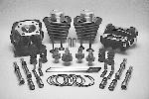
Proper headwork is far from cheap. Figure on paying $1000-$1500 for a great job.
I would highly suggest you consider a kit from Zipper's Performance, the
Super Hammer 1200 Kit². @ $2699, it includes the boring of your stock cylinders,
domed pistons, Stage II Thunderstorm heads with Stage II porting & competition valve
job, step lock valve guides & Teflon seals. Oversize stainless valves are used as well as
a performance spring kit and molly collars. Redshift 567 cams are provided as well as
Power Glide lifters, telescoping pushrods & telescoping pushrod covers and all required
gaskets. Zippers is claiming over 100 hp, and a spread of torque, which is over 70 ft-lbs from 3K-6500. and over 80 ft-lbs from 4200-6000. I have installed one of their Hammer kits, and I can say that it's worth every penny.

²) http://www.zippersperformance.com/catalogue/showproduct.asp?cat=580&prod=1572

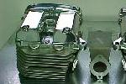
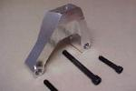
Max "T" Engines Four Valve Heads (http://www.maxtengines.com)

The Buell kit come complete with all gaskets and mounting hardware. The front cylinder
head mount, and top breather kit, along with the exhaust are sold separately.
Pistons require fly-cuts for 4 valve pockets and the pushrods and covers are sold sep.

Billet Front Mount (http://www.maxtengines.com)

Broken front mount? This mount from Max "T" Engines is machine billet and comes with
case hardened bolts. Stronger than stock.

Leaky Starter Motor Gasket

Oil on the top of the motor, right behind the rear cylinder, under the starter. Likely to be the starter motor gasket (PN 31488-81) that is weeping primary fluid. Overfilling the primary leads to the gasket weeping due to excessive pressure that the vent cannot handle due to foaming. Once the gasket starts to leak, it wicks primary fluid out. To replace the gasket, you have to remove the exhaust system and primary cover. Disconnect the battery and using a ball-end Allen wrench, remove the two Allen bolts next to the starter ring gear. You will have enough room to jockey the starter out far enough to replace the gasket without disconnecting any of the electrical leads. The factory installs these gaskets dry so just a wetting of "Hylomar" on both sides of the gasket surfaces is recommended.

Suspicions valve-train noise

First, did you just remove your stock bread box? You'll get a lot more intake noise... showing you part of the reason for the design.

Second, check your primary chain. When loose, it makes noises that can be confused for "valve trouble".

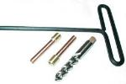
Pigtails (http://user.icx.net/~desj/pigtails.HTM)

This device fits Evo Big Twin and Sportster. It simply threads into the bottom of the
cylinder oil return and fits tight into the cases giving you a true oil passage that in no
way can leak like the Evo’s are notorious for. It simply provides a direct tract from the
cylinder return oil drains to the crankcase not allowing any chance of the oil to escape
by seeping over and under the base gaskets during warm-ups.

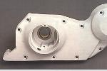
Cut Down Cam Cover

See how here …³

³) http://www.bikernet.com/garage/sturgisbuell2001-2.asp

Front engine mount bolt replacement procedure

Read it here¹, from the California Cafe Racers Home site.

¹) http://cafeRacers.editthispage.com/discuss/msgReader$218
In Reply to: Re: Front engine mount bolt snapped posted by Aaron on July 21, 2000
Here is the text from Buell Service Bulletin B-018, May 13, 1999

1. Position motorcycle on a suitable lift and position REAR WHEEL SUPPORT STAND (Part No. B41174) under swing arm. Secure
motorcycle to lift.

2. Disconnect negative battery cable.

3. Remove seat and fuel tank. See appropriate service manual, Section 4 for procedure

4. Remove airbox cover (and left fairing lower on S3Ts) and filter box.

5. Remove two nuts and 2 socket head screws from air cleaner backplate and front isolator mount.

6. Position floor jack under engine under front shock mount to support engine.

7. Remove and discard isolator locknut and remove bolt, two washers and D washer.

8. Remove and discard two bolts and washers from left and right side of front isolator mount.

9. Remove front isolator mount from left side of motorcycle.

10. Clean residual Locktite from threads in engine with a suitable nonflammable solvent and dry with compressed air.

11. Apply LOCTITE THREADLOCKER 271 (red) to threads of new front isolator mount bolts.

12. Apply a thin film of clean HD 20W50 engine oil to both sides of new thick washers and to bottom of bolt heads. Exercise caution to
avoid mixing oil on washers with Locktite on bolts.

13. Position new front isolator mount and secure with two new front bolts with new thick washers. Tighten bolts 60 ft-Ibs (81 Nm) initially
and then loosen each bolt full turn. Tighten bolts again to 60 ft-Ibs (81 Nm). Make sure flat on D washer remains oriented to front of
motorcycle while tightening bolt.

14. Position washer between front isolator mount and isolator. Install bolt, washer, D washer and new locknut.

15. Making sure flat on D washer stays oriented to front of bike, tighten bolt to 100 ft-Ibs (135.6 Nm)

16. Apply LOCTITE THREADLOCKER 243 (blue) to threads of airbox screws. Install airbox screws to airbox and isolator mount.
Install locknuts to screws.

17. Install air cleaner filter box and cover.

18. Connect negative battery cable.

19. Install fuel tank and seat.

Combustion Chamber Cleaner

Recently used a fine product from Mopar (yes, Dodge/Chrysler) called combustion chamber cleaner. My 30,000 mile 883 / 1200 XL recently developed a piston knock when the motor was cold that disappeared after the bike warmed up. The piston maker told me I probably had an egg shaped cylinder and I had collapsed the piston skirt and I was hearing piston slap that went away because everything tightened up when the motor warmed up. The shop that sold me the pistons said I probably had a worn piston/cylinder also. The bike only used 1/2 qt of oil in the last 3,000 miles though, so I did not have much faith in their diagnosis. My local dealer and I stuck a small light down the plug hole and saw a fair amount of carbon on the piston, so I checked out a bore scope from work (1/8" diameter fiber optic camera with light and TV/VCR!!) and did a little probing. The cylinder walls looked great, but there was a fair amount of carbon on the rear piston on the side opposite the spark plug. The old trick is to spray water in the motor with it running at high idle. Well, I did one better and went to the local Dodge dealer and picked up a spray can of the previously mentioned product. I sprayed some in the plug hole and let it soak overnight. In the morning I cranked the bike with the plugs out. Needless so say, all kinds of black soot and crap came out the plug holes! Keep a rag over the plug holes, this stuff makes a mess! After a few minutes of cranking on the starter and cleaning up the mess, in went the plugs. The bike smoked for a bit, but my piston knock was completely gone!! The idle also had a much better quality and the bike ran smoother. Mopar says to spray it in the motor when it is running (tried that before the soak and made a lot of noise in the process), but the soaking procedure worked much better. A fine $7 product for those out there with higher mileage machines.

XB Rocker Covers on an XL Buell Engine

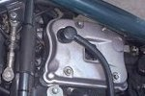
The benefit of doing this is greatly improving the engine’s breathing ability and therefore reducing the amount of oil puking out of the heads, a subject near and dear to every Sportster / Buell owner. A side benefit is the “cool factor” of having new XB parts on your old tube frame Buell.

Here are the parts that you will need:

- 17605-00YB Rocker cover, front head $39.
- 17642-02A Rocker cover, rear head $39.
- 17606-00YA Grommet, Viton, Black $2.95 each (need 2).
- 17607-00Y PCV Valve, $6.90 each (need 2).
- 868A Hex Socket Button Head Screw, $4.75 each (need 2).

Visit the DC-Brag website for replacement procedure¹.

¹) http://www.dcbrag.org/Rocker.htm

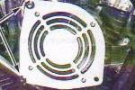
Cooling Fan

Fan Kit 91367-99Y. The installation instructions in PDF format is available.

Total Seal Gapless Piston Rings (http://www.totalseal.com/gaplesss.html)

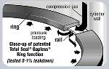
Time for new rings? Consider these... recommended by Hoban Brothers Racing 2002 National Thunderbike Champions...

We have used Total Seal rings in our bikes for a while now. Ed at Total Seal is a good
guy and I know they have held up well as we have done leak downs after races
continually and they are always right on! Whether that also has to do with Millennium
cylinders, I do not know, but the combination sure does work. The only issue that you
should be aware of is they create such a good seal that it will pull oil through valve
guide seals. If that does not concern you I would do as we have seen longevity and
excellent performance. Now, please don't tell everyone as I believe they were a key to us winning the National Championship!

And Nallin Racing Head Service...

We sell and recommend Total Seal rings. We've sold several hundred pair and can testify to their high quality. We've had tremendous success with them in both Nikasil and conventional cast iron bores. Most of what we sell is conventional (gapped) rings but we offer the gapless variety as well. Many times we see leak downs of under 2% with gapless rings (at those low levels it's hard to measure it!). Even after accumulating a lot of miles, the gapless rings show very little leak down. By the way, we bore and hone cylinders every day, using state of the art tools and torque plates. We also offer high quality Millennium cylinders, which are heftier and much more dimensionally stable than the stock pieces. Mic a stock cylinder with and without a torque plate sometime, then do the same with a Millennium, it's really an eye-opener. Then think about the stresses being placed on the front cylinder by the Buell chassis design.

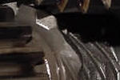
Oil Pump Drive Gear

The oil pump drive gear has been known to flag suddenly, with predictable results.

My drive gear looked similar to the one shown above only with at least 5 broken teeth.
Because of the teeth falling into the scavenging side the oil pump locked, retaining ring
came of, pump gear was pushed up(by the teeth left over) against the cam gear.
The moment the pump gear was lifted the oil pressure fell off and the oil light came on.

Checking Oil Pump Gear Drive

Drain oil tank.

Remove the clamp that holds the shock accumulator. Do NOT remove the accumulator oil line ever!

Remove the oil feed hose.

Remove the oil filter hose. Make sure to loosen pressure on the hose before loosening completely.

Remove the return hose, if possible. If the hose is long enough, its not absolutely necessary!

Carefully remove the two mounting screws (Allen NOT torx)... pump will drop with the screws removed, so be careful! Now you can remove the return line anyway.

Store the oil pump in a clean place, remember it's the heart of the machine!

If you place the motorcycle against a wall or support it safely to let it lean over the left hand side, you can look in the oil pump hole.

Now you can check the gear with a flashlight, rotate the engine by putting it in gear (engine not running of course) and riding it slowly back or forward.

If you see ANY signs of wear have it replaced. And then also examine the oil pump. Do not gamble with this, if you want to keep enjoying your bike for awhile!

If you're absolutely sure that there are no signs of wear assemble the pump again and liberally coat all moving parts in the pump with engine oil and install the pump with a new gasket.

Connect the hoses again (make sure they are clean), fill tank with fresh oil.

Refer to a BadWeb thread for further information …¹

¹) http://www.badweatherbikers.com/buell/messages/3842/19693.html

Totally Stainless (http://totallystainless.net/totally.html)

A fellow Bueller has researched replacing all the bike hardware with stainless fasteners, from a company called Totally Stainless.
See them here, along with catalog numbers:

12 point US | Type | Size | Length o.d. | Qty | Catalog | Allen head standard US | Type | Size | Length o.d. | Qty | Catalog
Front upper tie-bar left | bolt | 3/8” | 2 3/4 | 1 | 2-3839 | Rear subframe seat | cap | 3/8” | 1 1/4 | 4 | 2-0344
 | wsh-st |  | .815 | 2 | 2-4265 |  | wsh-st |  | .815 | 4 | 2-4265
 | wsh-sm |  | .630 | 2 | 2-4207 |  | wsh-sm |  | .630 | 4 | 2-4207
 | nut |  |  | 1 | 2-4066 |  | nut |  |  | 4 | 2-4066
Front upper tie-bar right | bolt | 3/8” | 1 1/2 | 1 | 2-3883 | Instrument panel | cap | 1/4” | 3/4 | 2 | 2-0303
 | wsh-st |  | .815 | 2 | 2-4265 |  | wsh-sm |  | .433 | 2 | 1-2003
 | wsh-sm |  | .630 | 2 | 2-4207 | Voltage regulator | cap | 1/4” | 1 | 2 | 2-0305
 | wsh-lk |  |  | 1 | 2-4307 |  | wsh-sm |  | .433 | 2 | 1-2003
Front lower tie-bar left | bolt | 3/8” | 1 1/2 | 1 | 2-3883 |  | star |  |  | 2 | 2-4348
 | wsh-st |  | .815 | 2 | 2-4265 | Headlamp mount | cap | 1/4” | 1 | 4 | 2-0305
 | wsh-sm |  | .630 | 2 | 2-4207 |  | wsh-sm |  | .433 | 4 | 1-2003
 | nut |  |  | 1 | 2-4066 | Fuel tank bracket | cap | 1/4” | 1 | 2 | 2-0305
Front lower tie-bar right | bolt | 3/8” | 2 | 1 | 3-3885 |  | wsh-sm |  | .433 | 2 | 1-2003
 | wsh-st |  | .815 | 2 | 2-4265 | ECM | cap | 1/4” | 1 | 2 | 2-0305
 | wsh-sm |  | .630 | 2 | 2-4207 |  | wsh-sm |  | .433 | 2 | 1-2003
 | wsh-lk |  |  | 1 | 2-4307 |  | star |  |  | 2 | 2-4348
Middle tie-bar left | bolt | 3/8” | 2 1/4 | 1 | 2-3886 | Handlebar | cap | 5/16” | 1 | 4 | 2-0324
 | wsh-st |  | .815 | 2 | 2-4265 | License plate | cap | 1/4” | 1 | 4 | 2-0305
 | wsh-sm |  | .630 | 2 | 2-4207 |  | wsh-sm |  | .433 | 4 | 1-2003
 | nut |  |  | 1 | 2-4066 |  | nut |  |  | 4 | 2-4064
Middle tie-bar right | bolt | 3/8” | 2 | 1 | 2-3885 | Ground strap | cap | 5/16” | 3/4 | 1 | 2-0322
 | wsh-st |  | .815 | 2 | 2-4265 |  | wsh-lk |  |  | 1 | 2-4306
 | wsh-sm |  | .630 | 2 | 2-4207 | Side stand | cap | 1/4” | 7/8 | 1 | 2-0304
 | nut |  |  | 1 | 2-4066 |  | wsh-sm |  | .433 | 1 | 1-2003
Rear tie-bar left | bolt | 3/8” | 1 1/2 | 1 | 2-3883 | Drive support arm | cap | 5/16” | 1 1/4 | 2 | 2-0325
 | wsh-st |  | .815 | 2 | 2-4265 |  | wsh-sm |  | .565 | 4 | 2-4206
 | wsh-sm |  | .630 | 2 | 2-4207 | Intake manifold | cap | 5/16” | 3/4 | 4 | 2-0322
 | nut |  |  | 1 | 2-4066 |  | wsh-sm |  | .565 | 4 | 2-4206
Rear tie-bar right | bolt | 3/8” | 1 1/2 | 1 | 2-3883 | Sprocket cover | cap | 1/4” | 2 | 1 | 2-0309
 | wsh-st |  | .815 | 2 | 2-4265 |  | wsh-sm |  | .433 | 1 | 1-2003
 | wsh-sm |  | .630 | 2 | 2-4207 | Allen head metric | Type | Size | Length o.d. | Qty | Catalog
 | nut |  |  | 1 | 2-4066 | Front axle pinch | cap | 8mm | 35 | 4 | 1-1264
Muffler front | bolt | 5/16” | 4 1/2 | 1 | 2-3814 | Rear master cylinder | cap | 6mm | 20 | 2 | 1-1147
 | wsh-st |  | .750 | 2 | 2-4218 |  | wsh-sm |  | 11 | 4 | 1-2003
 | wsh-sm |  | .565 | 2 | 2-4206 | Rear rotor | flat | 10mm | 25 | 4 | 1-1450
 | nut |  |  | 1 | 2-4065 |  | wsh-lr |  | 19 | 4 | 1-2013
Muffler rear | bolt | 5/16” | 2 | 3 | 2-3871 |  | nut |  |  | 4 | 1-3026
 | wsh-st |  | .750 | 6 | 2-4218 | Headlamp | cap | 8mm | 20 | 2 | 1-1161
 | wsh-sm |  | .565 | 6 | 2-4206 |  | wsh-sm |  | 14.7 | 2 | 1-2004
 | nut |  |  | 3 | 2-4065 | Front fender lower | cap | 6mm | 20 | 2 | 1-1147
Middle head mount | bolt | 3/8” | 1 1/4 | 2 | 2-3882 |  | wsh-sm |  | 11 | 2 | 1-2003
 | wsh-st |  | .815 | 2 | 2-4265 | Front brake assembly | cap | 8mm | 45 | 4 | 1-1166
Muffler / shock mount | bolt | 3/8” | 6 | 2 | 2-3893 |  | wsh-lk |  |  | 4 | 2-4317
Needs a spacer about” | wsh-st |  | .815 | 4 | 2-4265 | Rear brake lever | cap | 8mm | 30 | 1 | 1-1163
1/2 | wsh-sm |  | .630 | 4 | 2-4207 |  | wsh-sm |  | 14.7 | 1 | 1-2004
 | nut |  |  | 2 | 2-4066 |  | nut |  |  | 1 | 1-3025
Right caliper mount | bolt | 3/8” | 1 | 2 | 2-3881 | Body | Type | Size | Length o.d. | Qty | Catalog
Rear sprocket | bolt | 7/16” | 1 1/2 | 5 | 2-3868 | Rear fender upper | cap | 1/4” | 1 | 20 | 2-0305
 | wsh-lr |  | .920 | 5 | 2-4266 |  | wsh-lr |  | .560 | 30 | 2-4227
Case 1/2 | bolt | 5/16” | 2 1/2 | 2 | 2-3822 | Fender lower | cap | 1/4” | 1 | 2 | 2-0305
Front rotor | bolt | 5/16” | 7/8 | 5 | 2-3815 |  | wsh-lr |  | .560 | 4 | 2-4227
 | wsh-lk |  | 5/16 | 5 | 2-4306 | Chin fairing | cap | 1/4” | 1 | 1 | 2-0305
Isolator plate | bolt | 5/16” | 1 | 3 | 2-3816 |  | wsh-lr |  | .560 | 4 | 2-4227
 | nut |  |  | 3 | 2-4065 | Fuel tank cover | cap | 1/4” | 1 | 4 | 2-0305
Allen head standard US | Type | Size | Length o.d. | Qty | Catalog |  | wsh-lr |  | .560 | 4 | 2-4227
Primary cover | cap | 1/4” | 2 1/4 | 4 | 2-0310 | Scoop | cap | 1/4” | 1 | 3 | 2-0305
 | cap | 1/4” | 1 3/4 | 7 | 2-0308 |  | wsh-lr |  | .560 | 4 | 2-4227
 | wsh-sm |  | .433 | 11 | 1-2003 | Airbox | cap | 1/4” | 1 | 3 | 2-0305
Derby cover | cap | 1/4” | 5/8 | 4 | 2-0302 |  | wsh-lr |  | .560 | 3 | 2-4227
 | wsh-sm |  | .433 | 4 | 1-2003 | Flyscreen / chin | cap | 8/32” | 1 | 10 | 2-0927
Chain inspection cove | flat | 1/4” | 5/8 | 2 | 2-0641 |  | wsh-lr |  | .375 | 10 | 2-4214
Passenger footpeg | flat | 5/16“ | 1 1/2 | 4 | 2-0661 | Front fender upper | cap | 1/4” | 1 1/2 | 2 | 2-0307
mount | nut |  |  | 4 | 2-4065 |  | wsh-sm |  | .433 | 2 | 1-2003
Passenger footpeg | cap | 3/8” | 1 1/2 | 2 | 2-0345 |  | wsh-lr |  | .560 | 2 | 2-4227
 | nut |  |  | 2 | 2-4066 |  | nut |  |  | 2 | 2-4064
Speedometer sensor | cap | 1/4” | 5/8 | 1 | 2-0302 | Misc. | Type | Size | Length o.d. | Qty | Catalog
 | wsh-sm |  | .433 | 1 | 1-2003 |  | wsh-sm | 1/4” | .433 | 20 | 1-2003
Gearcase | cap | 1/4” | 1 1/4 | 6 | 2-0306 |  | wsh-lr | 1/4” | .560 | 20 | 2-4227
Some extras here, but | cap | 1/4” | 1 3/4 | 6 | 2-0308 |  | wsh-sm |  | .565 | 20 | 2-4206
complete | cap | 1/4” | 2 | 6 | 2-0309 |  | wsh-st |  | .750 | 20 | 2-4218
 | cap | 1/4” | 2 1/4 | 6 | 2-0310 |  | wsh-sm | 3/8” | .630 | 20 | 2-4207
 | wsh-sm |  | .433 | 15 | 1-2003 |  | wsh-st | 3/8” | .815 | 20 | 2-4265
Tappet retainer | cap | 1/4” | 7/8 | 2 | 2-0304 |  | wsh-lk | 5/16” |  | 20 | 2-4306
 | wsh-sm |  | .433 | 2 | 1-2003 |  | wsh-lk | 3/8” |  | 20 | 2-4307
Pushrod cover | cap | 5/16” | 3/4 | 4 | 2-0322 |  | wsh-lk | 7/16” |  | 20 | 2-4308
 | wsh-sm |  | .565 | 4 | 2-4206 |  | nut | 1/4” |  | 20 | 2-4064
Triple tree pinch large | cap | 7/16” | 1 3/4 | 4 | 2-0364 |  | nut | 5/16” |  | 20 | 2-4065
Triple tree pinch small | cap | 5/16” | 1 | 1 | 2-0324 |  | nut | 3/8” |  | 20 | 2-4066
Triple tree brake line | cap | 1/4” | 3/4 | 1 | 2-0303 |  | short nut | 3/8” |  | 20 | 2-4081
 | wsh-sm |  | .433 | 1 | 1-2003
 | wsh-lr |  | .560 | 1 | 2-4227

Rocker Box Gasket Replacement Procedure

See a little pool of oil sitting below rear cylinder and oil slowly dripping off the rear cylinder? Solution... a leaky rocker-box gasket. This is a VERY common problem with Evo Sportster engines in general. It is a relatively easy fix.

Get the manual, but you can read the basic steps here:
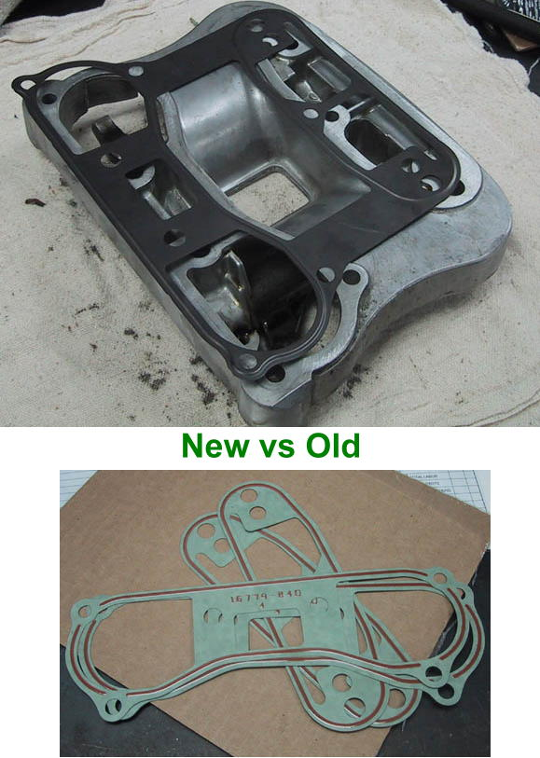

Rocker Box Gasket Replacement Procedure(basically)

Remove the gas tank. You might want to wear safety glasses when popping the fuel line, it may be pressurized and will blow fuel in an impressive manner. To depressurize, leave the bike idling and disconnect the fuel pump connection, until the bike dies. Then hit the starter a few more seconds.
You do this to relieve the fuel pressure and get rid of as much gas as you can before you disconnect the fuel line. Disconnect the fuel line that goes from the bottom of the tank to the fuel filter. Have shop rags/pans ready to soak up any gas that leaks.

Remove the cover, 4 Allen head bolts. The X1 has a nice frame design that allows easy access to the top end, other Buells may need a low profile Allen wrench for one of the bolts, cut off a wrench or better yet, get the $20 ultra low profile tool, Dennis Kirk carries it among others... part number H28-223, $22.99.

Position the cylinder such that both valves are closed (take out the plugs, rotate the motor with a few deft jabs to the starter, watch the valves).

Remove the lower rocker box (3 -7/16"- bolts on the floor of the rocker box, 4 -1/2"- bolts at each end of both rocker shafts, 2 more -1/4"- Allen head bolts).

Clean the gasket surfaces. The old gaskets are probably baked on really good. Use gasket remover, a well sharpened wood chisel or putty knife, and PATIENCE. Spray gasket remover, soak, scrape a layer, repeat. No need to rush, you may damage the mating surface.
Let the gasket remover do its job, it'll eat its way down through the gasket. If you're lucky, major pieces will lift up. But don't worry about the stubborn spots, they just need PATIENCE and repetitive use of the gasket remover. When you are completely done, polish the mating surfaces with 1000grit sandpaper.

Install the new gaskets. The new HD steel pieces go number side up & dry.

Torque all the bolts by the book - VERY important. Use the appropriate size torque wrench. I like using a -1/4"- drive below about 15ft/lbs, -3/8"- drive from about 15 to 40 ft/lbs. Torque wrenches are too inaccurate if they're oversized for the job.... you CAN twist off the little gr8 bolts on the floor of the rocker box when torquing to the high end of the specified torque range - use the low number!

Use Blue Locktite on everything.

Torque the 4 -1/2"- bolts first, 15 to 19 foot pounds.
Torque the 3 -7/16"- bolts next, 10 to 14 foot pounds.
Torque the 2 -1/4"- Allen screws next, 10 to 14 foot pounds.

Make sure 10 minutes or so passes between torque down and rotating the engine, so that you know the lifters have bled down.

Did you remove the rubber gaskets during the job, and now they won't fit back? Trying placing them in the freezer for a half hour.

It's probably the rear cylinder you're doing, right? Why not do the front one too now that you've seen how easy it is. Yes, the front is a little more snug getting the pieces out, but they DO come out with a little wiggling and pushing the harness out of the way.

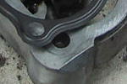
Better Gaskets

New Harley lower 1 piece METAL rocker box gasket. It's metal with a anodized type
coating on both sides. The part number is 16800-84, Parts and Accessories Bulletin
#709. Installation... the numbers go "up", the torque specs. are the same and install
the steel gaskets dry.

The James¹ stamped steel rocker box gaskets or Cometic² paper are superior to the
originals. The originals and other paper gaskets will also last a long time if you use just
enough Hylomar on them to discolor the material. It keeps them from becoming brittle and splitting. Cometic makes a steel embossed gasket that I have had no problems with. They sell them in two thickness in case you have deep scratches that won't seal. I have used James and S&S but Cometic has the best design I've seen so far. The other two work well and all three work better than the stock paper gaskets by far.
There is only ONE gasket company and that is Copper Gaskets Unlimited 623-780-0222 out of Phoenix Az. They make gaskets for ANYTHING, and supply gaskets for not only bikes, but Indy cars, Winston Cup, and NHRA. Incredible people, hard to come by in the industry... very conscientious, and caring, you won't be dissatisfied. Do yourself a favor, get a hold of them, any thickness in .001 increments, aluminum, copper VERY reasonable they are NOT stamped out gaskets...all their gaskets are CNC machined.

¹) http://www.jamesgaskets.com ²) http://www.cometic.com

Bad Valve Seal

Oil consumption & motor smoking? The oil drips along your valve stems and causes slight smoke at starting. The partly burned oil makes a mess in the combustion chambers. The compression is becoming somewhat higher with all that residue filling the combustion chambers. So the horses are there and your engine hunts the needle past the last numbers on your speedo. The engine starts knocking or pinging, then a neat circular hole is blown into the head of a piston.

Bad Valve Seal 2

Using a quart ever 500 miles or so. I thought it was just blowing out the breather. I kept noticing some blue smoke in my headlight at night while waiting for a stoplight. I pulled a rocker cover and probed the seals with a long thin screwdriver. Lo and behold, the valve guide seal on the rear exhaust was not in place. I wound up removing both heads, replacing the exhaust valves (pitted badly), reground the seats and installed Kibble White All Viton seals. The Harley units are really not up to date. The ones that were on the guide allowed oil to pass. Since then, I have added about 1/2 quart in 2,000 miles. Also, there is no blue smoke in the headlight. If you see any smoke, you may want to check your seals.

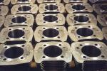
American Air-Cooled Cylinders (http://amaircool.com/)

Positives: Turn-Key Installation... no honing or other prep required; Power/Throttle
Response... less distortion/friction; Customer Service... George exchanged sets for me
with minimal charge; Weight/High Tech... 2-3 lbs less than Stock, 12 lbs less than Axtell;
Fast Break-In/Ring Seating... generally less than 100 miles; Ruggedness... they have
held up very well, and they seal well.

Negatives: Oil Leaks... there is usually leakage from the oil return passage directly to
the outside fin area. Suggest painting the cylinders immediately before installing for the first time; Poor Fit... I had to ream out, file, break off areas where the cylinders did not fit. Be careful when installing these.

Performance

Here's my take on X1 mods. Buell Race kit: Performance, sound, reliability. Now if you don't want to spend all those $'s go with: Race ECM $160 Venturi $0.95 Gutted airbox $0.00 K&N Air filter $45 White Brothers E-series $260 Total: $466 Buell Race kit $965 Savings $500. This combination will give you 95% of the performance of the race kit at 60% of the cost with 100% of the reliability. Will you be able to tell the difference with the "Butt" dyno?
I can't and I've ridden identical X1's set up this way back to back. Just my $0.02.

Drivetrain (Primary, Secondary, Trans)

Trouble finding neutral

Juice the throttle a bit with the clutch in, applying pressure up on the shifter. It should smoothly engage as the engine vibes jiggle the transmission cogs into place.

Baker 6 Speed (http://www.bakerdrivetrain.com/sportstersixspeed.asp)
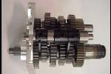
Six-Speed Overdrive, named the XL6 Conversion Kit, features full width gears for
uncompromised torque capacity and strength. Baker also developed a new shift drum
and detent plate with improved geometries for smoother and more precise shifting.

I have one in my 99 X1. It does shift better, but it isn't perfect. I have problems with false
neutrals if I don't concentrate on shifting. It is very quiet unlike other Big Twin Six
Speeds that I have ridden. The sixth gear is perfect for freeway cruising. 80 mph is
about 3200 rpm. I think that a speed much below that is too far out of the power band to
pull very well. Also, I had my bike at a track day at Road America and had good luck with the Six. My only complaint about that was the gear ratio difference between 5th and 6th was too large. I would shift at 6300-6500 from 5th to 6th and the rpm would drop to 5400-5500 and not pull back up to red line (max speed of about 143). I have about 1800 miles on it in an 91 cid 4" bore S&S engine that makes 110 RWHP. There haven't been any problems with it mechanically other than some false neutrals. It also has about 25 11 second drag passes on it. It is nice, but if I had a transmission that was working fine, I might not think it was worth the money

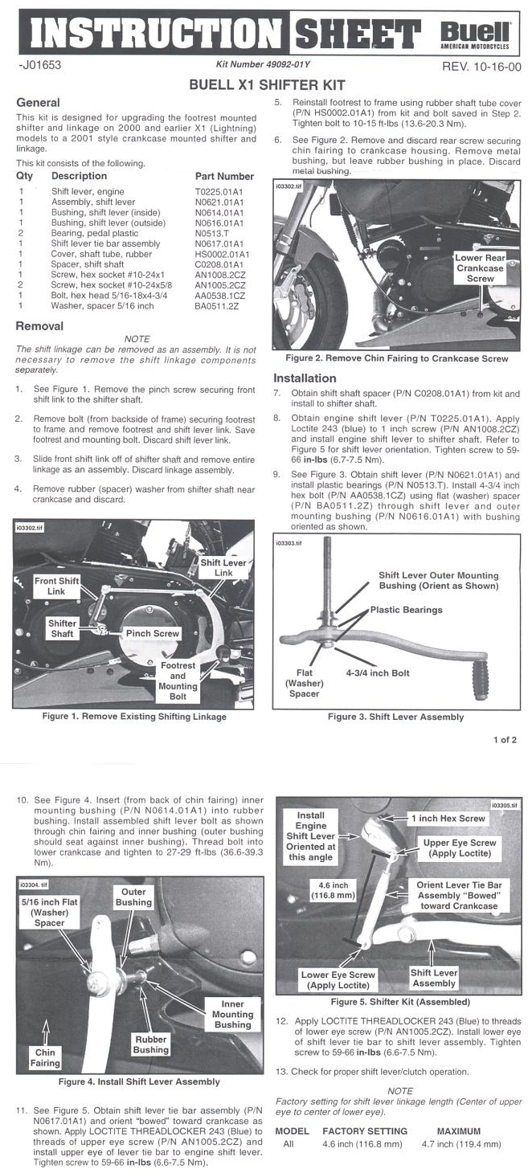
New Shifter

New unit 49092-01Y (or #49074-01Y for M2
and S3/T) is available as a replacement kit
for $99.95.

The 2001 model year shift linkage / lever
provides an apparent improved leverage ratio
(based on fish scale type tension measure-
ments of shifting force required), but is being
redesigned to improve geometry/leverage
efficiency of foot and lever interaction (I'm
guessing that the 2002 setup will be closer to
Banke's geometry where the leverpivot is
moved down via a bracket; it makes sense
when you compare side by side pictures of
each setup).
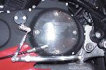

It works very well. The shifter has almost zero
play...quite a change from the original setup.
There is a clever nylon pivot built into the arm
which keeps the arm tight, while still allowing
movement where necessary. Shifts feel a lot
shorter than before....neutral is easy to find
now.

Anybody who has driven a sports car with a
"short shift kit" will be reminded of it when
they use this new shifter. Quality is good,
though it is not the show piece that the Banke
is. At $99.95, though...it doesn't have to be! In
contrast to the odd original design or the
gleaming aluminum Banke, the new arm
doesn't attract any attention (and when was the
last time you noticed a shift arm on any other
bike?).
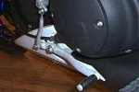

Read the installation instructions here:

Improve New Shifter

The ‘01 shift is a vast improvement but some
might find it harder to up shift than down shift.
The problem is the length of the shift linkage
requires the linkage coming out of the trans-
mission to be pointing almost straight down
when properly adjusted causing a reduction
in leverage. This problem can be greatly
reduced with addition of a slightly modified
threaded extension for less then a dollar.
Any hardware store sells threaded extensions used to connect thread rod. The smallest size is the correct length need to extend the shift linkage however you’ll have to increase the thread size to a 10/32. You’ll also need to cut the head off a 5/8” 10/32 screw to secure the extension. Use the screw to double nut lock the extension into the linkage and screw the universal into the other end, with the lock nut. Next move the shift linkage to one spine tool down from a 90-degree angle and reassemble the shifter.
A little trial and error will get you the best angle and you’ll probably find very little exposed 10/32 threads unlike before. The throw will be a tiny bit longer but much easier and the linkage will be much stronger overall.

Belt to Chain Conversion

- Texas Iron¹ 800.701.2925.
- Sprocket Specialists² 800.782.8202.
- DKF Performance³ 866.DKF.PERF.

You need 5 items. First the chain. A 530 110 link works with a 22 front and 48 rear. Texas Iron 04-583 $95 o-ring chain. Next the front sprocket. 22 tooth Texas Iron 04-484 $34.99 Next the rear sprocket. Sprocket Specialists Buell 48 teeth 530 chain. about $50. I used a steel Texas Iron 04-504 and enlarged the center hole to fit Buell. Next you need a 0.150" spacer for the front sprocket. I had Yankee Enginuity do this for me. Finally a rub block is needed. I just let the swing arm carrier wear down and then installed a piece of 1-1/2" angle iron bolted down just in front of the isolator. I change this about every 20k miles

¹) http://www.texiron.com ²) http://www.sprocketspecialists.com ³) http://www.dkf-perf.com/drivetrain.htm

Banke Drain plug in Primary

If you're tired of dropping the muffler to drain the primary, send $25US and the primary to: Banke Performance 1670 McLellan Rd. Felton, CA, 95018 The job looks excellent… actually have look around to see where the plug has been inserted.

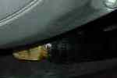
Primary Drain Hose

Shorten the head of a grade 8 bolt, and tap it for a very short 1/8npt 90 degree fitting.
The hose runs rearward then upward along the rear of the primary cover to a tidy little
billet plug/holder . The setup works great, and allows for an oil change in minutes

Update 99 2nd Gear
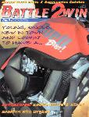
This excellent article compliments of Battle2Win magazine.

Unfortunately, this fine magazine is no longer in print

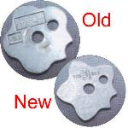
New Shift Detent Plate

Also known as the pawl. Recontoured to make shifting easier. Stock on 2000-up.
Part# 33656-90A.

Improved Chain Tensioner
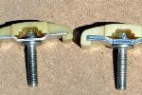
Anyone with a Buell produced before June of 2000 may want to check their adjuster if
you have the primary cover removed. The metal plate which the adjuster bolt goes
through was .115 of an inch thick. The replacement is improved with the metal
beefed-up to .250". The part number for the new one is 39975-90A.

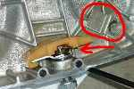
When the tensioner breaks, it may lodge in the primary
chain and pull bolts out of the tranny case. The whole
motor may have to be replaced. Have the chain checked for tension every 2,500
miles, check the tensioner for wear every 10,000 miles. Mine broke at 7,800 miles
on a 2000 X-1.

For replacement, you can read the basic steps here:

Primary Tensioner Replacement Procedure (basically)

1. Buy the parts:
- 1x 39975-90A tensioner. - 1x 7804 sealing nut (advisable
- 1x 34955-89A gasket. - 2x 41191-74 chain inspection cover screws (optional).
- 1x 37101-84 seal (advisable). - 4x 943 clutch inspection cover screws (optional).
- 1x 11105 drain plug o-ring (advisable). General note: Whenever possible, remove fasteners by striking, not pushing.
- 1x 25463-94 clutch cover o-ring (advisable). Especially important on the clutch & primary chain inspection cover
- 2x 11171 chain inspection cover screw o-rings (advisable). screws, but it's good practice in general.
- 1x 11188 chain inspection cover o-ring (advisable). - 4x 4 inch bolts (same thread as primary bolts) with heads
- 1x quart of Sport-trans oil or preferred equivalent. removed.
- 1x can aerosol brake parts cleaner.

2. Loosen the clutch cable adjuster all the way.

3. Remove the shifter (use a battery terminal puller if needed) if you wedge it open with a screwdriver, you WILL break it.

4. Remove the muffler... it's not that big of a job. Give yourself room to work.

5. Drain the primary... hold it upright to get it as completely drained as possible.

6. Loosen the locknut and back off the primary adjuster screw so you take all the tension off the primary chain.

7. Remove the clutch inspection cover. Loosen the four screws gradually, a quarter to half turn at a time until fully loose. This will help
prevent binding / stripping problems.

8. Remove the clutch linkage , turn the adjusting screw clockwise until the nut comes out, remove the ramp assembly and
disconnect it from the cable by maneuvering it into just the right position.

9. You ‘are’ going to take this opportunity to lube your clutch cable, aren't you?

10. Remove all the cover screws.(make sure you record which screws go where) there are two different lengths.
Slide the cover off, lay it on a rag, open side up.

11. Remove the old gasket and clean the surfaces.

12. Remove the old shifter seal from the cover and clean its recess.

13. Swap the tensioners, putting the new one open side showing / closed side toward the cover.

14. Hang the new gasket on the motor. It's going to be hard to see or verify its position as you put the cover on and if it gets out
of place you'll have a massive leak. To assist you, get 4 or so 4 inch bolts with the heads cut off... they allow you to position
everything patiently.

15. Slide the cover on, using the aforementioned headless bolts as guides. You'll have to reach in from underneath and push
the chain up so the tensioner shoe can slide under it.

16. Put the bolts back in. Torque to 95 inch/lbs. Torque bolts gradually in stages using a pseudo star type sequence.

17. Put a dab of grease into the center of the new shifter shaft seal. VERY CAREFULLY slide it over the shifter shaft.
This is tricky to do without damaging the seal. Use a 1/2" drive 9/16 deep socket to push it the rest of the way in.
A hammer is not necessary, use your palm.

18. Put the shifter back on.

19. Clean the drain plug and put it back in.

20. Stand the bike upright and add oil, until it just touches the bottom of the clutch spring. Too much is bad.

21. Put the clutch ramp assembly back in. Be very careful not to drop that little cable end piece down into the primary.
Slide the nut on and turn the screw counter clockwise, pulling the nut in, until it *starts* to seat. Now turn it clockwise 1/4 turn.

22. Put the little locknut with the spring on it over the screw and into its pocket. If you have to turn the screw slightly to make the
nut go on, make sure you're turning it clockwise.

23. Put the clutch inspection cover back on. Make sure that spring protruding from the lock nut is centered in the cover.

24. Adjust the clutch cable for 1/16" to 1/8" free play, measured where the cable housing meets the lever assembly.
Tighten the lock nut and pull the booty back down over the assembly.

25. Remove the chain inspection cover. Locate the chain's tightest position (blip the starter multiple time or try bumping the
engine from the rear wheel with the bike in 5th gear). Adjust chain to within spec at its tightest position. Adjust the chain
for 3/8" to 1/2" of up and down movement cold. Tighten the lock nut. The book says 20 ft/lbs. Put the cover back on.

26. Clean up the mess, using your brake parts cleaner or contact cleaner.

Primary Chain Adjustment

Start by lifting the rear wheel off the ground, you will need to rotate the motor over to do this, so pull your spark plugs. Put the bike in 5th gear, THEN remove the shift arm to get it out of the way of the inspection window. Remove inspection window, *don't lose the gaskets*, rotate the motor over by the rear tire until you GET TO THE TIGHT SPOT IN THE CHAIN! Once you are there, check by moving the chain up and down in the window. Perfect will be 5/8th to 7/8th inch or one width of chain (5/8th inch) with a COLD bike. The adjustment is the 7/8th inch nut and Allen screw directly below the adjuster window on the bottom side of the primary case. Loosen the nut and adjust with an Allen screw until you get your adjustment.

Nut and Retention Plate Problems

There are two problems with the Sportster drive train... the nut and retention plate that locks down the belt sprocket. It may come loose and back off the main shaft and still be in the retention plate. The sprocket will wear on the splines because the 5th-mainshaft is harder than the sprocket metal. So now the
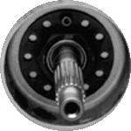
5th-mainshaft is banging against the inside of the sprocket and wearing it down and
causing the bearing to make noise. If this been going on for along time you may lose
the 5th-mainshaft and bearing and belt sprocket.

To check this, take off the belt sprocket cover and take off the two Allen bolts from
retention plate. Look at the nut and see if it is damaged, the back part of the nut will
look like a wrench slip off, all six sides of the nut will have a mark the same thickness
has the retention plate. This tells you the 5th-mainshaft is wearing the sprocket.

BUY the Jims Mega Nut¹ (Part#1708... cost $50.) DON'T use the H-D / Buell one
(cost about $6.) because it will happen again. If you do, loc-tight and torque correctly!

¹) http://www.jimsusa.com/cgi-bin/products.cfm?itemid=10134

Belt Considerations

The hardest part of driving something by chain is not the load in tension, rather it is the rpm the chain must turn and the repeated impact with the sprocket. The centrifugal forces and Gs of impact are far worse on a chain than the power input.

For any given operation a belt will provide superior life. Problem is, belts must be made quite wide to handle equivalent power transmission. This makes them not well suited for use on motorcycles where we must fit an appropriate belt inside the frame and swing arm/wheel combo. Chains work better here. Unfortunately many people hot rod their engines and strengthen con rods and run forged pistons etc., but seldom do you see folks putting effort into beefing up their drive chain. It's like adding power to an engine. Twice the power puts twice the load on internal parts, twice the rpm squares the load on the parts.

If you still doubt the capability of a belt, go to a national level drag race and check out the connection between engine and transmission on a Top Fuel Bike. 1000hp and no chain...Belt! Low inertia, relatively immune to impact on pulley teeth, and strong. Rear wheel drive is via chain for reasons mentioned above.

Ever seen a top fuel dragster with a blower run by a chain? Nope, you don't. The drive doesn't have to be narrow, just strong and efficient. My day job I work with machines that need to run 24/7 365 days a year. We avoid designing them with chains in any rotary power transmission at all cost. In summary: If you can fit a belt in there do it, if space is a concern, use chain.

Surging and stalling problems

Bad Bank Angle Sensor

Starts and runs fine for several minutes and then dies. (About the time it gets warm.) Will restart immediately and run fine for twenty seconds, and die again. Wait five minutes and try again and it will start and run fine for a couple minutes and then die. Does not smoke, miss, backfire or run rough. It just dies like the switch was turned off. Solution... bad BAS.

This may also cause your bike to not start at all. Try unplugging the BAS... it should cause an error 44 but allow your bike to start

Loose Intake Temperature Sensor

Problem turned out to be a loose intake temp sensor. The two best solutions for attaching the temp sensor: 1) Drill two small holes about 1/2" apart inside the airbox, then zip-tie it in place (discard the mounting tab). Put a dab of silicone sealant on the openings that are left around the zip-tie. 2).
Drill a small hole in the mounting tab and a small hole in the airbox, then use a pop rivet to hold the assembly in place. The mechanics at Brian's HD/B don't even bother with the two sided tape that comes with the race kit - they ditch it and use one of these two methods.

Loose Wire to Cylinder Head Temperature Sensor

The wire lead had pulled free from the Cylinder Head Temperature Sensor. You can pinch the wire where it exits from the sensor and GENTLY pull up on it and if it's broken you will feel the movement. If the wire is pulled free from the sensor, just cut the braid away from the wire and poke the wire back into the sensor. This will get you by until you can get a new sensor.

Bad Cylinder Head Temperature Sensor

Had a surge for a long time, never showed up on the scanalizer. Changed the head temp sensor and it started running good, no surge. $26.00 out the door...

Bad O₂ Sensor
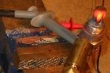
Bike won't idle, runs like it's on 1 cylinder, every now and then kicking in on second.
Make it idle at 3grand for awhile... engine light comes on. Bad O₂ sensor. Bike still ran
bad after replacement. Fouled plugs caused by bike running too rich because of bad
O₂ sensor. New plugs completed the job.

I just tested my old O₂ sensor, and compared it to the new one. Although I never got
any engine codes, it appears it is almost dead. The old one never gets above 0.027
volts (27.6 milli volt)when heated with a propane torch, and drops slowly. The new one goes to >0.8 volts and drops very rapidly back down. The O₂ sensor is like a battery, it generates a voltage on its own: <0.5 volts for a lean condition, >0.5 volts for a rich condition. Just connect one voltmeter lead to the O₂ wire and the other meter lead to the O₂ metal housing. Heat with a propane torch, and read the voltage - which should be >0.8 volts.

The sensor has to be heated to >600 degs F before it will read, and the oxygen in propane makes it read very rich (>0.8 volts). Put the positive lead of your meter on the O lead, and the negative lead to the body (ground) of the sensor.

As they age they get slower to react, so a new one will drop the voltage down rapidly once the flame is removed. The sensor is difficult to test on the bike, as you have to be above 2500 RPM (the rear cylinder doesn't fire often enough to keep the sensor above 600 degs at idle), and the ECM sends a bias voltage (0.45-0.50 volts) until it senses the O₂ sensor varying the voltage

See next section for O₂ sensor replacements.

Stalling when cold

They're grouchy first thing in the morning. It takes a few minutes of keeping the revs up before they will idle on their own. It's normal for a high performance hotrod, or a Harley... get used to it. Or get a throttle lock.

Check your seals

If your idle hovers around 2000 rpm and it comes down if you let out the clutch slightly, you have an intake leak. Check the seal around the airbox, the intake manifold seals and the injector o-rings. An easy way to check is to spray carb cleaner at the seals while it is running. If it coughs, dies, or idles differently when you spray, you've got a leak.

Gasket Sealer

The bike ran fine for an hour or so, but when nailed it a bit, it demonstrated that old familiar sputter again. Finally fixed it with gasket sealer. Yamaha makes a great gasket sealer called Yamabond.

ECM & TPS

Always reset the TPS when replacing the ECM. When they re-flash your TPS make sure they set your idle after it gets to running temp. (about 274 degrees).

Idle Adjustment

I had dealer install race ECM. Upon retrieving bike, cold engine idle seemed a bit high, but I anticipated normal idle after engine warm-up. Several miles down the road it became apparent that engine idle was becoming VERY high, almost as if throttle cables were binding. I stopped bike, checked cables and noticed idle adjustment knob under gas tank. I used it to adjust proper idle level, and have not had any further problems in 10,000 miles.

Clogged Injector

Fighting a low speed surge. Ran a can of BG 44K fuel injector cleaner through the bike along with a full tank of gas. My problem was reduced by about 85%. Replaced the O₂ sensor with Bosch 12014, and now my bike is all better. I would recommend the BG fuel injector cleaner for all fuel injected vehicles.

I used to own V.W.s and they were prone to injector clogging. The clubs and even the mo.co. reps recommended the Chevron F.I. Cleaner on a semi regular basis because of its ability to clean and yet not destroy or degrade rubber or seals in the fuel system. I was surprised to find it at Walmart. It helped me then with my VW and perhaps now with my S3T.
At the worst stage, the rear cylinder overheated strongly (pipe glowing orange) due to the lean condition on the clogged injector. I think this then caused the second temp sensor to go south. Long and the short of it was that the tech at Kegals removed the injectors then somehow "manually cleaned" them by blowing compressed air through them backwards (I still never figured this one out). He also replaced the engine temp sensor at the same time. Problem has now been cured for 3000 plus miles.

See next section for more information on bad injectors.

Never run out of gas

Ride the motorcycle in closed loop operation (2500-3500 rpm, approximately 40-60 m.p.h. in 4th or 5th gear with engine under load) consistently for 2-3 minutes. This allows the ECM to learn a new Adaptive Fuel Value (AFV).

Bad Fuel Pump

Bike suddenly died while sitting at a light. After a few minutes I got it going again, but every time I tried to get it to idle it would idle for several seconds, then die. It doesn't matter if the bike is in gear or out, clutch in or out, side stand up or down. To get moving I have to rev a little higher than normal and slip the clutch a bit. After riding steady without idling for a few minutes the bike seems to run ok until you try to let it idle. Then it will die in about 30 seconds.

All components (sensors, injectors, etc) checked out, fuel pump suspect. Before I replaced it I jumpered it so the fuel pump would run continuously without the engine running. It would sound fine for a minute or so, then I could hear it continuously speeding up and slowing down for another minute until it ran very slowly and stopped. I think the fuel pump motor was heating up and then it wouldn't maintain steady output.

Replaced fuel pump, problem solved.

Bad Speedo Sensor

Had a Buell come in the shop that would loose power when customer retracted the side stand. Was not the switch, clutch switch or neutral switch! Found in the wiring diagram the speedo sensor gets its power from the safety system. Found the speedo sensor wire rubbing against the cases, located right before the wire goes under the starter. I noticed the new speedo sensor comes with a plastic guide to prevent this! Check it out! A speedo sensor grounding out will shut down the safety system which will shut down the ignition....!

Bad Voltage Regulator

Started to misfire and wouldn't rev past 1500 rpm. After checking all the obvious battery and electricals and mechanicals the battery refused to turn over the starter. A diode in the charging system failed, causing the bike to run off the battery. The battery didn't last long after. It turned out to be a faulty voltage regulator (that finned black box in front of the motor).

Do you have a volt meter? If you do, Set it to DC volts, start the bike, put the voltmeter leads to the battery terminals. rev motor... does the voltage move? If it does not then the regulator is the common culprit.

Exhaust Header

If the bike surges, especially under 3000 rpm, check the exhaust header for leaks.

There's an easy way to test if you have a significant leak between the headers and the overheads. When the engine is cold, apply a viscous mixture of cleaning soap and water all around that link and start the engine. Immediately, you should see bubbles forming if there is any significant leak. After - say - 10 seconds, the bubbles will form because the mixture evaporates, but right after start, the place will still be cold and bubbles will mean leak.

Teflon Tape Fix

Wrap Teflon tape around the manifold and o-ring, then put on the mounting clamp. Do it one side at a time to make it easier, as in put one clamp on temporarily, wrap one then put the clamp on snug. Then do the other one. Then do a final tightening to torque spec. To make it easier to wrap the tape around cut the "guide rings" on the tape roll down flush with the tape dia. Teflon tape is about $ 1 a roll, so it's cheap to boot.

Plugs

Be aware that the Buell pro series plugs use an 11/16 hex instead of the standard 5/8 of the H-D plugs. I made the mistake of just buying them and heading out on a trip, only to find out the difference while trying to change fouled plugs on the road.

If you're fowling out your rear plug in the cooler weather you might want to switch to a hotter plug, but then how can you tell you need to do this? If the plug shows you're running the right fuel mixture but the porcelain is black your plug is too cold.
When the fuel mixture is close to right you'll see a very thin line around the porcelain about 1/16" from the top. If the tip is white you're too lean no matter what the plug temp. Ideally the porcelain should be white with just a splotch of brown where the fuel hits the plug and the tip a very light shade of tan.

Install 10R12 plugs (the Blast! plug) as soon as possible, it eliminates 90% of the detonation. The 10R12 is the rebadged H-D version of the Champion Plug #809 (or RA6HC... old nbr) and costs 3X more. Champion Plug #810 ( or RA8HC) is the old OEM plug.

The correct 10R12 replacement is NGK DCPR8E - its reach is a little longer but there is no interference. This plug has the correct terminal stud and uses the same 5/8" socket to install. Colder plugs use a higher number, e.g., DCPR9E. The DPR8EA-9 is the same heat range but it uses an 18mm vs. the 5/8" socket and has a terminal stud rather than a nut.

Other NGK plugs…
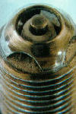
- NGK DPR7EA-9 HOTTER
- NGK DPR8EA-9 (#4929) 18mm / pre-gapped More $$$.
- NGK DPR9EA-9 (#5329) COOLER
- NGK DCPR7E HOTTER NGK DCPR8E (#4179) 16mm / large push on top connector
- NGK DCPR9E COOLER
- DPR7EIX-9 (#7803) IRIDIUM HOTTER
- DPR8EIX-9 (#2202) IRIDIUM 16mm / screw Terminal Nut
- DPR9EIX-9 (#5545) IRIDIUM COOLEST
- 145 degree difference between each heat range…

I have over 15,000 miles on my Torque Masters¹. I am running a 00' X-1, Race ECM, K&N and White Bros. E-Series. Never a pinging problem, never a fouling problem. Mine are equal to the 6R12PP H-D plugs not the 10R12. I know a number of FI Buelligans that have had fouling problems with the 10R12 or their equal. Once you go to the Race ECM and good gas you should not have pinging problems with the 6R12 equals. When ever I put my T-M's back in, I can always feel a smoothness difference between them and any new plug. That is even with 15,000+ miles on these T-M's. Give a shout to Maury (the Inventor and Owner) and he can make any heat range or hex size you need.

I've been running Torque Master Plugs for about 10,000 miles and all I can say is... save your money. The torque master plugs do last longer than any other conventional plug, but they are about $15! 5 times more than a conventional plug. In addition there is no performance increase. I reviewed both gas mileage and dynamometer testing and there is no difference. I personally like NGK since their tips don't seem to round off as quickly.

If you need a good plug use Auto-Lite # 4163 They are like the 10R12 plugs of stock Buell. They are both copper electros end plugs but Auto-lite is cheaper (#4163 $2.ea.) I don't believe in the Split-Fire plugs on Buells. I'd rather have one big spark than two little ones. From what I'm told the Torque Masters are like the Split-Fire ones but with more than one end. Buell ECM is set-up like a car... they'd rather have one spark than a lot of little ones. And don't use Bosch Plugs, they foul even quicker. If you want more power out of your plugs index them towards the intake valve w/copper washers from Jacobs. Also make your spark plug gap a little bigger and use the wire type feeler gauge. Don't use the slide ramp type gauge better yet use the s/p gapping pliers (cost $50.) Plug gap is usually .002 more (example .042 change to .044) Buell specs. calls for .038 to .043 go to .045 and index the plugs and get give it a run. The only time that I would go wider in gap is when you get a hotter coil like a Jacobs coil.
(my gap is .055).

For cross reference for other brands of plugs see http://www.clubplug.net.

¹) http://www.torquemaster.com

Valve Guide Seals

Fouled plug would be the first thing to look for... if so, could be valve guide seal. Overreved lately? Missed a shift? This could float the valves and the spring retainer could cut the valve guide seal causing excessive oil consumption. Two choices-- pull the top end and replace the seals or contact thndrb@msn.com for more information with lower cost to repair.

Fuel Injection

Bad Injector?

With the F.I and ignition system powered, give the injector a 12v feed and see if it squirts. If it does, you don't have a faulty injector.

Bad Injector Lead?

A common problem is a wiring break in a fuel injector lead. You can easily tell if you have a broken wire, and which cyl. is affected by removing the plugs and spinning the engine over with the starter. Keep the throttle open, there should be gas coming out of the plug holes if the injectors are working, if one of the cyls. is dry, trace the wire out, you will most likely find the break where it crimps into the terminal end.

O₂ Sensor Replacement

Bosch 12014 has the correct Weatherpack connector. It is just unplug, unscrew, screw in and plug in. The O₂ sensor from a 1993 Chevy pickup will work... it also plugs right in, the wire is about 2 inches longer but doesn't seem to be a problem on an S-3.

The O₂ sensor that K&N puts out for the Power Commander is actually from a 90/91 3.8 liter Ford Thunderbird part# F1SZ-9F472-A.

NOTE!!! If you do not use the exact part#, there are 3 different sensors for a 90/91 3.8 liter Ford Thunderbird... two will work, one will not. You want the sensor with FOUR wires and a WHITE plug and this comes in both a long and short lead version. The one that you do NOT want is the one with 3 wires and a black plug. The black plug has the same configuration as the white one except that one of the engaging prongs is approx. 30 degrees off from where it needs to be.

Zero the TPS

How to zero the TPS in two minutes or less. (not counting warm up time).
1. Connect scan tool
2. Select #3 Data Monitor
3. Scroll down to TP degrees
4. Back off idle adjuster until TP degrees reading stops decreasing
5. Turn idle adjuster one more full turn out
6. Snap throttle closed to seat the throttle plate
7. Press mode on the scan tool and select option #7 Calibrations
8. Select #2 TPS zero function
9. Press enter, then option #3 on the scan tool
10. Scroll down to TP degrees, adjust idle speed screw until TP degrees read 5.8 degrees
11. Press start button and start bike. Warm up to 280 degrees engine temp.
12. Adjust idle speed to 1050 RPM. NO MORE and NO LESS.

For DDFI Buells with poor engine performance problems, 80% of the problems can be resolved in less than twenty minutes simply by properly zeroing the TPS and verifying/setting the cam position sensor timing. How do you verify/set cam position sensor timing?
1. Remove sensor cover (drill out two rivets).
2. Attach voltmeter to sensor leads
3. Remove spark plugs
4. Support rear of bike to allow rear wheel to turn freely.
5. Put transmission into 5th gear
6. Turn Ignition on.
7. While closely observing the voltmeter, slowly/manually rotate the rear wheel in the forward direction so
as to turn the engine in its normal sense.
8. Stop when the voltmeter initially shows a change from zero to 5 volts.
9. Check the cam position sensor. It should be dead centered with the timing mark. If not, adjust so that it is
and recheck.
10. Any sensor timing deviation from dead center will adversely effect performance. Even as little as a
single degree off of center will hurt DDFI performance.

Running Lean

In city traffic after about 20 min the pipes got REALLY hot (burned your leg from a foot away). About 5 min later the RPM’s would increase from 950 to 1500 and about 2 minutes later the red engine trouble light would go on, and the engine began to run very poorly. Solution... bike was running lean.

Running Lean 2

Bike was "running lean," causing misfire and overheating. The techs looked several times but found nothing. It turned out that the bike was "running lean" and the techs were reading the manual wrong because the scanalizer said the mixture was acceptable. When the problem persisted had the dealer call Buell and there they found that the reading has to be EXACT and not just within tolerances.

Running Lean 3

Symptoms: gas mileage went from 200miles a tank to 160-170; plugs are wet fouling, especially on cold start; slow return to idle when hot (up to 15 seconds); runs great between 3000rpm-redline. Was resolved after replacement of the O2 sensor and a TPS reset. The AAV value was also reset. The TPS adjustment must be done 100% per the factory procedure. Plugs are a good indication of the symptom; i.e. running rich / lean etc.

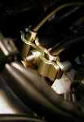
Throttle Cable Clamp

It bonds the throttle cables to the cable bracket (bucket), preventing a very dangerous situation.
These are stock items on the Y2K X1's... 56491-99Y.

Air/Fuel Ratio Meter (http://www.autometer.com/hp/searchby/product_type/airfuel/airfuel.html)

Here's a funky accessory from AutoMeter¹.

Read more about its operation here …

Attached to the tach via the AutoMeter cup. Their cups are designed so that the "flat" can be
mounted on a steering column or roll bar with a hose clamp, which is what I used. Since it's on
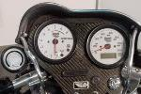
the tach any way, I used the tach's lamp to power the gauge. I ran the negative lead to an engine ground and spliced the sense lead to the purple O2 lead wire at the ECM -soldered and heat shrinked. No real need for a separate fuse- just replace the lamp fuse if it ever blows, It hasn't yet. It is balls on accurate. I have a friend that dynos bikes here locally. He used his pipe sensor to check my gauge. No discrepancy. Only problem is that it takes about five minutes of riding to heat the sensor enough to start sending info to the gauge.

¹) http://www.autometer.com/hp/searchby/product_type/airfuel/airfuel.html

Force Intake (http://www.useforce.com/index.html?dummy=HOME)

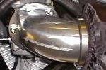
Lots of clearance, three Allen head bolts (the upper fwd will require a ball-style driver or
a seriously shortened standard driver) for mounting. In the rain, the supplied
"dry-charger" cover works pretty good. It will not stop 100% of water ingestion though...
mild rain with causes no ill effects.

Mounting the temp. sensor causes extra work in the XR1. The XR2 is set up for FI.

Options for the breather lines …

- Catch can... see Breathers Section.
- The new XR2 incorporates billet fittings, and plumbed with polished hard-line and AN fittings, it now loops
into the back of the filter for a clean, professional look.
- Kuryaking² sells a spacer (for the Hyper charger) that has plumbing fittings for the vent lines. This way
you can preserve the so called re-injection of the blow-by. These spacers will work on the Buell. Just need
to make sure you get one for the 40mm CV carb.

Concerned about performance in the rain? Regular rain does not affect it to any visible
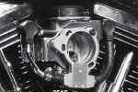
degree. I rode over 400 miles in torrential rain once. I had the "wet suit" cover on at the
time. With judicious throttle control, one would hardly notice the difference. Hard
acceleration was a no - no. I think the increased demand for air pulled in a lot more
moisture from the filter. With attention to the right wrist you should be fine.

²) http://kuryakyn.com/prodlist.asp?bn=harley&cn=Air+Cleaners

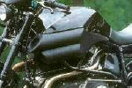
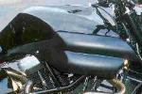
Cogitech (http://www.cogitech-design.com/fr/produits_

k_bc1.html)

From France....

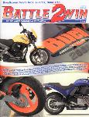
Buell FI Doesn't Have To Suck

This excellent article compliments of Battle2Win magazine.

Diagnostic Trouble Codes on DDFI Buell Motorcycles
Dynamic Digital Fuel Injection (DDFI)

Here's a quick way to get the trouble codes needed for diagnostic purposes.

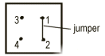 | Only a 2" jumper wire is required to connect pins 1 & 2

Using the jumper wire, connect pins 1 & 2 in the diagnostic port located just behind the steering head.
To run the test procedure turn on ignition but do not start engine.

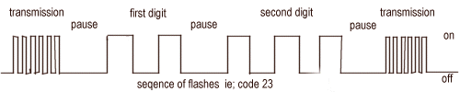
Trouble code is displayed by flashing engine light on the tachometer.

A transmission code of 6 fast flashes followed by a 2 sec pause then a series of slower flashes indicate the
first and second digits of the code. Either another code will be displayed or the transmission code will repeat.

Note: If the jumper wire is remove while the engine is running, the check engine lamp will continue to flash trouble codes.
Just turn off ignition to clear.

Below is a Table of Trouble Codes, which will enable you to troubleshoot any problems by referring to
the Service Manual or certified Service Dealer.

DDFI Trouble Codes
Code No. | Fault Condition | Code No. | Fault Condition
11 | Throttle position sensor | 25 | Rear ignition coil
13 | Oxygen sensor | 32 | Rear fuel injector
14 | Engine temperature sensor | 33 | Fuel pump
15 | Intake air temperature sensor | 35 | Tachometer
16 | Battery voltage | 44 | Bank angle sensor
23 | Front fuel injector | 52, 53, 54, 55 | ECM failure
24 | Front ignition coil | 56 | Cam sync failure

Broken Throttle Shaft
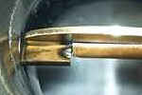
It started as what I thought was fuel starvation, possibly running out of fuel. I took off the
airbox to try to look at the throttle body, sure enough, the butterfly was jammed shut,
and the pulley that the cables ride on was against the front head. I freed the stuck
butterfly, and I thought I might try to limp the bike somewhere. I got it started and the
vacuum in the throttle body pulled the broken shaft against the other piece, this resulted
in a crude functioning throttle. It did not work too bad, I managed to get it up to highway
speeds to ride to my dealer. I ordered a new throttle body and it has a larger diameter
throttle shaft than the one that came on my 99 X1. The new one has a butterfly that is captured on both sides and the old one only has throttle shaft material on one side.

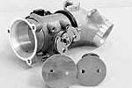
BC Gerolamy 50mm Throttle Body (http://www.bcheads.com/fuel.htm)

23% increase in butterfly area 21 CFM increase in airflow. Throttle Body Upgrade:

- Bore to 50mm.
- Install throttle linkage gusset.
- Install new butterfly.

Carb Conversion

In short here's what you'll need to convert to a carb: 1. Carb: 44mm SE CV $279 -or- 40mm CV Keihin (90+, late model XL and BT) about $50 used - or could use a Mikuni or whatever floats your boat, but I kind of like the CV's, they're good for drivability. 2. Intake Manifold: for above $69 for 44mm or about free for 40mm - of which the CV44 will fit. A little epoxy is needed with the 44 and the manifold. The o-rings roll sometimes and leak, epoxy doesn't. 3. Ignition: Crane HI-4 (nosecone - model 8-2100, $250) -or- HI-4E (model 8-3101, $272) - I'm leaning towards the 4E and fairly sure that the stock cam position sensor will work, but am checking the P/N. 4. VOES Switch - free or cheap 5. Petcock: $100 or so - I think I'll be able to separate the pump from the rest of stuff in the tank and easily adapt a regular petcock - and I'll get to keep the low fuel light, to boot...time will tell, as I haven't taken the tank apart yet. 6. Various electrical connectors, if you're like me and don't want to butcher the wiring harness. I'm going to make a special sub harness that'll just plug into the various bits...it looks like I'll have to pull the tach feed from one of the connectors, but other than that... Just time and willingness to do it.

Power Commander (http://www.powercommander.com/803-211.shtml)

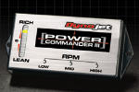
You will need the Hi-Perf O2 sensor if you want to control the mix below 3400 rpm
otherwise it will just use the factory settings. Also, the 5 minute installation time quoted
in the ads and on the box are not true. You have to remove the gas tank to install it...
make sure you have a fuel line clamp because they are not reusable and you have to
remove it. The dealer took about 45 minutes and they had done it before. You could
probably double that time for a home installation. The PC3, O2 sensor and labor were
a shade over $500.00 :-( but I think it was worth it. The bike runs like a raped ape!

Read more about it here …¹

Another opinion... PC3 is an add on unit, it requires an ECM to function, be it stock or race. The Race ECM raises rev limiter 500 RPM and has different ignition mapping and fuel mapping than a stock ECM. PC3 affects only fuel mapping. Race ECM is set up for Buell Race Header/Muffler/Air Cleaner. PC3 is used to fine tune other combinations of intake and exhaust modifications. PC3 with optional O2 sensor allows closed loop (real time feedback) control of fuel flow below 3400 RPM and 33% throttle. Dynojet says "typical aftermarket modifications will not require the additional sensor". FI cam set up is not designed to make power below 3400 RPM and crankshafts are balanced for higher RPM’s. Always keep your revs above that "below 3200 RPM vibration" and on the cams, and you shouldn't need to worry about having closed loop control below 3400 RPM. Get the Race ECM first, then if you feel the need, add the PC3.

¹) http://www.powercommander.com/803-211.shtml

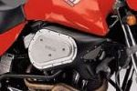
Roadracing (http://www.jacklilley.com%20)

Road racing Airbox ...the air box is made from Carbon Fiber. The steel plate
(comes in black or silver anodized) lets you access the K & N filter.. the whole unit
does NOT include the filter and costs over 300 British pounds.

Temperature Sensor Removal

Would like to remove your temperature sensor without cutting and soldering or removing your harness ? If you follow these easy steps it will take less than two minutes to remove and reinstall your plug housing.

Temperature Sensor Removal

Would like to remove your temperature sensor without cutting and soldering or removing your harness ? If you follow these easy steps it will take less than two minutes to remove and reinstall your plug housing. You will need a super small flat head screwdriver (jewelers type).

1. Once you have access to the plug/sensor disconnect the sensor from the plug housing. For reference keep the lock
part of the plug to the top. Mark your wires left/right with tape, or other marking device of choice.

2. The yellow piece of the plug will slide out approx 3/16" and stop. Careful not to break it. Gently work the catch until
the yellow piece comes completely off. Save in safe location for reinstall.

3. Choose a wire to remove Left/Right. Look down into the plug, you will carefully insert your mini screwdriver between
a female connector and the connector locking device. The locking device will be a metal piece at the rear of the
female wire connector inside the housing, (it will stay). You will gently lift up on the lock while gently pulling out
your first wire. (Note: be sure your wires are marked) Remove second wire.

4. You have now two wires to run into your device. My case, Force carbon ram cover. Insert through grommet and
install wires to plug housing. Replace yellow cap.

You're done! You will have a professional looking finished product. No cut wires, solder or shrink wrap. and it should only take a few minutes.

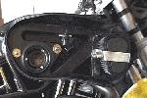
Gutted Airbox

Here may be the hottest set up for a Buell air filter. Take the stock bread box and
remove the snorkel tube. Replace it with a stock Harley venturi ring #29179-88, @ $.95.
Drop in a K&N; filter and you now have the perfect still air box.

One member also ground out the intake hole of the bread box to max size but still hold the filter and claims +6hp
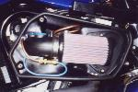
increase over stock. Here's a modified M2 box. Read more about it here¹.
I decided to get rid of the bread box. I didn't want to go to an aftermarket piece
(I like factory stuff when available), so I used a race air cleaner kit for the S3. Bolted
right on and had the hole in place for the IAT sensor. Looks great and works.
The bike feels noticeably stronger than with the bread box gutted.

¹) http://www.geocities.com/n2oinjection/page19.htm

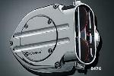
Kuryakyn (http://kuryakyn.com/prodlist.asp?bn=harley&cn=Air+Cleaners)

It looks cool and the butterflies open and close. The thing that I didn't know before
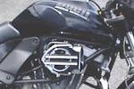
I bought it was that there is about a 1"x6" slot cut out
of the bottom... needed for the bike to idle. If you notice
when the bike is idling, the butterflies are mostly shut.
It kind of defeats the purpose of the ram charge effect
that I assumed I would get.
Also if you have long legs you might want to consider something else.
I'm 5'10" and my knee just skims it when in a natural sitting position.

Odyssey Kolors (http://www.eurocomponentsusa.com/buells.html%20)
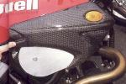
Euro components is the official dealer for Odyssey Kolors products in the USA.
Air cleaner and left side covers for X1s are made out of carbon fiber and come in a
clear-coated finish, so you do not need to paint them, and they are ready for installation.
Kit includes a smaller air cleaner cover (made by Screamin' Eagle) and a special air
intake on the left side cover, which provides more air to the rear cylinder for better
cooling. Both covers follow the lines of the tank for a super-smooth look. Both sides
feature built-in turn signals for a sharper look. Complete kit is $ 664.20.

Yodude Intake
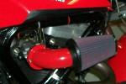
Company name is Yodude, designer and producer of intake and exhaust systems for
cars and motorcycles. It has a smooth bore without any casting flash or bumps that
would impede the air flow. It is all aluminum and includes a K&N Filter
(number RC-3680), chromed breather bolts and crossover as well as a catch can that
attaches to the frame under the intake. The intake is available powder coated or polished.
All pieces are available separately if you already have one component or another.

Other Intakes
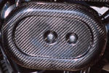
Buell CF Oval Air Cleaner is pricey, but works well.

I'm running a modified Screamin' Eagle round EVO air cleaner (approx. $70) with a
round cover ($39). This turned out to be a little more work than getting a Buell-specific
kit but at least I don't feel like I paid too much. The pricing for these things is ridiculous.

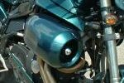
The S1 race kit filter fits the X1 with no problems.
Just drill a hole in the back plate for the oxygen sensor.
Just Harleys in Newcastle (England) convert most of their X1's like this.

From Japan, manufacturer unknown. See website here².

²) http://www.w-hsc.co.jp/frame/ram-f.html

Electrical

You're the problem!

Have you worked on your bike lately? Anything at all? Retrace your steps... you might have pulled something loose. Results may not be immediate either... see below.

Pulled Wires

I wrote a message on the forum a few days ago about my bike not starting and that I was frustrated...needed to vent. Come to find out the problem was ME! I pulled some wires while installing the tach or they moved possibly when turning. The wires fed power to my starter. I guess the bike is more reliable then the owner.

Common Rub Points

Down under the battery where the speedo-sensor wire and an oil line run up over the rear corner of the inside of the primary/clutch housing, that inside upper edge gets enough vibration and movement to almost wear thru the oil line and any adjacent wires. There are also some very tight wire bundles routed around/along the frame under the gas tank and heading up to the front of the bike. Also, check very closely around the electronic controller as there are also a bunch of wild tight bends around there.

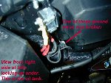
Broken Ground

Riding along, bike starts cutting out... engine light going off & on. Bike finally died
altogether. With ignition on Run, engine light no longer coming on, fuel pump not
coming on, no odometer display, no oil pressure light. Plenty of power... horn blasts.
With ignition on Park, odometer display flashes. Scanalizer not getting any input.
Solution! Broken ground wire, back of gas tank next to the 30A circuit breaker.
See photo.

Loose Connection at Circuit Breaker

While the bike is running, ie cruising down the road, the odometer will flicker or turn off, the speedo will drop to zero and the engine will stumble then die. The check engine light does not come on. I pull in the clutch, coast to a stop, turn the ignition off then back on. The ECM does its diagnostic check, the check engine light goes out, and if the odometer is lit up the motor will start and I'm on my way again. If the odometer isn't lit up the starter motor just clatters (the headlight is also dim), that usually gets the odometer back on, then the starter will fire the motor. Solution... Found it at the 30A circuit breaker under the seat/tank (see above photo).The black wire from the starter and the red wires from the voltage regulator and key switch/fuse box were slightly loose. Man, that circuit breaker post gets hot when there is a little resistance there!

Loose Wires to Fuse Box

Bike won't start... no power to fuel pump. It turns out that the wires going into the bottom of the fuse box were loose. Gave it a shake and the fuel pump kicked in. Engine started right up.

Broken Ignition Wire

The dash won't light up at all when I turn the ignition key to any of the positions, and not even the horn will sound. The battery still has a normal charge. The ignition fuse is not blown. I checked the ground cable and it is secured.
So I figured it was a broken wire somewhere... after combing thru the wiring harness, battery ground wires, fuse box, ECM, I looked up more thoroughly under the battery tray and saw the ignition wire that comes up from the starter blown clean through and self-welded to the underside of the battery tray. I had initially missed it because it still appeared like both ends were together & felt secure when tugging on it, but this was only because it fused itself securely to the metal tray and even burned a divit into it! The wire had been routed very close to the tray and had apparently worn through after 6700 miles of vibrations and shorted out. My solution was simply to peel the wire off the tray, strip down, re-join with a butt-connecter and re-route out off to the side out of the reach of tray, frame, etc. I plan to go back and solder the wires when I have time, but the possible slight possible voltage (12 volts still here) drop hasn't seemed to affect the ECM. After that she fired right up and is running strong.

TPS-Wire

Beware of the routing of the TPS-wire. Problem with the ignition cutting out (fun ride to the shop) and mechanic discovered that the throttle cable was rubbing on the TPS-wire.

Bad Neutral Switch

About 1/3 of the time with the tranny in neutral, the neutral light won't come on. Have to pull in the clutch for the fuel-pump to work. Starting the bike with the clutch in, the neutral light will often come on, and the clutch can be let out. Possible solution... try cleaning the Neutral Switch connector where it attaches to the tranny fitting. It's probably intermittently making contact which would explain why the light comes on after the engine starts.

Speedo Sensor Problems

The speedo died and the trip odometer still registers but does not change. It is not a fuse … it turned out to be the pick-up unit that is mounted on top of the transmission box. As you are sitting on the bike it is right-of-center. It has a large black wire, 1/2" x 1/2" black plastic piece and one Allen bolt holding it in place just back of the starter.

Make sure your plug wires are not chaffed at all. Also make sure that they are routed away from the wiring harness of the bike... the wires can cause stray voltage in the engine and destroy your speedo sensor. As a matter of fact, Buell recommends replacing your plug wires with your speedo sensor just to make sure.
Get the updated sensor p/n 74431-01Y (the old number was 74402-95).

Our friends across the pond at Trojan Horse have come up with a nifty little product. Speedometer sensor failures are fairly common with these bikes and at about $55 a pop not including installation it’s a pricey nuisance. If you’re lucky a speedo failure only results in a dead speedometer but as has happened to me, it can also blow your ignition systems thereby killing your bike. Trojan Horse has made a fail-safe device that sells for about $36 , installs in about 5 minutes and is small enough to mount on the strap holding your battery. OK, so what does it do? Something in the bikes electrical system causes a spike that in turn shorts out the speedo sensor. Generally you’ll get a warning when your sensor is about to go bad because the speedometer will start acting erratic. At the first sign of this pull over and disconnect the speedo sensor before you blow an ignition fuse. The Trojan Horse device is spliced into the wire delivering power to the speedo sensor thereby acting as a surge protector. The device will not fix a failing/failed sensor but it should protect a good one from going bad. The Trojan Horse unit is weatherproof and it has a power LED to let you know the device is working. The only importer I’m aware of for this device is Dave Stueve at 1-800-342-7539 Ext 14 or dave@iowaharley.com.

Refer to a BadWeb thread for further information on “homebrew fixes”.¹

¹) http://www.badweatherbikers.com/buell/messages/3842/10307.html?1058936921

Blowing 20amp Ignition Fuses

Problem with speedo sensor... it shorted out and would blow the 20 Amp Ignition Fuse when you would turn the key switch on.... did this 4 times. As soon as you would turn the switch on it would blow the fuse... had lights but no start circuit or power to the ECM. When you power up this puts 12volts to the speed sensor (and a lot of other things) and it was shorted to ground, thus taking out the fuse.

Blowing 20A ignition fuses at various and frequent times. Turned out to be a bad Ignition Relay.

Would blow the ignition fuse with a passenger on it. It turns out the wiring harness, as it comes out of the ECM and down the left frame tube, was routed under the rear Heim joint, which would pinch the bundle on top of the swing arm mount with the additional weight of a passenger. This wore the insulation off of one wire which would only short out with any additional weight. To fix the problem the dealer rerouted the wiring bundle on top of the Heim joint. The rear brake line had to be disconnected to do this, and rerouted under the wiring. I also pulled the bundle up higher, at the bend, and zip-tied it to the battery tray.

Blowing 20A ignition fuses... found the wire loom under the steering head rubbing on the mounting boss in front of steering neck. It is nice and square (sharp) and has cut some wires open, leaving them exposed so when I turn they must go to ground.

Chafed Plug Wire

Noticed several chafing cuts on the rear cylinder wire. One cut exposed the inner insulation.

Magnecor Plug Wires (http://www.magnecor.com/)

APPLICATION | 7mm  (Black only) | 8mm  (Blue only) | KV85 8.5mm  (Red only)
Carbureted engines, 1995-2000 (except Blast) | 2743 | 2043 | 2543
Fuel injected engines, 1999-2000. | 2748 | 2048 | 2548
NOTE: This set is supplied with a straight boot at the spark plug which improves on the factory 90º configuration; particularly if you have had the modifications of the Buell factory recall 0819 done to your engine (which adds a new fuel filter mounting bracket that interferes with the rear spark plug wire).

More Light

PIAA sells a Super White 80W/80W bulb Part # PA15080 (PA15680 for a pair) which has the equivalent lighting of 100+ watts. You can get these from ASB, some bike dealers or any decent speed shop for $35-$40. Expect trouble if you really use a bulb with 130+ watts of draw...meltdown time.

Our stock alternators should handle extra lights and heated vests as it is the same capacity alternator as those used on older HD touring bikes, which were often outfitted with the same type accessories running off stock alternator.

Taillight... find a parts house handling Wagner bulbs. Use #98, it is a heavy duty replacement for the #1157 style bulb. It has been used in the trucking industry for sometime. Other manufacturers make the #98, Wagner is probably one of the better ones available.

Bad Ignition Switch

Check engine light would come on intermittently on my X-1. Always one of three codes, front or rear injector and IAT sensor. Also occasional fart or pop, seemingly from intake area, setting no code or C.E. lamp. A careful check of injectors, sensors and wiring revealed nothing and since the bike ran fine I dismissed the C.E. light as an annoyance. Then my ignition switch failed, as in will not turn to ignition position or supply ignition power. So I replaced it and that seems to have solved my C.E. light problem as well.

Apparently there was an intermittent low power supply to the ignition system which resulted in the check engine light problem.

Here is a tip someone may need in the future. When my ignition switch went bad, there wasn’t a Buell switch this side of the Mississippi river, and to order one could take up to two weeks. Harley part #71441-94 is a ringer for the original Buell switch, all you must do is splice your Buells ignition switch harness connector to the Harley switch, there are even butt connectors supplied with the switch, and the wires are color coded the same.

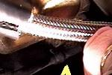
Starter Solenoid

After installing braided oil lines, turned key, bike goes "click". Solution... inadvertently
dislodged the starter solenoid plug during oil line installation.

Pinched Wire

The wiring from the fuel pump had been pinched between the tank and the rocker box. The wiring was bare! The hot wire, the ground wire and the brain wire was shinier than a polished gold nugget. Also found that the fuel hose was loose. These two things coupled together could have spelled disaster. It might be a good idea to check to see if your wiring is not sitting between your tank and your rocker box!!!!

Starter Problems

Most starter problems are actually battery problems. First check the tightness of your battery cables then check the connections at the starter. Be careful not to arc the battery by touching a wrench between the positive and a grounded part of the engine or frame. Try the starter again. If the problem still exists, test the battery with a volt meter, anything under 12 volts is definitely bad, change the battery. If the voltage is over 12 volts a load test should be performed on the battery because it may still be bad when under a load. You can buy a load tester at Sears or an auto parts store for about $20. Sportster starters are pretty reliable, Buell batteries are not so.

Battery Tender (http://www.superior-cycle.com/chargers.htm)

You'll save a lot of money by purchasing the trickle charger that MCN has once again rated as the "Best Buy". It is the charger Tat offers at ASB. I've been using it this winter and have had no problems at all. Everyone should have one for each bike they own that has to sit un-ridden for a few weeks at a time.

Batteries

Hawker 545¹… the nicest thing about this battery is the three-year full replacement warranty. The battery also has 545 CCA(cold cranking amps) and is a fully sealed special type of gel battery that resists vibration damage

Odessey batteries².

Red Top batteries³.

¹) http://www.dmstech.co.uk/hawker.htm ²) http://www.odysseybatteries.com/ ³) http://www.dmstech.co.uk/varleyredtop.htm

Short in Battery

The bike started to bog down like it does when it's time to switch to reserve. When I looked down I had no lights. Everything was off. I coasted to a stop and looked for anything obvious. Couldn't see anything. When I turned the key back on the power came back, but low. The lights and speedo were real dim. Then it seemed to come back to a "normal" level. When I tried to start it there was a click, but nothing happened and the power went dead again. This was repeated several times with the same results. Solution... Got it to the shop & they couldn't find anything at first. It started & ran perfectly. They kept it a couple of days & finally the battery shorted out. It was an intermittent short. New battery.

If the battery is low, the ECM goes into fits, and if you have a wiring harness short, the ECM goes haywire also. The 2001 X-1's have a new wiring harness.

At 4500rpm's the Tach started fluttering up and down... it only lasted a second or two but long enough to catch my eye. Checked all connections, etc. About 2 days later, battery went dead - while I was riding the bike! After sitting in the parking lot for about 90 minutes, started OK, but then began running rough as the Tach (and Speedo) started convulsing. Also noticed headlight dimming. Managed to get home by keeping the bike in 3rd and revs up above 4 grand. Replaced the battery, hasn't been a problem since. I think there's a threshold voltage at which the Tach or Speedo will/will not work, and if you fall below that, your ECM starts to go nuts as well.

Testing your Stator

You should have your multi-meter in AC mode with Voltage/Ohm lead connected to one stator output wire and Multi-meter common lead connected to other stator output. You should have between 32-58 volts @ 2000 rpm and above. If you fail this test (AC out put too low) your stator is bad, or your rotor has lost magnets and/or left the shaft to pursue other interests. If you pass this test, the fault lies up stream in the wiring / regulator / bat dept.

Bad Voltage Regulator

On a recent ride the engine light came on, then minutes later the speedometer died, followed a minute later by the tachometer dying. Shut the bike down... it would not re-start and the electrical was completely dead. Once it cooled all the electrical components came back, but the engine would not start. The cause of the failure was a defective voltage regulator. The bike was less than a year old and has a little over 4000 miles on it.

If you're eating a lot of taillight bulbs, I'd suggest a quick check of voltage with the engine running at >3000rpm. One known failure mode of Harley's voltage regulators is to go over-voltage (running >15v rather than 14.4). The bulbs seem to be the most sensitive to this and usually fail first. Still, over time, an over voltage will cook your battery, burn out those halogen headlight bulbs, and most expensive, possibly fry the ignition or FI controller.

Make sure your Voltage Reg is Grounded

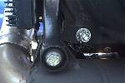
If you get either an upgrade shock installation or an exhaust bracket retrofit kit
installation, make sure that your bike can charge its battery when you pick it up. Both
jobs involve removing and installing the voltage regulator to a new mount where the VR
must be properly grounded, otherwise charging system failures afterwards are likely.
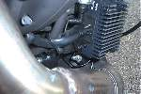
Chris, the BUELL mechanic at Ft. Washington HD,
installed this SECOND GROUNDING WIRE between the
back of the voltage regulator and the engine case.
It goes between the back of the voltage regulator and the new mounting plate and
ends at the case there on the right with the star washer. The first ground wire is
part of the group of wires that exits the voltage regulator.

It is very important to remove the paint from the muffler mount and the case where they connect to provide a good
electrical contact. Make sure your mechanic checks for continuity through the ground to make sure it is working.

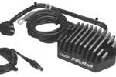
Crane Voltage Regulator (http://www.cranecams.com/motorcycle/evovoltreg.htm)

Unique "Series Design" regulator provides proven HP increase by eliminating alternator
"drag"! At high RPM or when battery is fully charged, "disconnects" alternator operation,
applying formerly wasted HP to rear wheel! Plug-in 110v AC outlet "Smart" charger
keeps battery "Topped Off"! Prevents damaging overcharges and dangerous "boil-over"!
Extends battery life! Compact, convenient, "take it anywhere" size!

Clean Connectors

When you disconnect your electrical connectors clean the contacts with the electrical contact cleaner. I have had problems in the past with crud building up on the connectors. After cleaning the connectors, if you can find any (aircraft parts store) pack the connector with electrical potting compound. This will prevent further crud problems.

Basic Troubleshooting

If the ignition fuse blew without warning while you were riding disconnect the speed sensor and try the spare fuse. If the fuse blows again and you don't see an obvious short in the wiring harness better have someone come get your bike. The first thing you need to do to find a short is identify where you should be looking. This can be a quick process with a few basic tools and a simple methodical process. Some have suggested unplugging everything and then plugging them back in one by to see what blows the fuse. Unless you get lucky THIS DOES NOT WORK! This requires removing the gas tank, bodywork, and fairing much of which may not be necessary. Because many of the circuits are interrelated this process could easily lead you in the wrong direction not to mention the many combinations you'd have to try. You could get lucky which is probably why those who've stumbled on the short doing this method recommend it. It's much easier, and quicker, to focus on first identifying where the short will be and then finding it. To find a short you'll need a wiring diagram (service manual), plenty of extra fuses (at least 5) and an ohmmeter. Once you think you've found the short verify it by consulting your wiring diagram.

STEP 1, (ignition fuse) - If the short didn't melt your wiring harness the short is on the load side of the ignition fuse. If the wiring harness melted then the short is probably between the fuse and the ignition key switch. The load side of a fuse is what you might consider the negative side of the fuse, the side that goes to the relay unit, not the side that comes from the ignition key. First test for continuity on the load side of the fuse, it shouldn't but it will have continuity. Next remove the ignition relay unit and repeat the test. If there is continuity then the short is between the load side of the fuse and the relay unit. If there isn't continuity then go to step 2.

STEP 2 (Relay unit) - Switch the two relay units (they're identical), put in a good 20 amp fuse and turn the ignition key to see if the fuse blows. If the fuse dose not blow then you have a fault relay unit and you'll probably blow accessory fuse. If the fuse blows then your short is on the load side of the relay unit, go to step 3. Remember the relay unit completes the circuit that provides electricity to the ignition and related parts so if a fuse blows when doing this, the short is past the relay unit.

STEP 3 (Load side relay unit test) - Remove the ignition relay unit and test each of the four wires on the load side for continuity. Your wiring diagram will identify which color wire you should be testing. Once you've identified the wire(s) that have continuity with ground you now know where to look for the short. Using your wiring diagram identify which devices could be effected and unplug them. Put in a good 20 amp fuse and turn on the ignition. If the fuse doesn't blow then one of the devices you unplugged is at fault. Plug each one in and out to see what blows the fuse and if this doesn't identify the culprit plug them all in one at a time. If the fuse blew when you had everything unplugged you have two wires rubbing together, go to step 4.

STEP 4 (Testing the wiring harness) - Since you know where to look for the short this is the part where you start jiggling the wiring harness to see where the ohmmeter reacts. If you get a reaction then consult your wiring diagram to see which wires should NOT be grounded and test them one at a time. Remember to have the related components (Speed sensor, oil pressure gage..) unplugged. At this point you've narrowed it down to about six wires so this shouldn't take that long. At least you'll know the short is somewhere between point A and point B.

There are a couple of very remote possibilities not covered here but if this doesn't identify what's blowing your ignition fuse it's time to consult an expert. At this point you'd probably do better talking to an auto mechanic that's ASE certified for ignition systems because they will probably be better equipped to help you then the average H-D mechanic. The issue is vehicle electronics, not motorcycles. This is what I did and by just looking at the wiring diagram he was able to identify where the short would most likely be and how to test for it. Oddly enough what he told me to do identified the problem as being the speed sensor, something I did not detect when I tried the unplug everything recommendation (interrelated circuits?). He also pointed out that bridging the fuse to see where the wiring harness starts to would only melt your wiring harness if the short was caused by a component like a speed sensor. Either way you need a new harness because at the very least you've weakened it by over heating it. Anyway, following these steps I was able to identify the problem in about 15 minutes.

Oil & Filters

Correct Oil Level

Check your oil at the end of every ride. Steaming hot, fill it 75% up the stick. Don't bother looking at it cold... it'll scare you! Results of overfilling? Well, you're sitting on top the oil tank. Think about it.

Problems with GL-5 Oils?

I had an interesting problem come up on my Buell. The wiring to my stator completely corroded and the only culprit that comes to mind is, in my testing of different transmission oils, I had neglected to take into account the copper wiring of the stator. GL-5 oils use Sulphur as an EP component but it is corrosive to copper and its compounds, e.g., brass. You typically only see GL-5 oils recommended for rear differentials and not for transmissions (except in race applications were you drain the oil every weekend) because of the brass parts in the transmission, e.g., synchronizers.
So, if you are using GL-5 oils in your Buell and have problems keeping a good charge on your battery then I'd anticipate you are looking at a stator rebuild soon. Check the AC output to the Voltage Regulator and see. Otherwise stick to HD's oil…

Best Oil?

A discussion which will never be resolved! Basically...

- HD=OK+.
- Any SJ=OK.
- Any CG4 diesel-rated=OK+.
- Any synthetic=OK++ after break-in... Mobile1 15w50 car or 20w50 motorcycle specific oil is highly
recommended.

Primary Oil? Popular choices...

- Mobil 1 Synth Gear Lube.
- HD Sport Trans fluid.
- Redline Shockproof Heavy.

Redline now recommends their 75W90 Gear Lube or 75W90NS in place of the Heavy Shockproof. The additive in Shockproof leaves a waxy residue on clutches and bearings. It will actually collect under the needle bearings that support the gears - I don't think it causes any damage but it does displace where gear oil should be. Don't use a gear oil that's above 90 weight as it is too thick and will result in reduced mileage (5% reduction) and horsepower. Compare the viscosity of the Harley Sportster gear oil vs. 90 weight and you'll see the difference.

I've been using different transmission oils to try to see which oils behave best for shifting and engine performance. My results indicated that the HD Sport Trans Gear Oil had consistently 5% better mileage with similar shifting ability than any gear oil I used. The oils I used were Red Line's Light Shockproof, Heavy Shockproof and GL-5 Transmission oils, GL-5 Hypoid Gear Oil 75w-80, GL-5 Synthetic Gear Oil, 80w-140.

I had the HD Sport Trans Gear Oil analyzed for what type of oil it is and I got some surprising results. It is not a GL-4 or GL-5 gear oil! It is actually a Hydraulic Fluid, as used in tractors, with extra additives: EP (Extreme Pressure) and Friction Modifiers for the wet clutch.

So in summary, the HD oil is indeed a special oil that gives good performance and I'd recommend its use for both shifting performance and horsepower. The other gear oils are simply too viscous to perform as well as the Sport Trans oil.

I've heard many people like to use Redline, AMSOIL and Royal Purple for better shifting, and indeed these oils are more tolerant for out of adjustment clutches. I, too, used to use Redline, but on a properly adjusted clutch there is no difference in shifting performance. I would advise that at a minimum the clutch adjustment at the primary be performed every other oil change. It also helps if you have the clutch lever free play set to the minimum so you have a faster clutch engagement. So if you're not going to be consistent in keeping the clutch properly adjusted then these oils may work better for you.

Oil Filters

63805-80A Harley-Davidson XL motor Black, 64793-77A Harley-Davidson XL motor Chrome. You can use any filter that crosses to a Motor craft FL1A as well. It's large (holds a quart more). Wix 51515 of Napa 1515...or Wix 51516 or Napa 1516, Fram 2870. The Fram HP10 Racing filter will fit also. Same size as the 2870A, with the added benefit of steel filter end caps vs. card board of the PH8 and 2870A, increased flow, as well as a anti drain back valve. Two draw backs… expensive (around ten dollars), and smooth end vs. small flat areas for cup type oil filter wrench to grab on to (But looks much cleaner with the smooth).

MOBIL 1 filters: - PN M1-301 is equivalent to FL1A - PN M1-204 is equivalent to F300 - Both are $11.99 at Auto Zone - Single Pass Efficiency: 98% - Multiple Pass Efficiency: 95% - Synthetic filter medium - Medium gray in color - This thing is a hoss! It is very noticeably heavier than other equivalent filters - Base plate has 8 holes around central mounting hole.

BOSCH filters: - PN 3500 is equivalent to FL1A - PN 3402 is equivalent to F300 - Both are $5.49 at Auto Zone - Single Pass efficiency: 98% - Multiple Pass Efficiency: 93% - Filter medium is a combination of paper and synthetic fibers - Gloss black in color - Base plate has 6 holes around central mounting hole.

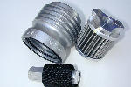
Scotts Performance Reusable Oil Filter¹... Made from laser cut, medical grade, 304
stainless steel micronic filter cloth, this filter provides 200% more filter area in many
cases. Most good paper filters will pass particles in the 90 to 95 micron range, some will
pass particles in the 300 micron range! A human hair is about 40 microns, a white blood
cell is approximately 25 microns. Our stainless filter catches items down to 35 microns
"absolute", which is about 3 times better than most paper or brass filters. The pleat seam
is welded, able to withstand up to 600 degrees in our filter, not glued, like paper filters.
One point of caution however, included in the package is a different adapter nipple with instruction to remove the stock HD piece and replace with theirs, the problem is that the new one is shorter on the end installed to the engine's filter mount, this does not allow the ball and spring device to work properly. The bottom line is the stock one on the Buell is fine allowing for the filter to get 2.5 to 3 turns prior to gasket contact.

Check out Engine Oil Filters Overview…²

¹) http://www.scottsperformance.com/ ²) http://minimopar.net/oilfilters.html

K & N Oil Filter (http://www.knfilters.com/oilfilter.htm)

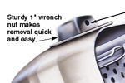
K&N just released the new motorcycle oil filters. They have a nut on the end for easier removal with pre drilled holes for safety wire.

Available from Custom Chrome...

- 29-263 Black (KN-171B).
- 29-262 Chrome (KN-171C).
- 29-261 Short Chrome (KN-172C).
- 29-264 Long Chrome (KN-173C).

Secure Oil Filter
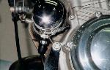
Here's a preventive maintenance type accessory, for anyone who has ever had an oil
filter come loose or needs to secure a filter to pass tech inspection at the track. These
clamps are used as radiator hose clamps on trucks and buses or as turbo ducting
clamps, in other words, common in the heavy duty trade.

My oil filter backed out, dumping a quart of oil before I could shut the engine down.
Turns out it wasn't the filter's problem, the double ended "oil filter adapter" that screws
into the engine AND the filter backed out. The filter was still securely tightened onto the adapter. I cleaned and reinstalled the adapter with Locktite on the engine side of the adapter. I have since found a sufficiently large hose clamp (any NAPA auto parts store) and safety wired the damn thing on. Even if you don't have high miles on your bike, it certainly couldn't hurt to put a $1 hose clamp on your oil filter, but be sure and check the tightness on that adapter next time you change your oil. After this happened, I estimated that I had removed and reinstalled an oil filter fifteen times or more without ever checking the adapter (never even thought about it). Pick up a hose clamp next time you're out.

Oil Coolers

Most Harley mechanics say that oil coolers are not needed and that the oil in the bike has to reach something like 250 degrees to be at its optimal operating temperature. With the oil cooler it never reaches that temperature and this can result in more wear on the internal engine parts. As long as the bike is not overheating leave it alone. Buells run best hot anyway.

" I've been tracking bulk oil temperature over the summer to determine if I need an oil cooler or not. Here are my results: for commute type driving -- 5 miles, between 25 and 55 mph, ambient temperature of 100 degrees F., bulk oil temperature is 170 to 180 degrees F. During spirited, redline riding in the mountains, 100 miles, 2,000 ft elevation change, between 40 and 90 mph, ambient temperatures between 90 and 105 degrees F., bulk oil temperature is 205 to 215 degrees F.

So should I get an oil cooler? Considering that a recommend bulk oil temperature range is between 180 and 205 degrees F., I'd say that it would make more sense to just change my oil more frequently during the summer. With oil coolers running around $150, and an extra oil change for the summer costing me $25, it would take over 6 years to pay for the cost of the oil cooler. If you're lazy and don't change your oil during the recommend intervals then an oil cooler would help if your ride hard in hot weather. Here's a note I copied from Mobil 1's website about synthetic oils... "Mobil 1 with SuperSynTM products protect engines up to 204°C (400°F). " With the temperatures I encountered I would recommend the use of synthetic oil without the need of an oil cooler. "

Oil Cooler (Billet Cool) (http://www.billetcool.com/)
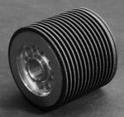
American Sport Bike has a billet aluminum spin on oil cooler that fits between your existing oil
filter and the engine casing... bike runs 25 to 30 degrees cooler.

For the second time my spin on oil cooler has backed out and dumped oil all over. This time
I was again lucky that my ridding buddy was behind me to see the oil coming off. Yes, he did
get a little oiled down but he saved my ass. My back tire was soaked!! I lost most of the oil
but the bike is OK because this all happened so fast that I got her shut off before any damage
was done.
The first time this happened was in Daytona this year but it didn't happen until the
bike was parked for the night and we found a puddle under it the next morning. This never happened when the cooler was on my old 97 S3. Different vibrations maybe? I will remove the cooler until I can safety wire the thing. If you have a spin on oil cooler and you really ring the bikes neck like I do check the thing regularly and safety wire it.

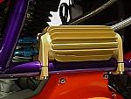
Oil Cooler (Spurgin) (http://www.motorcycle-innovations.com/)

Read an article originally published at Sport Twin¹.

The Spurgin does not properly fit the 99,00 X1. The cooler will either hit the air scoop,
the primary cover, the shifter or the battery. I tried several different mounting spots and
got many second opinions. It seems that when Buell repositioned the battery (laid it flat)
on the X1 they blocked the spot where Spurgins are usually mounted on S1s. Move the
cooler forward and it will hit the air scoop and the primary.

It will fit X1s with the 2001 shift linkage since on older models it was coming in contact with the top linkage rod which has been eliminated on the 2001 linkage. The Spurgin is simply tilted downward, in this position it clears the battery and the primary cover.

The Bosch and Fram XG8A filters will not fit on your Buell if you're running a Spurgin oil cooler, at least not with the fittings exiting the thermostat in the suggested position (they foul the filter housing, preventing it from threading onto the mount . . . move the filter down about 1/8", relative to the mount). Rotating the fittings 90 degrees will create the needed clearance too.

¹) http://www.sporttwin.com/

Oil Cooler (Slip On)
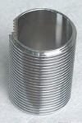
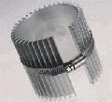
Just slip it on when needed. Special price for ATC members... $25
for the 3" & $30 for the 5" including S&H for the spun aluminum
ones. Also chrome for $5 more. Contact here...²

Similar product, from J.C.Whitney³.

²) mailto:oilcooler@aol.com ³) http://jcwhitney.com/productnoitem.jhtml?CATID=5217

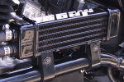
Oil Cooler (Jagg) (http://www.jagg.com/buell.htm)

Sportster Oil Cooler part number 62874-99 and an optional thermostat kit part number
62878-99 which keeps the temperature over 180 degrees. FYI It's a Jagg⁴! Jagg now
makes a kit for X1 that mounts BEHIND the air scoop. The place where the canister is
on Cali bikes.

⁴) http://www.jagg.com/buell.htm

Breathers
Puking 1

Think your cam cover gasket is leaking along the top edge near the front lifter blocks? Did you check inside your airbox? The oil is probably just coming out of the breathers, leaking from the airbox to the top of the cam cover.
to the top of the cam cover.

Understanding the whole breather story...⁵

Read about "The Cure" here...⁶

⁵) http://www.et-performance.com/article.html ⁶) http://www.creativecycleprod.com/

Puking 2

Oil coming from the little hose hanging under the motor (all over your muffler, back wheel, etc.)? What you're looking at is a breather hose. It will blow oil mist if the dealer over-filled the primary... the manual mistakenly states a full quart, when it really only takes 28 ozs.

The bike needs to be upright when you check the oil level, and it's believed that everything will be ok as long as the primary chain is bathed in oil. At most fill until the oil touches the bottom of the clutch compression spring.

Puking 3

HD/Buell sent a tech tip to dealers explaining the reason for excessive oil coming out of the breather tube. It seems the breather hose on late model primaries exits the primary, goes UNDER the brake line, then travels up to the seat and bends over...the part under the brake hose acts as a catch can with oil as it tries to return to the primary. Eventually it plugs the hose and the pressure finally blows it out all over your fender. Reroute the hose over the brake line and keep it going up so there is no dip and don't bend it at the end to the right side of the bike.
Continue on the left side and tie wrap it to the frame.

Puking 4

If your motor oil consumption has gone up, you may have a bad seal on the crank shaft behind the front pulley... lets motor oil into the primary and you eventually get an overfill situation. The only special tools required to replace it are a torque wrench which can do 190-200 ft lbs, as this is the spec on the front pulley nut, and the seal installation tool, which , unless you're a shop, you're not allowed to buy. You might be able to borrow one from a friendly shop or be able to find someone who does have one. You can make your own tool, using a piece of 1/8" flat-stock aluminum, through which you drill a hole just big enough to allow the crank shaft through, and a PVC coupling. The aluminum goes up against the seal, the PVC goes up against the aluminum, the original washer fits perfectly inside the PVC, and the original nut drives it all in, installing the seal. (New Crank Seal Number 35151-74).

Puking 5
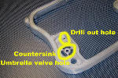
For those who have oil puking problems through the head breathers, you can try two
modifications to the middle rocker box cover to cure this problem, or when the rocker box
gaskets are replaced: (1) drill out the oil drain hole to 1/8" so that oil can drain more
easily, and (2) chamfer 60 degrees the hole in which the umbrella valve sits. The new
umbrella valves will not sit down fully (and seal off) because of their new design / material
-- chamfering the hole allows more of the stem of the umbrella valve to pull down into the
hole and seal off better.

The counter sinking of the hole where the umbrella valve mounts into the rocker spacer "can" help the valve seal. It may or may not help with a carry over issue. There are no absolutes on engine breathing. Enlarging the drain back hole "can" help evacuate the oil from the area in some cases. What really has a better chance of helping with carry over is NOT using the 10 micron filter. There have been cases where simply changing the oil filter ONLY has reduced carry over by more than half. What works on one motor, may not on another. Each motor has its own "personality".

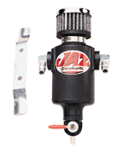
Catch Can (Jaz) (http://www.jazproducts.com)

Catch that oil with a Jaz¹ catch can part# 605-375-01. (3/8 inch fittings). The dimensions are
2 3/8" round and 7 3/8" long from tip to tip. Approx. cost $45... available from speed shops
or Behrent's Speed Center Inc².

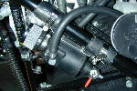
Fits perfectly on the frame member under the Air Scoop...
rubber hose to protect the frame & stainless hose clamps
don't make for the prettiest installation, but it's all hidden
by the Scoop anyway. Other Buells may want to invest
more time in installation. The angle of the can allows you
to drain fluid off before it overfills... if you're pumping out a
full pint, you've got other problems anyway.
Another mounting idea...
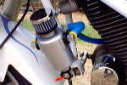

¹) http://www.jazproducts.com ²) http://www.behrents.com

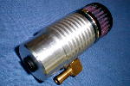
Catch Can (RVB) (RVB100@attbi.com?subject=Inquiry from TheX1Files.com)

Here's another can being produced by a Bueller.

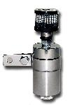
Catch Can (EBOC) (http://www.sel-motion.com/eboc.htm)

Available from Tat at ASB.

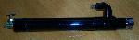
Catch Can (YoDUDE)

This pipe holds 4oz. is about 11" long and has a 1" dia. It comes powder coated black,
but any color is available. The hose barb is 3/8 " but again any size the customer wants
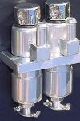
is available. Also available is a complete setup that includes the breather bolts, cross tube and a stainless braided hose that runs to the pipe.

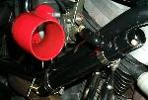
Company name is YoDUDE, designer and producer of intake and
exhaust systems for cars and motorcycles.

Also available is a Twin Catch Can.

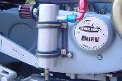
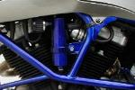
Catch Can (Pingel) (http://www.pingelonline.com/)

Pingel @ 608-339-7999 will sell it direct. Part #62084
$45.00. It's about 2.5 inches around and 4 to 5
inches long. It has a brass drain cock.

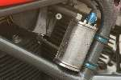
Catch Can (Trojan Horse) (http://www.trojan-horse.co.uk)

This differs from other offerings as it is manufactured from heat treated acrylic tube,
highly resistant to oil, fuel and scratching. The ends are billet aluminum. The photo
shows a pre-production prototype, but later versions will have an anodized drain plug
at the bottom, along with the chromed 3/8" entry pipe and vent. This kit comes complete
with frame clamps etc. Cost is £75 (UK) or approximately US$105.

Plugged Breather

Trans fluid leak?... check your vent hose first... had a MUD WASP nest in it. Unplugged it, washed the engine, rode it, and NO LEAKS!!! Make sure the motor can breath before doing anything else...

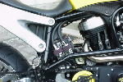
Crankcase Breather Kits (http://www.r-r-customizing.de)

This setup from R&R Customizing, Germany¹.

¹) http://www.r-r-customizing.de

Routing Head Breathers
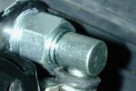
Drag Specialties² Breather kit (banjo style): DS-289059 $30. +/- These will allow you to
route the head breathers in any direction you desire, with no interference.


Mikuni makes a breather vent kit also. Custom Chrome³ part # 23-862.
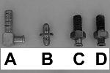
Other Breather Bolts...
A. Force.
B. Aeroquip.
C. Russel.
D. Stock.

Yodude has a breather bolt setup that uses chromed banjo bolts and a manifold
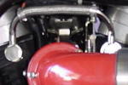
connected thru stainless hoses that attach to a catch can. Cost is $65.

From Crossroads⁴... this thing is designed to replace the existing breather setup.
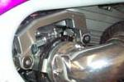
The piece is billet aluminum, and actually spans the
gap between the two breather bolts.
It apparently allows a pooling of the oil mist in the top,
which then is able to slowly return to the crankcase, rather than exiting through the breather hose. The breather hose on this thing comes out from the back of the unit, so it remains hidden. The benefits are supposed to be a better working breather setup, no clutter from hoses, and no catch can necessary.

Read about an actual installation here...

A Devonator Installation

I just installed it on my X1. I had to replace the rocker box gaskets and have been having a hard time with puking. While the rocker boxes were off I drilled out the return hole 1/8" and installed new James umbrella valves (more silicone content so they stand up to the heat better).

I also installed the "cure vent plus". The "cure vent plus" does seem to make a difference in performance like they said it would. I still have a bit of puking though.

The way I can tell is that it is weeping out from the banjo bolts supplied with the Devonator. They rely on the 82 degree countersunk hole to seal with the banjo bolt head. Not good. I knew it would leak when I saw it. However, nothing has come out of the actual inlet on the Devonator and I have ridden it like I stole it since it was installed. Overall I am happy with the new breather setup.

I am going to uninstall the Devonator and use a bit of Permatex around the banjo bolt head. This should keep the oil in. The inlet on the Devonator comes with a big hose barb that doesn't fit on an X1. I replaced it with a right angle street tee and screwed a cintered pneumatic muffler into it . The bike now breathes through the muffler and doesn't have a hose.

You just have to push the fuel pump connector up out of the way when you mount it. It looks very neat and clean and I haven't seen a drop of oil yet except around the banjo bolts.

Another

If you are like me, you want your oil to stay within the confines of the engine case or confined to just the moving parts. So when I was getting oil on my leg from the air box on my 2000 X-1, I turned to the web and came up with the Crossroads breather called the Devonator. Had a good theory behind it, and looked good. So I bought it and that is when I found out a few things.

First, the unit has no seal between the bolt heads & the body of the unit. It relies on a "good" fit using a cone head bolt & a tapered hole. Forget it. Mine leaked & when I confronted the company, all they said besides "they wanted to sell it with better bolts but were forced to go with these", was to "use sealant". Well, I did. Don't think I should have to, but did. Yamabond by the way. The best I found for metal to metal sealing. Why don't they just use different bolts and a nylon washer like the washer they supply for the unit to head seal.

Second, the theory has not proven out. They believe the vertical rise & shape will cause the oil to fall back and nothing but the air will be ejected. In fact, if you call the manufacturer, they will tell you one of their guys doesn't even run a filter on the exit port. Now, as we all know, some engines blow oil and some don't. Also, some blow more than others at one time or another. Ever look down after a 100+ run compared to a 50mph cruise? Well mine, a moderate blower (only 3K on it) still has oil coming from the Devonator unit. I even ran the exit hose up higher under the tank before bringing it down. So, has it done me any good, NO. Further, I do not recommend it until they change the bolts and baffle it better or something to help separate the air and oil. Oh yes. I requested another set of bolts.

Another

If you are like me, you want your oil to stay within the confines of the engine case or confined to just the moving parts. So when I was getting oil on my leg from the air box on my 2000 X-1, I turned to the web and came up with the Crossroads breather called the Devonator. It was listed on the X-1 Files & several others. Had a good theory behind it, and looked good. So I bought it and that is when I found out a few things.

First, the unit has no seal between the bolt heads & the body of the unit. It relies on a "good" fit using a cone head bolt & a tapered hole. Forget it. Mine leaked & when I confronted the company, all they said besides "they wanted to sell it with better bolts but were forced to go with these", was to "use sealant". Well, I did. Don't think I should have to, but did. Yamahabond by the way. The best I found for metal to metal sealing. Why don't they just use different bolts and a nylon washer like the washer they supply for the unit to head seal. Second, the/there theory has not proven out. They believe the vertical rise & shape will cause the oil to fall back and nothing but the air will be ejected. In fact, if you call the manufacture, they will tell you one of their guys doesn't even run a filter on the exit port.

Now, as we all know, some engines blow oil and some don't. Also, some blow more than others at one time or another. Ever look down after a 100+ run compared to a 50mph cruse? Well mine, a moderate blower (only 3K on it) still has oil coming from the Devonator unit. I even ran the exit hose up higher under the tank before bringing it down. So, has it done me any good, NO. Further, I do not recommend it until they change the bolts and baffle it better or something to help separate the air and oil. Oh yes. I requested another set of bolts. Will I get it? They haven't answered my e-mail yet. Have to wait and see.

Wimmer Machine⁵ Top Breather Cross Over Assembly Kit... other kits also available..
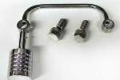
see website.

²) http://www.dragspecialties.com ³) http://www.customchrome.com/
⁴) http://www.nvo.com/crossroads/displayroom/category.nhtml?catuid=10039
⁵) http://www.wimmermachine.com/topbreather-C.htm

Routing Head Breathers 2
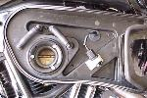
Kind of a clean and cheap method. No Banjo bolts, just some cheap plastic elbows.
They should hold up to the heat and such. I used 2 hose menders to pass through the
back of the airbox instead of direct plumbing to the Jaz can. Just a little easier if someone
needs to R&R the back plate, for some TPS work or FI work. The clamp for the IAT is an
electrical clamp with a piece of 3/8" hose on the IAT for fit and protection. A lot cleaner
in reality and better looking than stock.

XB Rocker Covers

I went one step more in controlling the breathing and oil mist. I have put XB rocker
covers on both heads!

Visit the DCBrag website for replacement procedure⁶

⁶) http://www.dcbrag.org/Rocker.htm

Exhaust
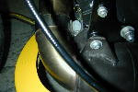
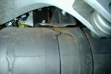
Exhaust Woes

Pre-flight your exhaust mounts regularly. Pictured are
failures. It's not a question of "if", but "when"!

Exhaust failures

The studs break because of strain on the system. And they also possibly break because the studs may be poor. Next time, replace the broken studs with NAPA studs, they are a shelf item. Re-hang all the exhaust components to make sure there is no deflection in the system. Use ny-lock (5/16 coarse thread) nuts, and viola, end of problem. DON'T use grade 8 exhaust studs. If you break one it will be extremely hard to drill out of the head!

Read some thoughts on replacing broken studs:
Replacing broken exhaust studs.(some thoughts...)

Occasionally a stud can be removed with an easy out but more more often than not it has to be drilled out along with the partial or total loss of the threads. Helicoiling is frequently necessary. A mess no less but not uncommon. Results of a snapped easy out?
The bolt/screw removers (don't) work by putting a wedge into a part that is ALREADY wedged in too tight, and attempting to rotate a part with a radius roughly HALF of the radius of the thing that already proved too weak to break the bond. It took three diamond tipped Dremel bits (at about $10 a pop) and about 4 hours to get the bits of easy out out. I ended up just drilling the &$*(# bolt out after the whole mess with the easy out was cleaned out. By the time I got to full depth, I was off by less then half a bolt width (and the old bolt was still wedged tightly in there. I just tapped the newly drilled hole, put on lots of Locktite, and sunk in the replacement stud. No problems in about 1000 miles, but not the best solution.

Custom Chrome makes a tool that includes a jig and drill bit that will allow you to drill the old bolt out squarely. Costs a little under $100.

Jim's makes an Exhaust Stud Drill Plate¹ that is designed to guide and keep alignment of drill bit to completely drill out a broken exhaust stud.

Note that an entire new bolt on head (complete with valves) is less then $300 direct from Buell, so there is an upper bound on how much $$$ damage you can inflict on yourself. If you have the time, get the Custom Chrome tool. If not, grab the drill, take your time, and do your best. Could get you back up and running in an hour, so if your time is worth enough to you it is likely worth the gamble.

You can buy cobalt left hand drill bits for drilling broken studs. The benefit is that the drill bit is turning in the same direction that the stud needs to turn to come out. Sometimes when you are lucky, they will come out on their own whilst drilling.

Tack weld a 1/4" nut to the broken stud.

You could also remove the head and take it to a machine shop, and they can fix it there.

Upgrade the front exhaust mount soon, this is what causes the bolts to vibrate off, which is then what causes the stud to get beat until it shears. Double nut the header , as much to make it easy to see when inspecting as to keep things from coming off.

¹) http://www.zippersperformance.com/catalogue/showproduct.asp?cat=589&prod=1507

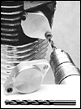
Also, I highly recommend mounting a Buell system from the muffler-up. Loosen the header and
install new seals (2 hours in the freezer allows the header gaskets to slide right in!), then
torque-down the muffler mounting hardware. Then, with the header-to-elbow clamp loose,
torque-down the header stud nuts. The last step is to tighten the header-to-elbow clamp.
This procedure was recommended to me by a Buell mechanic who says doing it this way
saves header studs.

Loose Header

The exhaust header nuts had worked loose, and the header flange was vibrating, but only under load. Had even lost one of the nuts (5/16x24 lock nuts). Simple check: grab the exhaust pipes under the air box and pull. If there is any play, you need to tighten the exhaust header. BTW, finding replacements for those nuts is difficult (if the local H-D shop doesn't carry them), since they are fine threads. Check out industrial fastener shops to get them.

I've started torqueing the bolts before each ride. 72 inch lbs. or 6 ft lbs. is all I do. My torque wrench reads in inches. It's working great. I use an 18" extension to make things easy. The whole process takes about two minutes total.

Loose Header 2

I think the header should be completely torqued before you install the new elbow and muffler. When I snugged and tightened everything uniformly, I recall having to push the header about 1/8" to secure it in the engine head. I didn't think anything of it at the time. While the rest of the new exhaust has worked great I suspect it may have been leveraging against the engine head with just enough vibration to loosen the nuts. Considering the several types of metals that will be working together in a rather violent environment, I don't think you can be too careful installing any brand of muffler. Any joint not properly fitted will result in a leveraging action which could result in a failure.

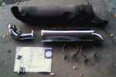
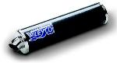
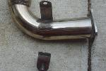
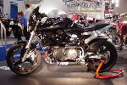
WileyCo (http://www.wileyco-racing.com/English.htm)

"It came in the nicest box I have seen a MC part come in. Also included in the box with
the pipe was a t-shirt, baseball hat, lapel pin, key chain, stickers. Pretty nice. The pipe
mounted up pretty easy, looks similar in shape to a V&H. The sound is similar but with
a little more snarl to it. Cost through a local Harley shop was $260.00 complete."

"Life warranty is on all parts except glass wool (but
lifetime is more than 10000 miles because they use a
special glass wool without organic binder). The sound is fantastic (seems between V&H and Pro series) and looks great. I find that WileyCo is the best compromise: nice look, good sound, good perf, life warranty, good price and, till now (9000 miles), no crash."

“Just had my WileyCo front mount fail. I only had about
500 miles on the pipe. Not a good sign, looks similar to
the Vance and Hines type problems.
But at least it's covered under lifetime warranty.”

Two Brothers (http://www.twobrothersracing.com)

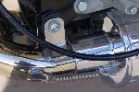
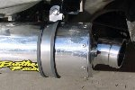
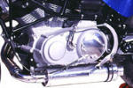
It's just a little quieter than a
Vance & Hines.

The elbow is clamped to the
header and is bolted to the engine
but is separate from the muffler
and is held to the muffler with two
stainless steel springs.

The rear is held up by a rubber covered strap that goes around the muffler and is bolted to the bike.

Staintune (http://www.staintune.com/index.htm)

Being an Aussie I decided to go with the local product ... 8,000 miles later I couldn't be happier. No problems at all with the pipe. It tucks well out of the way and the front mount is rock solid. The seat of the pants dyno told me it helped with the midrange dip the X1 has when stock. As a package with the race ECM and an S3 race air box it is excellent. I think that to bring out the best in any pipe the FI bikes need the race ECM and better breathing.
Down side of the Staintune is that it is as loud as hell. I wear ear plugs on long rides
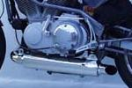
now. The X1 is the loudest bike I've owned since I had a Laverda with a chopped
muffler.

I have traveled 10,000 miles on my '97 S1 using an Australian made Staintune
stainless steel muffler. I have no problems to report at all. The muffler is well made,
performs to expectations and looks fantastic. Would I buy their product again
(when I buy my Firebolt)? You bet I will.

Kooks (http://kookscustomheaders.com/specialties2.html#12)
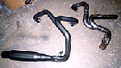
"It definitely generates the power of the Buell Race Pipe, if not more. It is louder but
sounds really good at power. I've had mine on my bike for 8 months and have had no
problems whatsoever. I would definitely recommend the system to anyone that wants
more power and a powerful sound."

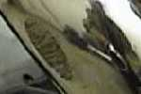
"The sound is awesome, and the power is the way it
was supposed to be. Battle2Win says it's the only pipe combo that has better
numbers than the Buell Race! This mutha is solid as a block of unobtainium!! It is
much smaller than the stock unit and the bracket is for real."

"Try to be a little more conservative in tight right-handers than lefts with your new
Kooks pipe, or this may happen to you..."

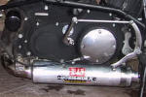
Yoshimura

"My X1 was delivered with a Yoshimura can on it. The Yoshi lasted less than 2,000 miles
before the front mount broke. Mostly my fault because it constantly dragged through
corners (it hung way too low)."

"My chin fairing was touching the exhaust so I shaved 1/4 inch off. Still wasn't happy so
I removed the chin fairing."

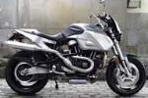
Sundance (http://www.sundance.co.jp/)

From the Land of the Rising Sun...

HAS (http://www.HsaExhaust.de/)
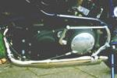
From Germany...

I have a Buell M2 with an HSA exhaust. I'm very happy with this. That's the street legal
version. The engine is empty without it (in Europe, there's a big hole between 2500/rpm
and 3500/rpm) ; not with the HSA exhaust, the engine is full everywhere.
The sound is very good, and not so strong (and much better than with the original
exhaust).

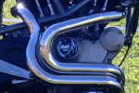
Eyeball (eyeballbikes@btinternet.com?Subject=Inquiry from TheX1Files.com)

From England...

"We have been in business since 1984 making custom parts in stainless steel.
We got into exhaust manufacture in 95, and because the owner is a Buell nut have
been experimenting with various set-ups since 97.”

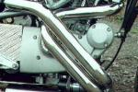
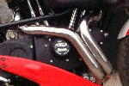
“Over this time we have reached the following
conclusions: mufflers do make a difference over the
stock item (anything would though) but the real gains
are to be had with the headers.

“To this end we offer a 2" dia equal length 32" header
and a 2 1/2" connector, this is the best compromise
between performance v. noise."

Scorpion (http://www.scorpion-exhausts.com)
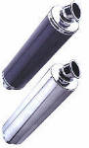
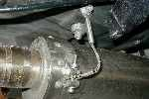
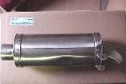
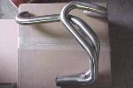
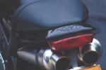
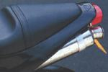
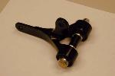
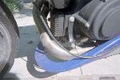
From England...

The muffler is slightly longer than most of the other aftermarket ones, therefore making it a bit
quieter, but not at the detriment of power and torque.

Scorpion are pretty popular in the UK, although they do tend to snap front mounts as much as
any. I have heard stories of them refusing warranty work, but no personal experience.

Buell Race Muffler (Old)

This system no longer available as it is under recall. See Service Bulletin.

Buell Race Muffler (New)

82000-99YA, X1 Race Kit.

JB Motorcycles

Ducati style... from France.

Full system is now available from JB Motorcycles, nearby Dijon, France, but only under
individual request.

The price of the full system, including the exhaust pipes, mufflers, new oil tank and
relocating kit for the battery (now under the seat) will be 12000 French Francs, i.e.
about 1600 US$ + shipping. One should expect a delay of about one month between
the order and the end of production of the system + time for shipping which will depend
on the shipping option considered.

They take Visa card payment and have somebody speaking relatively good English in
the shop, so it's possible to deal straight with them. They now have an e-mail address:
jb.motorcycles@wanadoo.fr Their phone number is +33 3 80 74 09 25,
fax is +33 3 80 72 15 93.

2001 Mount

Upgrade your failure prone exhaust mount with the upgraded
2001 mount. From California Cafe Racers Homesite¹.

Part# S1001.01A1.

See Service Bulletins for more information.

¹) http://caferacers.editthispage.com/

Sealant

All Buells except fuellies (see below). When you put the muffler back on did you use any sealant? Try Permatex Ultra Copper High Temp RTV Silicone part no. 27B item no. 81422, it is in a orange tube.... that way you're assured of no leaks.

When you install the muffler you put on a light coat of the silicone on the pipe. This will seal any air leaks that can't be tightened down by the clamp. It is cooler at the muffler connection than at the header pipe, so the heat does not affect the silicone.

Make sure you apply the sealant to the female end of the connection. That way when the two are slid together you don’t end up with a giant glob of seal on the outside of the connection. Makes for a much cleaner install.
Regarding the use of silicone sealants with exhaust headers and mufflers: silicone is NOT recommended for Buell fuel-injected bikes, as even the fumes from silicone have a detrimental effect upon the Oxygen sensors. Of course, you can pull the O2 sensor and put it away, but still need to wait at least 24 hours for silicone to dry before re-installing the sensor. Difference between a DDFI bike with a "good" O2 sensor and a "bad" (this can even be an old one; we recommend replacement every 10,000 miles or better, sooner than that) can be 6-8 horsepower.

Nord Lock
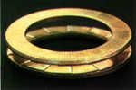
Try these lock washers from Nord Lock¹. They worked great on my 99 with 25k miles
and they are doing fine on my 00. They are different from any others and are priced at
less than a $1.00 each. Plus they are easy to use and still easy to take off when the
need arise.

¹) http://www.nord-lock.com
Stage 8 Locking Fasteners

Another idea from Stage 8².

²) http://www.stage8.com/index.htm

D & D (http://www.sporttwin.com/dd/)

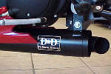
The muffler is made of mild steel for durability, and should not need repacking anytime
during the life of your Buell. The muffler is coated with an industrial black high heat paint
that D&D has tested to withstand temperatures of up to 1800 degrees.

I recently installed a D & D full exhaust system on my 2001 X1 Lightning. Unbelievable
results! The D & D system is a little on the expensive side, but well worth it. If you have
fuel injected system you will need the race ECM because the D&D full system was
specifically designed for use with the race ECM. If you have a Power Commander 3
you can still use it with the race ECM, I also recommend the use of the high performance 02 sensor. You will also need the "Y" style exhaust mount. The power increase is highly noticeable. It feels slightly stronger in the mid-range and top end than the Buell race pipe. The low end is just a hair on the mild side. Starting at 4000 RPM in first gear roll on wheelies are a lot easier. The placement for the 02 sensor is much easier to get to than the one on the stock pipe. The sound is a mega bonus, it has all the volume of the Force System but a little deeper, very loud.

White Brothers (http://www.whitebros.com)
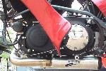
"I've been running a White Brothers E-series for over 15,000 miles. From dyno testing
it is 98% of the Buell Race kit. It matches the race kit in peak Torque and HP, but falls
just a shade short in part of the midrange (read that as 2-3 ft-lb). For the $'s in difference
and the reliability issues with the race kit, the W.B. can't be beat. My 99' S3T loved it
and so does my 00' X1 Race Stripe. The rear bracket is billet aluminum welded onto the
body of the muffler. Much stronger than ANYTHING else that I have seen as far as the
rear bracket."

Dealer installed the E-series before I took a 3600 mile trip--after 2600 miles elbow fractured--Dealer (HD in Ft. Lauderdale, FL) refused to warranty part (despite 90 parts & labor warranty) White Bros. has yet to respond to mail (they don't return Email). Worst of All the fracture flaked the beautiful Jet Hot off my stock header. Have yet to find out if Jet Hot will honor their "lifetime" warranty. That's the problem with aftermarket stuff--even if it breaks through some dealer tech's fault--you may still end up out of pocket.

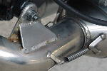
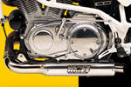
Vance & Hines (http://www.vanceandhines.com/pages/SBuell.html)

After 4000 km the muffler ripped off at the front. I welded an extra ring on it so it is much
thicker now. At the moment it is still on (6200 km).

When I had about 10000km on my bike the stud broke off the tube of my exhaust
(where it is welded). So I welded it again and put a second stud in place. This is a much
stronger combination. I have now about 13000km on it and it's still working fine!!!

With the original muffler my Buell starts to perform at 5000rpm (which I found very late)
that means only 1700rpm of power, but in that range very aggressive
(max speed 220km/h). With the V&H it starts to perform at 2500rpm but it doesn't have
as much peak power, but the engine responds much quicker and the sound is very
beautiful (max speed 210km/h).

BUB (http://www.bubent.com/makes/harley/buell/index.html)

You can not use the chin spoiler... other than that - the sound is much more like a traditional Harley - the throaty-ness is deeper than my old bullet or my Supertrapp internal - and the fit and finish is VERY nice.

A little aggravating to install, instructions not clear. Would be nice if they supplied hardware to accommodate chin fairing removal. Rear pipe heat shield kept losing retaining springs... due to airflow getting underneath guard? Removed guards and now run exhaust wrap over pipes up to point of taper at muffler.
On the plus side- much lighter than stock, immediate torque and hp increase and a
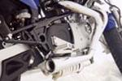
nasty sound when you're WOT. About as cheap as you can pay for a decent exhaust.
I would buy them again.

Rode about 700 miles before heat shields tried to fall off. Finally just took them off.
Ran another 2300 miles before rear pipe broke. Rear mount near brake pedal pulled
business card sized square piece out of the pipe. Fifth exhaust system to fail on my bike.

I just purchased the Bub Bad Dogs for my 2001 X1 & let me tell you they are LOUD. The make the Harley Engine sound like it's supposed to. Maybe too loud for some. If you don't mind dirty looks from your neighbors, surprised looks from all other riders & scolding looks from the officer writing you a citation then these may be the pipes for you. Installation wasn't too difficult... but it may take a spare set of hands & some gorilla strength. Follow the directions that come with the pipes diligently & be persistent; they are a tight fit. I am by no means a mechanic, all my home improvement jobs have my trademark "goof up" in which I have to hide. I do enjoy trying to turn my own wrench on some things. So if your in the market for some LOUD nice looking pipes & want to save on the install charge... try on a pair of Bub Bad Dogs for your Buell. I've heard that it may take some top end hp away, who knows... all I know is that I now have no problem getting the front wheel up in 1st or 2nd.

Anyone considering buying pipes from this company should be made aware that you'll need a strong mechanical background in customizing these pipes to fit on an X-1 correctly. When I purchased these pipes I was not expecting to have to modify them to fit my bike, but instead I spent three days adjusting the brackets and making provisions for frame and primary drain plug clearances, not to mention my voltage regulator. By the way you can forget using the heat shields without seriously cutting them for frame clearance on the rear pipe near the O2 sensor. Once all this was done I also realized that they don't triple plate their pipes in the chroming process, so be prepared to lay down more money for that to be done correctly. Once you've put numerous hours of your blood and sweat into fixing these problems I'm sure that you will be happy with these pipes.

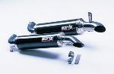
Borla (http://www.borla.com)

"I have a Borla carbon fiber muffler on my 99 X1. When they first came out there was an
issue with the mounting but Borla did an update and since that retro it has been solid as
a rock. I have about 5000 miles on the new setup with no problems.
Also the sound is really great; not really loud like the Kooks, but much louder than the
stock muffler, plus it looks GREAT.”

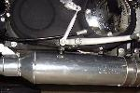
SuperTrapp (http://www.supertrapp.com)

Numerous stories of catastrophic failure... sometimes within a day of mounting.
Replace!!! ...
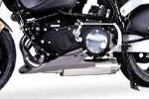
For 2001 SuperTrapp has come out with a new muffler,
which is a very good evolutionary step from the old one.
It still uses the same disks, but it tucks-up closer to the
bike (by a good inch), and the mounting system is far
superior to the old one. Also, the front elbow and muffler are one piece, so the
constant exhaust leak isn't occurring anymore.

SuperTrapp is also doing a exchange program on their old mufflers for free. Contact the company and ask em... The number is: 216.265.8400 x121.

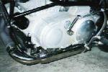
Daytona BOSS (http://www.daytonahd.com)

"The Daytona BOSS muffler isn't available any longer. The pipe from Stainless
Specialties is in essence the same design as what was the Daytona BOSS. I've even
heard the pipe from SS is because they bought the rights to make and market the
BOSS"

"The BOSS has been great for me so far, but you may or may not like it. It's only
really loud when you rev the engine, at idle it just has a deep rumble to it, but by no
means is it loud then. On the road it purrs right along. Everyone I've talked to so far who's heard my pipe says it has the best sound of all the Buell cans available now. Guys who've run Borla and Vance and Hines said they liked mine better for it's sound. Value wise, I think it's a good buy. ($325). The finish on it maybe isn't as professional looking as the Borla or the Vance and Hines, but then again neither of those mufflers looks very good when it's bouncing down the road behind you after it breaks and falls off. The mounting system on the BOSS is very solid. I don't foresee any problems with it because there aren't any welds to bust."

Be ready for a lot of mounting aggravation !! No clear way to mount without a lot of trial and error. Hope you're up for the challenge!"
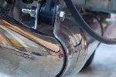
After purchase from and initial installation by the local Buell/HD dealership (Pikes
Peak HD), and running this beast on my 2000 X-1 for almost two years I have had
repeated failures on both front and rear mounts, with final detachment of the baffle
inside the can. Noting that the unit was sold with a lifetime guarantee, a year's dialog
with the manufacturer and numerous assurances that they would make good on any
repairs and/or replacements that were needed only resulted in a final referral to
Daytona HD for all further customer service. I currently await replacement of the
exhaust and mounting hardware which (I hope) will last longer than the first. As far as performance is concerned the exhaust worked exactly as advertised, with a nice throaty rumble at idle and a satisfying roar on acceleration. Combined with a Force winder intake I noticed a slight increase in power with no apparent impact on fuel economy.

After purchase from and initial installation by the local Buell/HD dealership (Pikes Peak HD), and running this beast on my 2000 X-1 for almost two years I have had repeated failures on both front and rear mounts, with final detachment of the baffle inside the can. Noting that the unit was sold with a lifetime guarantee, a year's dialog with the manufacturer and numerous assurances that they would make good on any repairs and/or replacements that were needed only resulted in a final referral to Daytona HD for all further customer service. The replacement Boss exhaust unit was sent at no charge (other than the shipping cost to get the broken pipe to Daytona HD). Remount was completed without incident and performance is as good as with the original pipe. Sadly, the hanger mounts (both front and rear) are of the same poor design and fitment. Strongly recommend custom after-market fabrication of mounts made of stronger, thicker gauge material, with fewer bends at critical stress points.

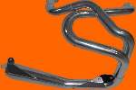
Force (http://www.useforce.com/index.html?dummy=HOME)

A full racing header, NOT a slip-on glass pack. Features a step header, mega-merge
collector, reverse-cone megaphone, front mount, and JET-HOT coating, in your choice
of Shimmering Silver or Bad Black.

Some fitment problems¹ recorded with X1 installs, but Johnny at Force seems to
have a rock solid rep. for customer service.

I have the Force exhaust on my 2001 X1. Awesome sound to it. The Harley guys are jealous. Although it is louder than most people like, it is advertised as a full race exhaust. I think it sounds mean. Although it does focus the power above 3000 it isn't bad below. You hit that 3000 mark and you know it though. Downshift and let the clutch slip and you're looking at the sky. I also have the Forcewinder intake and the Powercommander on the bike. One awesome setup.

¹) http://www.geocities.com/MotorCity/Track/6161/x1pipe.html

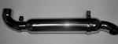
Stainless Specialties (http://www.stainless-specialties.com/products2a.htm)

High performance combined with great looks. Polished stainless. Lifetime Guarantee.

Suspension
Hyperpro (http://www.hyperprousa.com/s_buell.shtml)
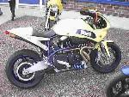
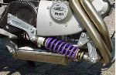
Their system reverses the suspension action so that a com-
pressed shock is used. This way the forces are being transmitted
into the large body of the shock, not pulling outward
against the small amount of metal that is outboard of the
mounting points. Read more about it at Buell World...²

²) http://lightning.prohosting.com/~buells2t/shock.htm

Buell World Rebuttle

There are no inherent problems with a pull-type shock. There are problems with the Showas on Buells, but that's because Showa is reworking standard shock components to work on the pull stroke....not the best way to approach it. Penske's cheaper than the Hyperpro, just as effective...but anything is better than the Showa. WPs and Penskes use the spring collars and through bolts...no flexing of the shock.

Replacing Your Isolators

The X1 has a removable isolator cover on the left side only. By disconnecting the rear heim-joint, you can replace both isolators without removing the swingarm.

I would also not recommend using the factory tool for changing them. Instead, check the ATC tech tips site.

2001 Isolators

The Z0010.CB kit ( $46.40 ) includes a pair of new isolators, a new pulley cover and hardware. The front isolator does NOT have to be replaced but it is recommended that it is inspected for tears and replaced if needed.

BMC is also coming out with a updated isolator replacement tool that will be available soon. All Buell dealers were sent two service bulletins on these new isolators and procedures on how to change them on all Buell models.

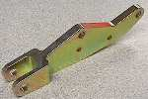
WestTek Lowering Kit (http://www.cjnetworks.com/~westtek/ShocBroc.htm)

Lowers seat height 1 inch.

Polishing your swingarm

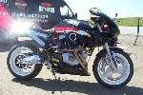
Removing the powder coat is the hardest and is taken care of quickly with a 4.5" grinder
and 2 grades of Bear-Tex pads, Maroon=Medium, Blue=Fine. After that 400, 600, 800
wet-dry (depending on how proficient you are with the Bear-tex pads) followed by
polishing wheels in a drill motor with finer and finer grades of compound. You need at
least 3 polishing wheels, 1 for each grade of compound your going to use. You just can't
get that coarser compound out of those cotton spiral sewn wheels and it takes for ever to
get that "see yourself" shine. The last grade is jewelers red rouge and then some
Denova, Simichrome, or Flitz. You may find Mothers Aluminum polish is too abrasive. Try Denova polish¹. One helpful tidbit is at a good Home Center like Lowes or Home Depot, they have many grades of Bear-Tex or Scotch-Brite, for things like the brake and shift pedals or those spots you can't reach with the electric tools, you can use the Scotch-Brite pads with Mothers and then Denova and then just Denova and a rag. It takes about 10 steps progressively getting finer and finer to get that shine we all want. BTW: After you polish all your goodies, don't use S-100 on your bike. It white streaks the polished surfaces very badly. Cycle Brite (by Blue Coral²) works better and does not white streak the polished surfaces. You can get a really polished swing arm in about 5 hours. X1's are easier than S3's or M2 since you can remove the rear triangle that holds the passenger pegs. That way very little hand work is required.

¹) http://www.denovashine.com ²) http://www.bluecoral.com

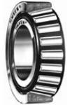
Sealed Head Bearings

Timkin # L44600LA-902A1 This is the inner cone bearing part.
Timkin # L44610 This is the outer bearing race.
Timkin # L44643 Standard inner cone non-sealed variety (Just in case anyone was wondering...).

The outer race was about $3.00 each, the inner bearing with seals was about $16.00 each. The
non sealed type bearings were around $6.00 if memory serves. No problems removing or installing
the races, just used a long punch to tap out the old ones and then used the threaded rod and
wood block "tool" to pull the new races in flush. I then used the old race and light taps all the way
around to seat the new race. The old race will stick in the steering stem but a couple of light taps
on the exposed lip takes care of that problem. The new sealed type bearings have a bit more
friction than the open style. I haven't really noticed it when everything was reassembled. If I was to do it again, I would use the open style on the top and the sealed unit on the bottom.

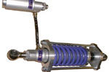
Maxton (http://www.esling.btinternet.co.uk/maxton/)

The Maxton Buell Unit, as with all their units, is built to order and is valved and sprung to
suit rider weight and the use of the bike - fast road use, racing, touring. The shock is fully
adjustable for rebound and compression damping with an infinite range of compression
damping to help set the bike up for different styles and preferences. It also has adjustable
ride height so you can, if needed, make the bike turn quicker.

Technoflex (http://www.htc-sa.com.au/technoflex/product_info.html)

... provides the best shock for Buells on the market (and the most expensive as well - it's about $1100). This is not a simple damper unit, they add a "lever" system with a standard shock - pushed not pulled like the original shock. It's perfect on the street and under race conditions as well. Most sensitive with a separate high-speed and low-speed compression damping unit, widely adjustable in any direction. They offer a spring kit as well ~$120 (Oil and Fork). Which is a big step in the right direction without removing the whole fork. All German Buell Race Teams are using this system.

Penske (http://www.penskeshocks.com/motorcyc.htm)
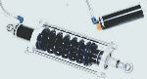
Considered by many the best shock for your Buell.

2001 K1400.C Shock
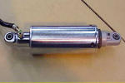
1.77 inches shorter than the old setup and requires that the new front shock mount that
comes with the kit be installed.

Rear suspension sag for Buells equipped with recall shocks should (per the appropriate
service bulletin) now be measured from shock rod-end to rod-end, not via the rear axle
to tail-section method prescribed by the owners manuals for pre-2001 Buells).

See Service Bulletins for more information.

Check your isolators

When they tear it sends a vibration through the peg. The tear can be difficult to spot but examine the inside and outer isolator. Sometimes the isolator bolt will be buried into the wall of the isolator. Don't be alarmed if it is off center (it is supposed to be), but if it is actually making contact you probably have a problem.

Looking at the mounting bolts can be confusing because the isolators are made off center so the mounting bolts look like they are at the rear of the isolator. Here is what to look for 1. any tears in the rubber. The rubber material may separate from internal washers and show a rip around the outer side. 2. any tears under the isolator at about 7:00. This is where the locator pin goes into the isolator. many of the earlier Buells had the pins too long and would hit an inner washer and cause a rip right below the pin. All the dealers were notified of this and was supposed to check the pin height when they did the recall. 3. you will feel a lot more vibration in the foot peg on the side that goes bad. 4. if the isolator rips all the way through, you will find the handling will get bad.

Isolator failures were primarily due to improper installation. New style (model year 2001+) isolators are much more robust and are retrofittable for prior model Buell twins. Impending failure of old style isolators is evident by distortion/waviness seen in the two or three parallel rings circling the visible surface of each isolator.

Hyperpro Damper (http://www.hyperprousa.com/dampers.shtml)
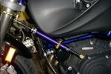
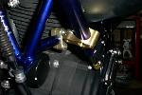
The only thing I had to do to provide proper clearance for the
scoop was to move the bottom scoop bracket up a bit to pull
the bottom of the scoop up a tad.

The picture makes it look like it is touching, but there is
about a 1/4" of clearance. Rockin setup and it works nicely.
Definitely the way to go keeping the stock scoop and airbox.

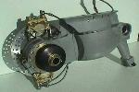
RAM Single Sided Swing Arm (http://www.ram.mc/buella.html)

The RAM aluminum single sided swingarm is supplied as a kit, complete with brake
system, (in this case the optional Heavy Duty using twin Brembo light alloy racing
calipers), transmission bearing carrier, wheel shaft, pulley flange (to accept the stock
pulley), and hardware.

Wheels & Brakes
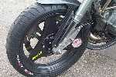
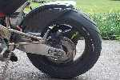
Dymag Carbon Fibre Wheels (http://www.dymagcarbon.
com/carbon.htm)

For those with lots of spare cash...

Removing tire weights

Mount your new tire, and check the balance before you remove the old weights. Sometimes, the tires are balanced the same and the weights won't need changing. Warm them up with a hair dryer and they should come off easier, if there is "glue" left behind take some salad oil on a rag and rub it.

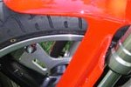
Polished Rims

Simple mod for painted wheels: (as long as you do it at a tire change). Sanded rims with
orbital sander (220 grit, didn't want to take too much rim off). Wet sanded with 400 and
600 by hand. I found some metal polish while I was at the marine store called Flitz (I
think it may be the same as that stuff, Semi Chrome polish). I didn't polish it to a chrome
like finish, that would be too hard to maintain with out a clear coat.

Wheel Alignment

Buells are pretty sensitive to wheel alignment and handling (short wheelbase, steep head angle). It makes a world of difference in handling (tank slapper at 90mph when passing a car on crowned roads will make you check your alignment and your underwear). Don't set your alignment to try to prevent belt rubbing, I have two 8 ft straightedges of aluminum and set them to the back wheel and measure the gap in the front wheel (back wheel is wider so the edges run parallel. Once you think it is straight go down a flat uncrowned road or parking lot, do the "look ma no hands" and see if the bike goes straight, if you have to use your body leaning one way or the other to keep it straight try aligning again. You will love the newfound handling when both wheels are pointed in the same direction.

Wheel Bearings

Make sure to check your wheel bearings, front (2) and rear (3) every time you replace a tire. Can go bad after less than 10K miles. The bearings have a habit of seizing and then spinning in the hub of the wheel, ruining the wheel. This seems to be more prevalent on PM wheels than Castaloys.
Replace the OEM wheel bearings and the steering head bearings at 10K miles as a preventative measure. Look for German, US or Japanese bearings and avoid others. NSK (good quality Japanese) bearing part numbers - Rear wheel (Castoloys) Right side - 2@6205-2RS Left side - 1@62205-2RS Front wheel 2@6204-2RS The left side rear bearing has been a little difficult to locate at times.

Try Boss Bearing¹...

¹) http://www.bossbearing.com/

Demystifying Brake Fluids

The discussion of whether to use DOT3, DOT4, DOT5, or the new DOT5.1 brake fluids is a common topic. The information provided herein should help you to decide which of these brake fluids are best for you:

Brake Fluids

The discussion of whether to use DOT3, DOT4, DOT5, or the new DOT5.1 brake fluids is a common topic. The information provided herein should help you to decide which of these brake fluids are best for you.

I would also take this opportunity to point out that the type of brake fluid used is far less important, from a safety standpoint, than a properly functioning braking system. If you are working on your own brakes, be extremely careful, don't skimp on poor components, and bleed the brake system very carefully and thoroughly.

- DOT3 brake fluid is the "conventional" brake fluid used in most vehicles. One of the most familiar brands is Prestone.
Advantages:
- DOT3 fluid is inexpensive, and available at most gas stations, department stores, and any auto parts store.
Disadvantages:
- DOT3 will damage natural rubber brake seals and should not be used in any car suspected of having natural rubber seals
(most Triumphs prior to 1968).
- DOT3 fluid eats paint!
- DOT3 fluid absorbs water very readily. (This is often referred to as being hydroscopic.) As such, once a container of DOT3
is opened, it should not be stored for periods much longer than a week before use.
- Since DOT3 fluid absorbs water, any moisture absorbed by the fluid can encourage corrosion in brake lines and cylinders.

- DOT4 brake fluid is the fluid suggested for use in late model Triumphs. The most familiar brand is "Castrol GT-LMA".
Advantages:
- DOT4 fluid is available at most auto parts stores, and at some (but not all) gas stations or department stores.
- DOT4 fluid does not absorb water as readily as DOT3 fluid.
- DOT4 fluid has a higher boiling point than DOT3 fluid, making it more suitable for high performance applications where the
brake systems are expected to get hot.
Disadvantages:
- DOT4 fluid eats paint! Small leaks around the master cylinder will eventually dissolve away the paint on your bodywork in
the general vicinity of the leak, and then give rust a chance to attack the body of your car!
- DOT4 fluid is generally about 50% more expensive than DOT3 fluid.
- Since DOT4 fluid still absorbs some water, any moisture absorbed by the fluid can encourage corrosion in the brake lines
and cylinders.

- DOT5 brake fluid is also known as "silicone" brake fluid.
Advantages:
- DOT5 doesn't eat paint.
- DOT5 does not absorb water and may be useful where water absorption is a problem.
- DOT5 is compatible with all rubber formulations. (See more on this under disadvantages, below.)
Disadvantages:
- DOT5 does NOT mix with DOT3 or DOT4. Most reported problems with DOT5 are probably due to some degree of mixing
with other fluid types. The best way to convert to DOT5 is to totally rebuild the hydraulic system.
- Reports of DOT5 causing premature failure of rubber brake parts were more common with early DOT5 formulations. This
is thought to be due to improper addition of swelling agents and has been fixed in recent formulations.
- Since DOT5 does not absorb water, any moisture in the hydraulic system will "puddle" in one place. This can cause
localized corrosion in the hydraulics.
- Careful bleeding is required to get all of the air out of the system. Small bubbles can form in the fluid that will form large
bubbles over time. It may be necessary to do a series of bleeds.
- DOT5 is slightly compressible (giving a very slightly soft pedal), and has a lower boiling point than DOT4.
- DOT5 is about twice as expensive as DOT4 fluid. It is also difficult to find, generally only available at auto parts stores.

- DOT5.1 is a relatively new brake fluid that is causing no end of confusion amongst mechanics. The DOT could avoid a lot of
confusion by giving this new fluid a different designation. The 5.1 designation could lead one to believe that it's a modification of
silicone-based DOT 5 brake fluid. Calling it 4.1 or 6 might have been more appropriate since it's a glycol-based fluid like the DOT 3
and 4 types, not silicone-based like DOT 5 fluid. (In fact, Spectro is marketing a similar new fluid which they are calling Supreme
DOT 4, which seems less confusing.) As far as the basic behaviour of 5.1 fluids, they are much like "high performance" DOT4 fluids,
rather than traditional DOT5 brake fluids.
Advantages:
- DOT5.1 provides superior performance over the other brake fluids discussed here. It has a higher boiling point, either dry
or wet, than DOT 3 or 4. In fact, its dry boiling point (about 275 degrees C) is almost as high as racing fluid (about 300
degrees C) and 5.1's wet boiling point (about 175 to 200 degrees C) is naturally much higher than racing's (about 145 C).
- DOT5.1 is said to be compatible with all rubber formulations.
Disadvantages:
- DOT5.1 fluids (and Spectro's Supreme DOT4) are non-silicone fluids and will absorb water.
- DOT5.1 fluids, like DOT3 & DOT4 will eat paint.
- DOT 5.1 fluids are difficult to find for sale, typically at very few auto parts stores, mostly limited to "speed shops."
- DOT 5.1 will be more expensive than DOT3 or DOT4, and more difficult to find.

General Recommendations

- If you have a brake system that doesn't leak or show any other signs of failure, but has old seals in it, don't change fluid types as a result of reading this article. If it isn't broken, don't "fix" it -- you may simply break it instead!
- Flushing of the brake system every couple years to remove any absorbed or collected water is probably a good idea to prevent corrosion, regardless of the type of brake fluid used.
- DOT3 is dangerous to use in Triumphs with natural rubber seals, and thus should not be used in such cars, except as a temporary "quick fix to get me home" solution. (If this is used as a "get-me-home" solution, bleed the system as soon as possible, and be prepared to replace all your seals.)
- DOT3 is an adequate brake fluid for use in later Triumphs, although it is rarely preferred. My recommendation would be to simply not use it.
- DOT4 fluid, for a slight increase in cost, will give significantly increased resistance to moisture absorption, thus decreasing the likelihood of corrosion compared to DOT3.
- DOT4 fluid has a higher boiling point than DOT3, making it preferable for high performance uses such as racing, autocross, or excessive use of the brakes in mountainous areas. For even greater braking performance, consider going to DOT5.1 or a high-performance version of DOT4 fluid.
- DOT5 is a good choice for the weekend driver/show car. It doesn't absorb water and it doesn't eat paint. One caveat is that because it doesn't absorb water, water that gets in the system will tend to collect at low points. In this scenario, it would actually be promoting corrosion!
- DOT5 is probably not the thing to use in your race car although it is rated to stand up to the heat generated during racing conditions. The reason for this recommendation is the difficult bleeding mentioned above.
- When changing from one fluid type to another, as a minimum, bleed all of the old fluid out of the system completely. For best results, all the seals in the system should be replaced.
- As always, your experiences may vary.

Possible Brake Lockup Causes

Reason:
# 1: Because the front brake can get real hot during heavy breaking road dirt that normal flys into them can get
cooked onto the caliper pistons. Normally this isn’t a problem unless you’ve just replaced your pads or bled
your brakes. The crud that cooks on the pistons limiting their additional travel necessary due the changes
you made. (Pads whatever)
# 2: Overfilling your master cylinder with brake fluid. Brake fluid expands when it gets hot so leave room for expansion. If you topped off the reservoir and later replaced the pads then you have too much fluid in the system and it will cause the brakes to drag.
# 3: A blocked bleed return port. This port is how the fluid returns to the MC after braking and thus allowing the pads to retract away from the disc. The debris could be part of a seal, MC body that has been worn away by the piston motion, or debris that has fallen into the reservoir when the top was removed. Inspect and clean to restore the brakes.
# 4: The piston isn't returning fully and is blocking the bleed return port. Inspect the piston for damage, and inspect all parts that come in contact with the piston and clean, repair, or replace the offending part.
#5: Also warped rotors can drag on the pads making it seem like the pads aren't retracting. Check rotor with a
straight edge and replace if necessary.

On the road: The moment you think your front brake is binding pull over! If it is binding the disk will be hot as opposed to warm to the touch. Let it cool down about 15 minutes and bleed your brake. If you don’t do this you will warp your rotor. Remember this is just a road side fix to get you home.

At home: Check your front rotor for warp by spinning it to see if it wobbles. Next (consult your manual) remove the front wheel. Place a piece of wood between the caliper pistons and VERY carefully squeeze the front brake so the pistons are out about a 1/4 to 3/8”. Remove the caliper and remove the bolts that hold the two halves of the caliper together. Using a shop rag (do NOT use pliers) you can now remove the 6 pistons and wipe them clean. Technically you should replace the O rings. Anyway reassemble your bike and you should be good to go.

Lyndall Racing Brakes (http://www.lyndallracingbrakes.com)

You seldom ever think that if you change something as simple as your brake pads that it will change your motorcycling life forever. I have always used OEM, and took for granted that "There only brake pads...right? They're all the same." Well the Pro-thunder racer in our pack slipped me a set of LYNDALL pads after he heard me squeak up to one of our meetings ( I had 7k on OEM pads and they were already spent). I changed the pads, and I let the racer break them in, and OH MY FRIGGING GOD!!!!, I now stop in half the distance, the grip is smooth, I never feel like I will lock it up and still I have to be careful or I get a good stoppie. I teach motorcycle safety for the military down here in San Diego and we have to show our students the difference between rear brake and both brake application, the drill has you riding down a shoot at 15MPH and stopping in the shortest distance, usually 10 Ft for that speed, as soon as I apply the brakes I stop smooth in less than 4ft. I don't know I just wanted to share this with all of you. And By the way I have 10k on the LYNDALL pads and very little wear.

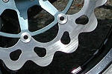
Braking USA Wave Rotor (http://brakingusa.com/pages/buell.html)

Available for 1998 and newer Buell models. Will fit all models with supplied hardware.
Full floating and light weight, these rotors are a great addition to any custom Buell, or for
anyone wanting to upgrade their brake systems. The part number for the Buell is
STX42D and retails for $319.90 each.

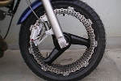
RAM Perimeter Braking System (http://www.ram.mc/buell.html)

The revolutionary XXL Perimeter Brake System, featuring 16.6 inch wide brake rotors.

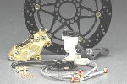
Dual Brakes (DKF Performance) (http://www.dkf-perf.com/n5100.htm)

'94-'01 All Twins, Kit Includes: 320mm full floating rotors, Brembo 4 Pot Calipers, Ferodo
brake pads, Nissin 5/8" master-cylinder, hard anodized billet aluminum hangers &
Goodridge braided steel line kit.

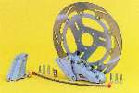
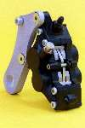
Dual Brakes (Trojan Horse) (http://www.trojan-horse.co.uk)

Twin front disc brake conversion. Using a Nissin caliper on the left
fork leg, and a directional copy of the original disc, this is the most
cost effective twin disc system available at £650 (US$900).

There is also a 4 piston rear brake assembly available at £335
(US$470).

Dual Brakes

Cap can build the bracket for the Nissin so you can run dual discs cheaply. You will have to run a Buell rotor reversed on the left side. He can also do a mirror image of the rotor carrier to make it look right but that drives the cost up. With dual 6 piston Nissin calipers you will need a 9/16 bore MC and a dual disc hose. This method is the cheapest way but will still cost in the $500-600 range with all the parts needed. If interested in a dual disc setup, give Cap a call at 865-546-3380 or e-mail (LyonsDunn@aol.com) him and he will point out all of the options and costs.

Removing Brake Rotor

I tried removing the rotor screws in the front rotor. No good. Just ended up bending tools and wallowing out one of the screws. I figured I would just remove the front wheel and take it to my local shop and let them do the exchange and rebalance the wheel. Eddie, the Buell certified mechanic at Bumpus HD/Buell in Murfresboro, Tn. took all of about two minutes to remove the old bolts. He said Eric Buell showed him that if you take a brass rod and a ball peen hammer and tap the top of the screws, it 'shocks' them and allows the air gun to remove them easily.

No pressure at the rear brake

The line coming from the master cylinder to the reservoir was too long and kinked slightly (more like a little bend) not allowing any fluid to pass. The kink was so slight that it wasn't noticed... tried for two days to bleed the brake but couldn't get any peddle pressure. Changed the line to a little shorter one and that worked.

Rear Brake was awful . .. bled it repeatedly, no change, changed pads, no change. Removed the caliper, cleaned the hole in the forward portion of the caliper where the pin slides in and out, allowing said caliper to move back and forth, all of a suddenly, I got rear brake! I used a .32 bore bruch (brass) and flushed the daylights out of the bore with contact cleaner, but anything shy of a .45 would likely work . . . I then covered the pin with Never-Seize.

Rear Brake Dragging

Look at the sprocket cover with a rider on the bike, the tail of the cover may put a little pressure on the brake linkage.

Misc
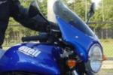
Givi Fairings (http://www.givi.it/home/frame.asp)

Buellers have mounted Givi A750 & A755 fairings to M2’s & X1's with little problems and
have been happy with them.

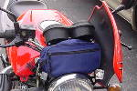
Yodude Flytrap

The Flytrap is a hinge kit that allows the flyscreen on your Buell to open. This creates a
storage area large enough to store a cell phone, camera, sunglasses etc. The kit
includes a unique hinge that allows the screen to open at an angle , all the nuts bolts &
washers as well as a set of dual snaps to keep the screen closed. They even powder
coat the outside cap nuts to maintain the original look.

Cool Product. I got the hinge and the travel case. My advice to anyone? Buy just the $15 hinge and find your own travel case. I am looking at cases designed for Gameboys and they fit better and are of a higher quality than what Yodude sent me.

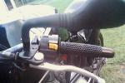
Better Mirrors

Buell improved the mirrors for 2001 but didn't tell anyone. Same vendor, same design,
but 3/4" longer arms. No left or right, just rotate 180 degrees and they fit nicely and are
really stock. Part # N1161.01A1.
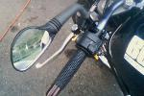
Mirror from KTM Duke II, right: 58712041000,
left: 58712040000 ~$30. ea.

The KTM mounts are required as well, 58412040050 adapter (qty 2), ~$14.ea.
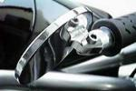
Skyking 3inch convex bar-end mirrors. See it here...¹

CRG bar-end mirrors. Make the Napoleon mirrors look pretty crude.
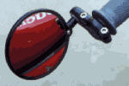
Expensive though, as they are all
black anodized billet aluminum. See it here…²
Third Eye bar-end mirrors. Available at a bicycle shop for about 12 dollars each.
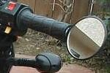
The optics are great and they don't vibrate even at 135mph plus. See it here...³

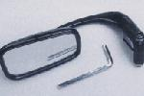
Napolean bar-end mirrors. See it here...⁴.
There are problems mounting these...

Do NOT cut your handgrips! There is a design flaw in the
rubber spacer used on these. Having tried several solutions I found the simplest is
the best fix. The problem is the thin wall of the bushing expands causing the mirror
to slide into the grip. Soultion, turn the rubber bushing around and tighten that grip
with confidence! As I recall you may want to move the washer to the other side of
the rubber bushing, try both ways.
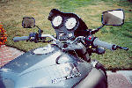
Or, go to a dirt bike shop and get a set of Enduro Engineering⁵ bar mounts for steel bars.
They work with two slash cut aluminum pieces that pull together when the bolt is
tightened. I had to do a little modification to my mirrors but they now stay adjusted and
the mounts extend the mirrors about half inch from the bars.

You can mount the "Napolean" bar-end mirrors in the same location as the stock ones –
not an easy thing to do, but they work pretty good.

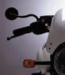
Paul Yaffe Mirror Kit⁶

¹) http://www.skykingproducts.com ²) http://www.constructorsrg.com/page2.html ³) http://www.3rd-eye.com/(09).htm
⁴) http://www.mgcycle.com/mirror.html ⁵) http://www.enduroeng.com/handguards.htm
⁶) http://www.paulyaffeoriginals.com/pyo-catalog_pyostuff-bmk.htm

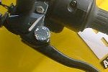
Adjustable Levers

The adjustable brake lever from a Kawasaki ZX9R around 95-96 is a perfect match
Part# 13236-1185. And the Kawasaki Zephyr had an adjustable clutch lever
Part# 46076-1165. Adjustable clutch lever needs a little modification (10min switch in
side) because Kawasaki switch connecter has 3 pin, Buell has 2 pin and reverse action.
Brake lever is just bolt on. Total parts cost about $80.

Handlebars

S3T bars fit, with minimal mods required, for a more upright seating position. They do
need a hole drilled to align the left switch cluster. Also the cables and wires are TIGHT...
they need to be freed from their captive ties.

Handlebars from a Ducati Monster (M900), they are a very close fit to the tank when
"hard over", but they don't actually touch.

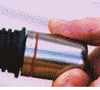
Throttlemeister

Bar-end cruise control. Available from American Sportbike¹ for ~$125.

¹) http://www.americansportbike.com/%20

Cheap Cruise Control

Ask one of your Harley buddies for a small hair band they use for their pony tails. Doubled up, and placed between the grip and the instrument housing, it works very effectively! Can't see it either.

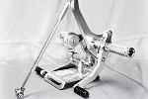
Sato Racing Rearsets (http://www.satoracing.com/rearsetsbuells1w.htm)

"These newly released rear sets were born from development and testing not only on the
street but also in World GP3 and the All Japan GP 125 track for more than 2 seasons.
(Masao Azuma, who uses our rear sets in World GP3 won twice in 2001 series). The
goal of our rear set production is to offer the best operation, best quality and excellent
design. We use double miniature stainless ball bearings for the shift and brake levers
alleviating any looseness or wobble. We knurl our foot pegs for non-slip characteristics
during aggressive riding---even the GP riders love the non-slip feel! Our pegs are adjustable so that you can choose your best position. Our rear sets are precision made, CAD/CAM designed and CNC machined. We give them anodized finishes, to prevent from oxidizing and scratches. You can choose from either silver or black.”

Part Numbers

Harley part #71441-94 is a ringer for the original Buell switch, all you must do is splice your Buells ignition switch harness connector to the Harley switch, there are even butt connectors supplied with the switch, and the wires are color coded the same.
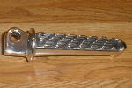
The Service Manual for 99/00 X1 is 99490-00Y and the Parts Manual for 99 is 99571-99Y.

Millennium X1 Parts... Frame screen kit M1044.Q Rear Vent(L & R) Screen Kit.
Footpegs N0403.Q N0404.Q Footpeg pivot pin 50795-00Y Spring 50794-00Y
Washer 6045Y E-clip 50178-96Y.

ECM is 91437-99Y.

Pro series race header 65400-99Y Pro series race muffler 91424-99Y Pro series race air filter 91420-99Y.

Front isolator 16207-79B Rear isolators 47680-94Y.

PPG paint codes:
- Canyon Red - DBC 75049. - Billet - DBC 36571.
- Carbon Black - DBC 9700. - Spark Red - DBC 75056.
- Red Snap - DBC 75050. - Reactor Yellow - DBC 81746.
- Blue Streak - DBC 19038. - Orange - DBC 61876.
- Amazon Green - DBC 48449. - Demon Blue - DBC 5246.
- Black Magic - DBC 95055. - Onyx Alloy - 95152-32.

Sport Twin has an excellent page on BMC Paint Formulas¹.

¹) http://www.sporttwin.com/paint.html

Shifter Replacement

Need a field repair for a broken shift peg? A standard 5/16" bolt, a little Locktite blue, then wrap the exposed threads with black electrical tape.

Key Trick

The other day I discovered that the fork lock was turned so that I could not insert the key to unlock the fork! I solved this problem by filing off the tab on the outside of the key enabling me to insert the key and unlock the fork. Removing this tab in no way impacts the key's functions except that by removing the tab there is nothing to hold the key in place. You might want to remove the key when riding the bike so you don't loose it and make sure you have the lock code for the key so you can replace it.

Fasteners

There are only two types of fasteners that are good; all others are EVIL. The good fasteners are regular hex head bolts and standard Allen head cap screws. Generally the tools for the EVIL fasteners lack sufficient hoop strength causing the tool to break. To that end, I changed the derby cover bolts to 1/4 x 5/8" standard Allen cap screws (DUH now I can use the SAME TOOL to R&R primary cover). My front rotor uses 5/16" by 1-1/4 hex bolts; the old EVIL star bolts of course broke the tool. Now R&R-ing the tire is a breeze; the GOOD bolts come right out; no problem to free the rotor. (both the older style and the Y2K rotors) Various other fasteners have, where possible, been converted to GOOD types; i.e. the bolts holding the plastic body parts onto the frame, for example.

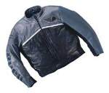
Buell Vanson Leathers (http://www.vansonleathers.com/store/buell_garments.htm)

I purchased a Vanson coat with the Buell lettering and Pegasus logo on the back and
cannot be more happy with the garment. They installed a zipper on the liner so you can
put in your choice of hard or soft armor or none at all. They encourage you to "beat" on
the leather and make no bones about riding in a driving rain. They guarantee no dye will
bleed out during a driving rain (which I can personally attest to). They also stand behind
their products. Also, I just purchased a Buell for my wife and wanted to order a women's
model Buell coat from Vanson. I could not locate a single women's Vanson in stock in
Minnesota so I called the factory to figure out how to measure and get the right size.
The people that I talked to were great to deal with and when we finally figured out that it would be really difficult to get the right fit by me measuring my wife, they volunteered to send the single salesperson that they have to my town and measure my wife to make a custom fitted Buell jacket for her. Now I don't know what kind of customer service you are used to but I have to consider this way above and beyond the call. Oh, and by the way...their jackets really kick ass too!

99 - 00 - 01 Models

The 99 models have a little different gear ratio between 2nd and 3rd than do the 00 models. The 99 also has a heavier flywheel. The flywheel was lightened in 00 to allow the engine to rev up faster but it affected reliability by changing the harmonics of the motorcycle. The lighter flywheel seems to cause the 00 to vibrate more and hence more vibration related failure (witness recalls on 00 but not on the 99 models). The brake rotor was changed on the 00 models also.

The 01 has the updated shift linkage, updated isolators, new shock, the body work is color molded not painted, reworked oil routing, hidden wiring harness, and the new front exhaust bracket.

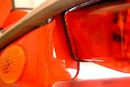
Eurocomponent Problems

Here is my humble testimony regarding Euro components parts for the S1 and X1...
These are nice parts for bikes which stay in...showroom. The conception (design) does
not take into consideration the "killing" vibrations of our bikes and the result is ALWAYS
the same after 200 or 300 miles : the part begins to crack and finally breaks... I've
enclosed some pics of the second "rear under panel - fender eliminator" mounted on
my '2000 X1, the first presented the same defect and was changed but as you can see,
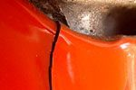
this one didn't last either... I experienced the same problems with a rear fender and
an air dam offered by the same company for the S1. So I know these products very
well...they are manufactured in my country, France and I even visited the site
where they are located (Odyssey Kolors in Toulouse). Unfortunately the "after
sales service" is not very good...the answer for me was : "you didn't mount it
correctly, it's your fault !" Very easy...to consider that conception flaws can be
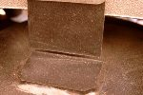
hidden by a so-called incompetence of the customer.
I've always done my bike services myself and never experienced any problems with
other brands like RRC, Buell OEM parts, Road Racing etc...and my advice is to stay
away from Euro components parts for Buell which are "only" expensive body parts for
showroom bikes. Just my opinion, based on my own experience, using these parts
and contacting this company since the end of 1997.

Libertek Integrated Tail lights/ Turn signals (http://www.libertek.com/Products_diamond_lights.htm)
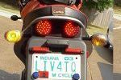
"Diamond Lights" are aftermarket LED lights that utilize the latest in high intensity LED
technology. They are housed in a CNC machined aluminum housing, mirror polished by
hand and then custom anodized in 5 different colors.

Restoring Black Finish

The black finish on my '99 X1 started to turn white from cleaning and waxing things. Rich, service manager at Lancaster H-D, told me to spray it with any one of the "no rub" tire sprays. I was skeptical, so he sprayed the primary. It works, no white, nice shine, holds up, and it's hassle free. As for the durability of the black finish, it is almost bullet proof.

Gas Cap Problems

You normally turn the key; flip up the release and turn it to pull it out. When you turn the release it is supposed to turn the whole plastic piece under the fuel cap. Unfortunately the plastic piece on mine has wallered out (it no longer stays in line with flip release on the top of the cap). Solution... lubricate the O ring every year. Not doing so causes the plastic to stick, causing the nut to turn inside the plastic, stripping the plastic.

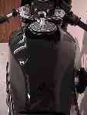
X1 Racing Gas Tank (http://www.racingmotorcycles.com)

Weight 4.9 Pounds - Material aluminum - Uses stock fuel pump assembly - Uses stock fill cap
assembly - Allows use of any style clipons - Looks almost identical to stock tank –Weighs
less then stock plastic tank - Stock tank cover not used - Very simple bolt on - Each tank is
hand made over a 3 day period
Comes unfinished needs to be smoothed and Painted -Developed and used on the Leading
National Championship Buell Lighting Series Buell X1. The First Fuel Injected Buell to win a
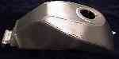
National Road Race & Daytona Winner -Developed by Innovative Motorcycle
Research and Built by ProtoFab. Cost approx. $850

Contact mailto:rich@racingmotorcycles.com?Subject=X1 Racing Gas Tank as
seen on TheX1Files

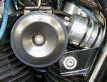
Blast Horn

For anybody who has put carbon tank accent panels on their X1 here's a solution to the
"where and what kind" of horn should I use problem. This is a stock horn off a Buell Blast
and costs about 8 bucks. It bolts right on and plugs in, comes with the mounting bracket
attached and when installed does not stick out past the frame. Also it is pretty loud for
its size.

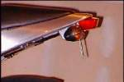
Fender Chop

Read all about it, and other X1 mods, here...¹

¹) http://www.geocities.com/MotorCity/Track/6161/x1fender.html

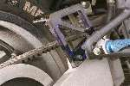
Belt Guards (Trojan Horse) (http://www.trojan-horse.co.uk)

Acrylic belt/heel guards designed for use on post '99 models with the rear hugger/fender
removed. Made from 10mm heat treated acrylic sheet, it is available either tinted (blue
shown) or clear. Top and bottom guards are available separately if required. Price for
the pair is £75 or £40 each.

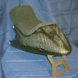
Seat (RRC) (http://www.trojan-horse.co.uk)

This is not just a piece of cosmetic carbon fiber, but a full Formula One grade rear subframe and
seat that replaces the entire rear end of the X1. Contains a cushioned tray in the seat hump to
house all the electrics, and comes complete with removable suede effect seat pad. Available
from RRC or Trojan Horse.

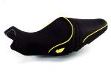
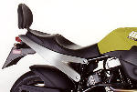
Seats

Buell²

Corbin³

¹) http://www.buell.com ²) http://www.corbin.com/buell/x1menu.html

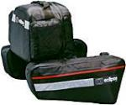
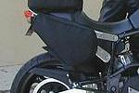
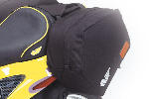
Soft Bags

Buell⁴

Eclipse⁵

RKA⁶

Ventura Bike Pack⁷
I have been using the Ventura Bike-pack
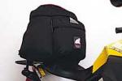
system on my '99 X1 for almost 18 months. I have had not a single complaint.
Nothing coming loose or breaking. My pack stays dry in the rain.
The distributor in the USA is great I lost the locking screws, all my fault, When I
asked to buy new ones they sent them to me free of charge. Great company to
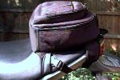
deal with

Samsonite Photo Video Carry-All from WalMart.

⁴) http://www.buell.com ⁵) http://www.eclipseluggage.com/bags/102.htm ⁶) http://www.rka-luggage.com
⁷) http://www.ventura-bike.co.nz/english/fitments/display.asp?manufacturer_id=3

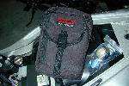
Toolkit

You can fit an impressive amount of tools under the seat. You can get a toolbag
anywhere that has a good selection of hiking bags... to find one that fits perfectly
look for something that is approx. 10in x 6in x 3in . Here's my current kit:

- Ratchet, extension, multi-tipped screwdriver.
- Sockets and wrenches... 8mm, 10mm,12mm, 14mm, 7/16, 1/2, 9/16,
5/8, 11/16, 3/4.
- 22mm wrench (O2 sensor), custom made shock tool (for new shock) 60mm/52mm.
- 36mm bicycle headset wrench & 36mm socket for rear axle, 15/16 socket for front axle.
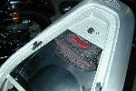
- Hex sockets 5mm, 3/16, 5/32, 1/4 ; full set of English & Metric hex keys.
- 5/8 sparkplug socket, 2 spare sparkplugs, gapping gauge.
- 8 inch adjustable, needle nose vise grip.
- Various electrical ends, wire, electrical tape, cable ties, spare fuses,
spare exhaust stud locknuts.
- 2 tie down straps.

Cruz Tools¹ sells a Buell specific toolkit.

¹) http://www.cruztools.com/Buell.html

Cable lube

Try a product called "DRI-SLIDE". It is a thin liquid with graphite suspended in it. When the liquid dries, it leaves the graphite behind. The bottle comes with a needle attachment that will allow you to insert it between the cable and sheath - so far it seems to be a very good product. Will definitely have longer lasting effect than WD40. Cost was $8. at the local Kawasaki shop. Black plastic squeeze bottle (8oz. +/-), with a bright green label. OR... HD sells a little tube of oil with a needle type injection tip just for lubing cables. Works slick. Just remove the cables at the bars (only) and stick the needle in between the cable and the housing and inject some oil. Gravity will take it down. OR... If you remove the cable from the bike or at least expose both ends you can get a length of hose about a foot long that has an I.D a little larger than your cables O.D. What you do is this...... Push hose a short way over the outer cable and TIGHTEN it with a Jubilee type clip. At the opposite end of the hose attach an air line connector then fill the hose with WD40. Attach air line at a pressure of around 50 psi and watch the stuff come out of the opposite end of the cable. Repeat again with oil. There is nothing works better, period, and you will not believe the difference until you have tried it!

Centerstand (http://www.centerstand.com/%20)
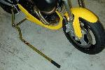
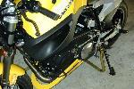
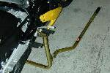
Highly recommended.

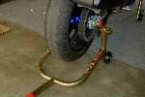
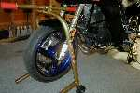
Pitbull (http://www.pitbullmotorcyclelifts.com/)

Highly recommended.

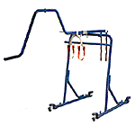
K&L Crate Lift (http://www.klsupply.com/lift/mc360/)

A versatile shop tool that allows one person to remove a motorcycle safely out of the
crate for assembly. Allows operator to lift up to three times their own weight to a max.
of 900 lbs. No more struggling or additional manpower for lifting.

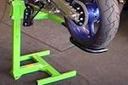
EazyRider Bike Lift (http://www.bikelift.com/how_it_works.htm)

The ONE Model of EazyRizer Lift is suitable for ALL Bikes, just choose the inter-
changeable mounting brackets to suit your type of bike or the task in hand.

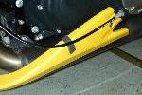
Paint Savers

Foam rubber weather stripping with adhesive backing. Use it everywhere "stuff rubs".

Recalls & Service Bulletins (X1s only)
Carb, Ignition, & Sparkplug Update

The 10R12s and other stuff.
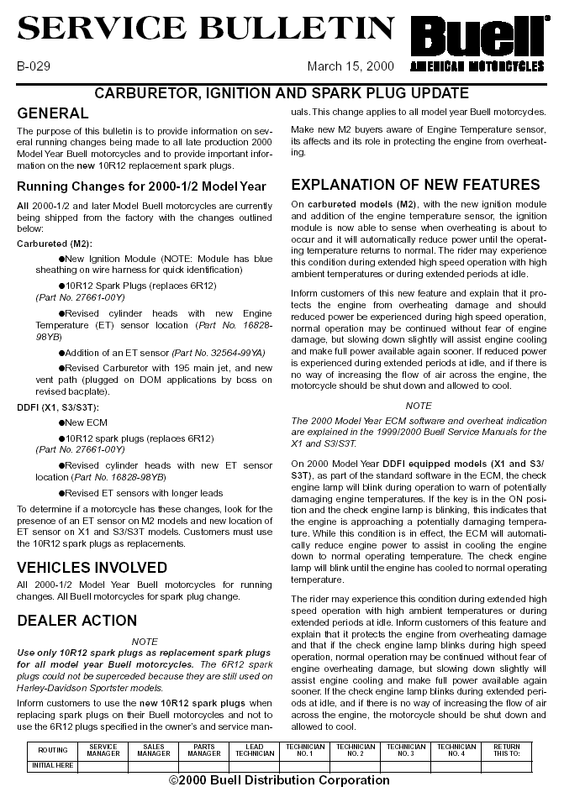
Exhaust Header Mount Retrofit Kit

Upgrade your failure prone exhaust mount with the upgraded 2001 mount.
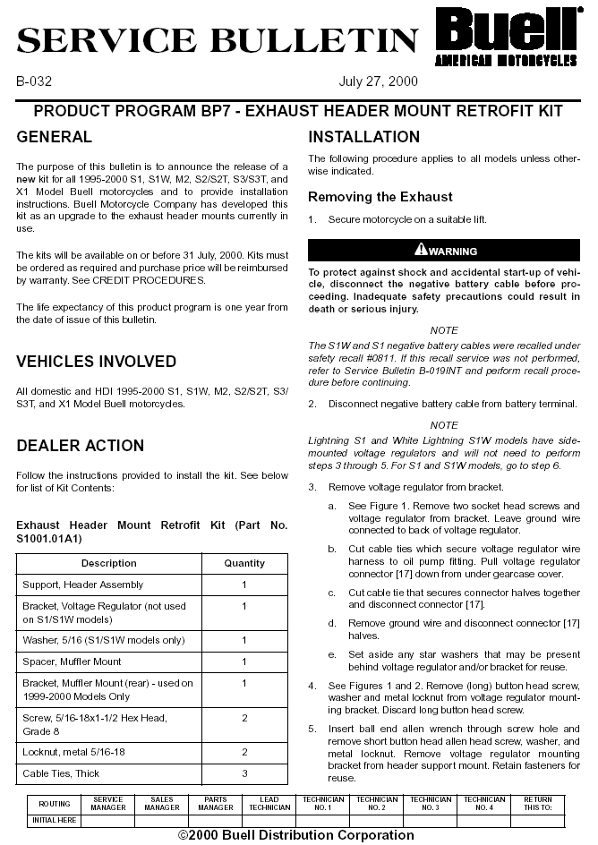

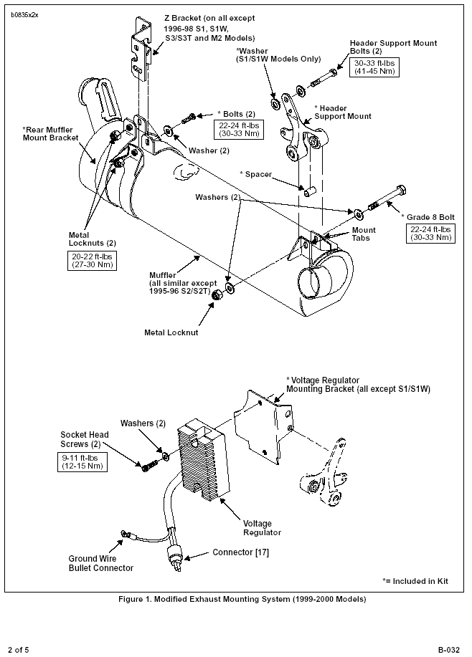

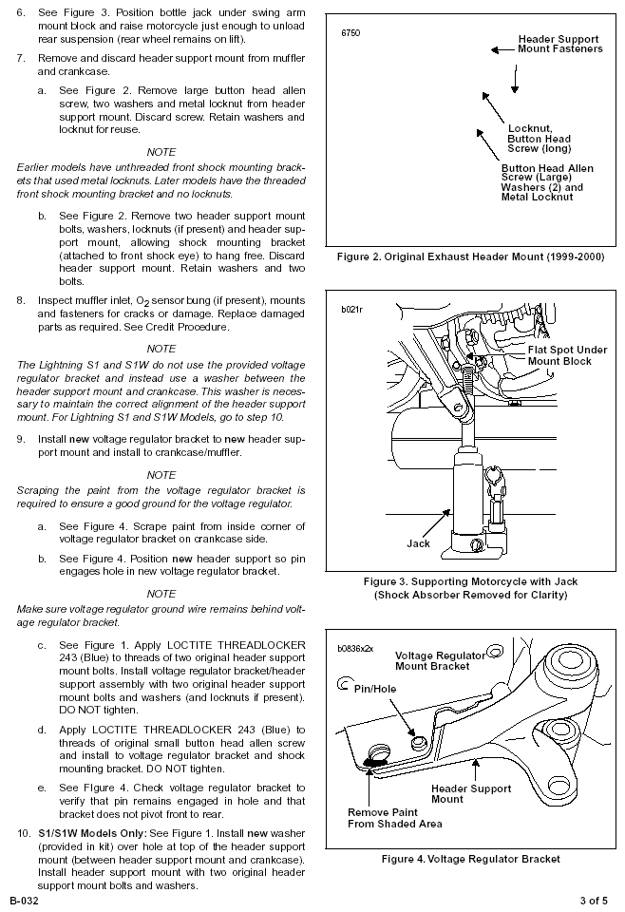

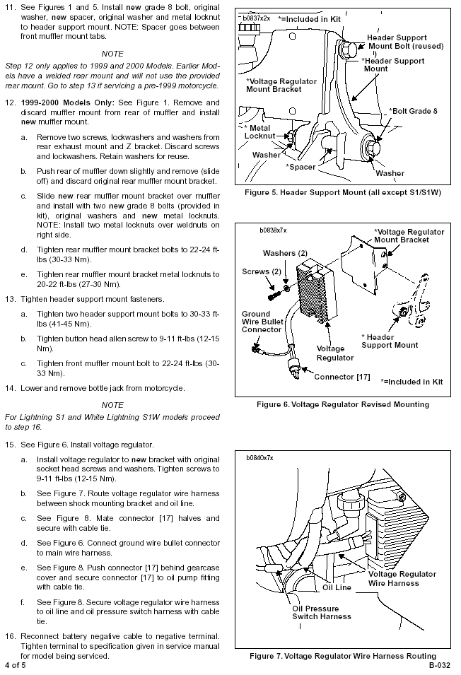

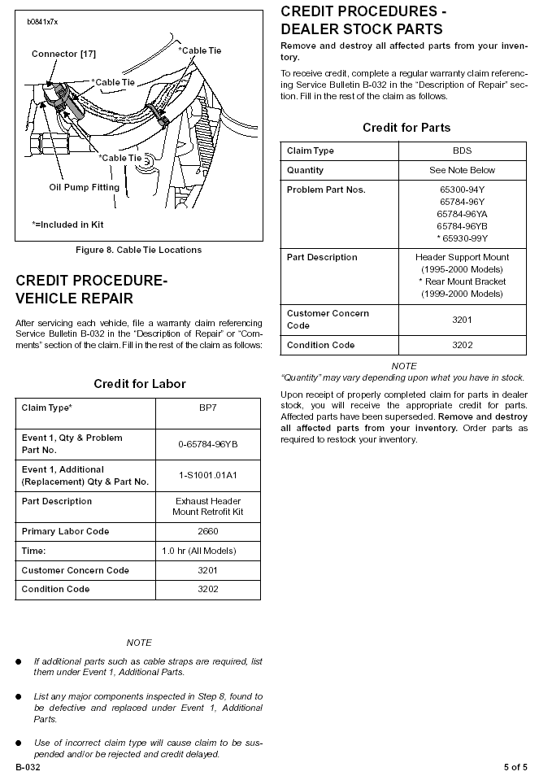

Updated Isolators

The original isolator kit has been revised to include newly designed, improved rear isolators.

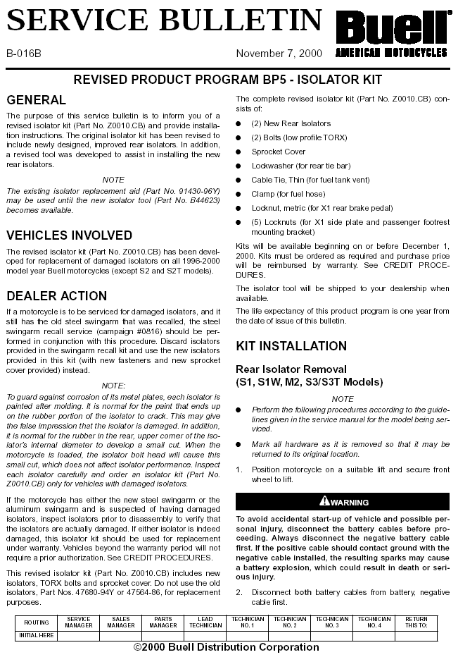

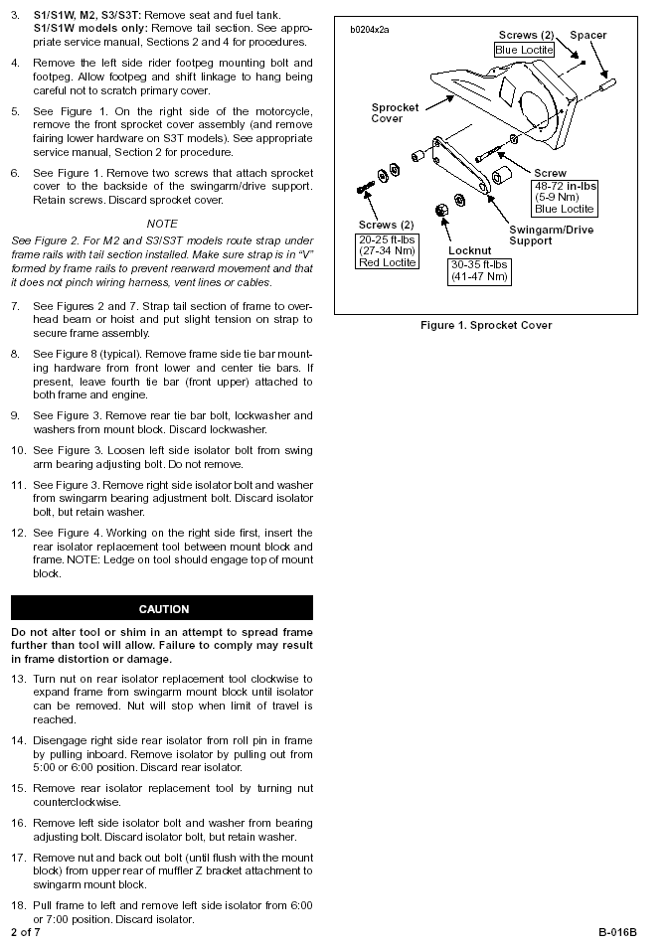

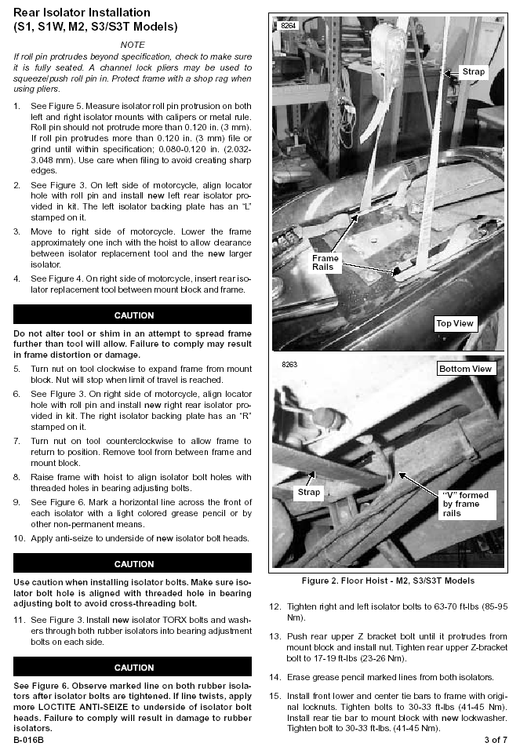

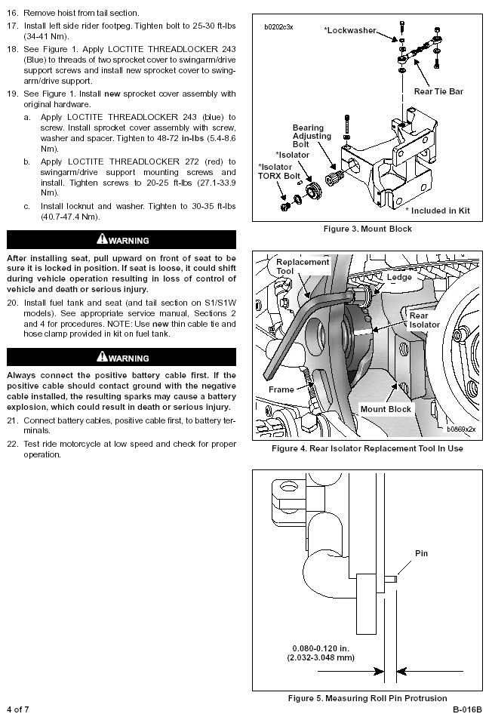

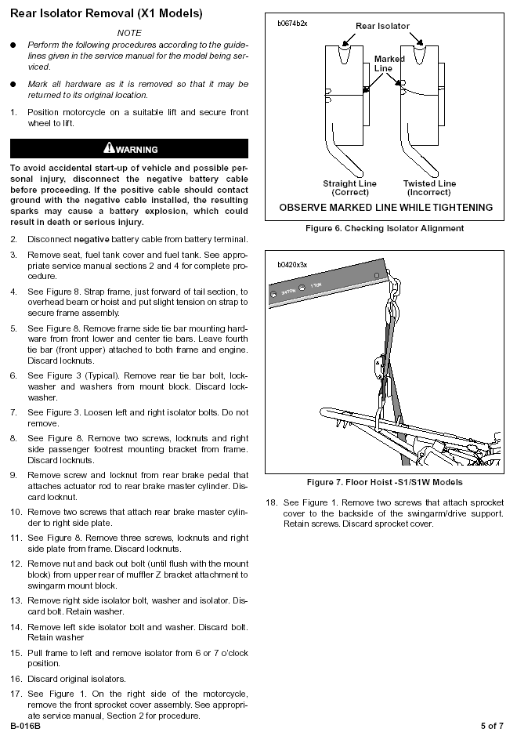

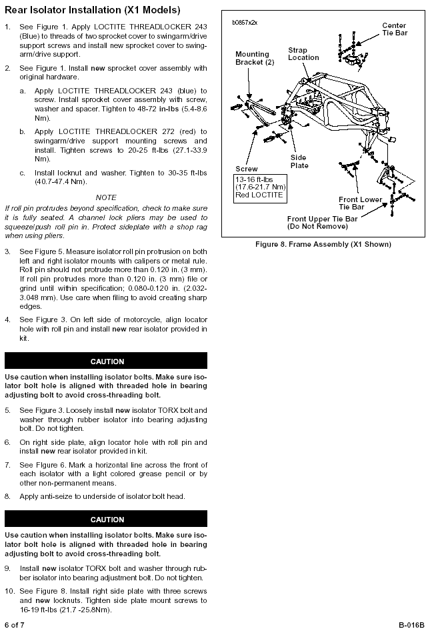

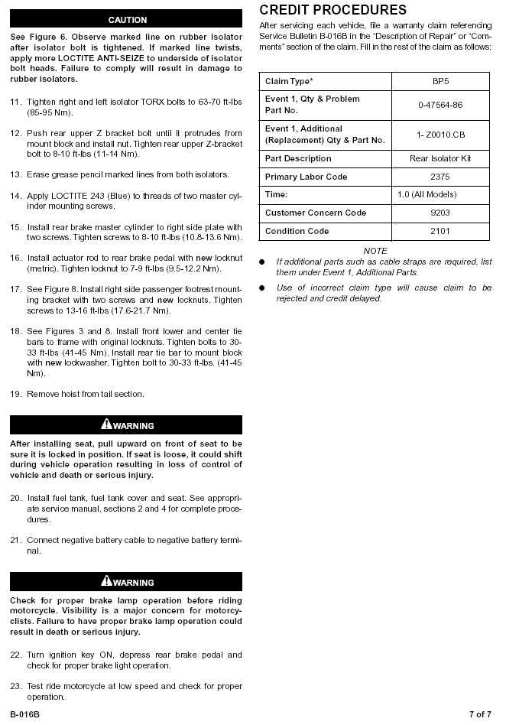

Chafing Brake Line

The rear brake line can chafe, resulting in loss of brake fluid. Should this occur, the rider could experience loss of rear braking capabilities. Dealers will replace the rear brake line. Owner notification began June 1, 1999.

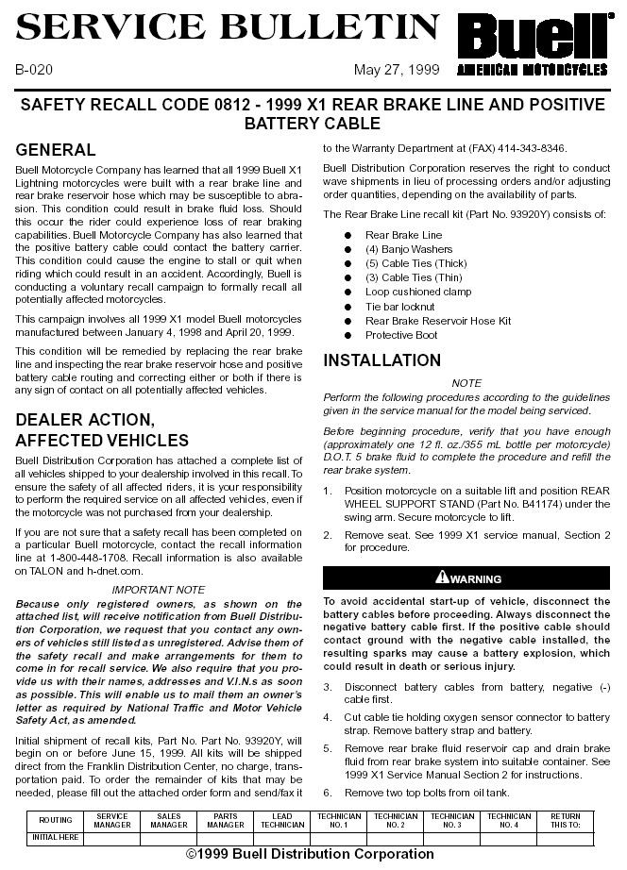

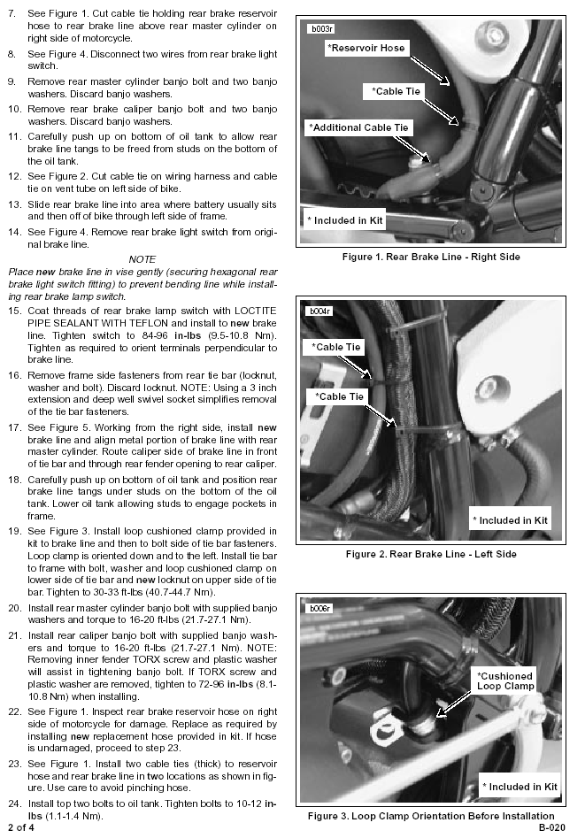

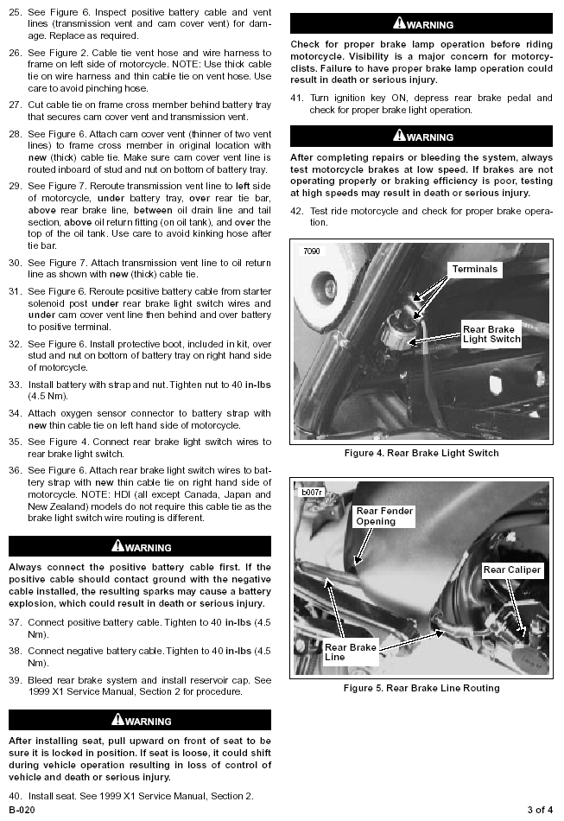

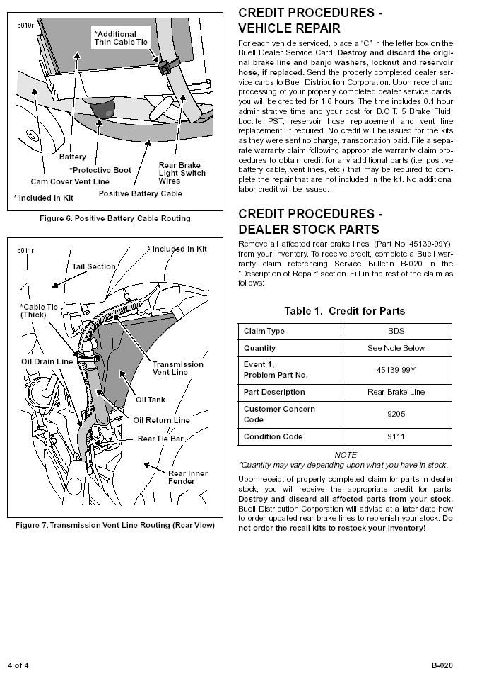

ECM

The computer on early 99's should be upgraded with a new program.
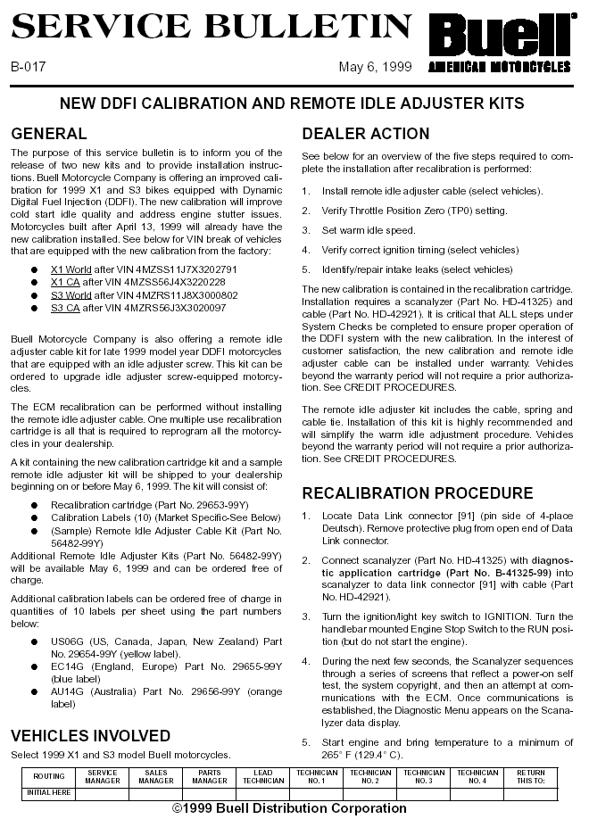

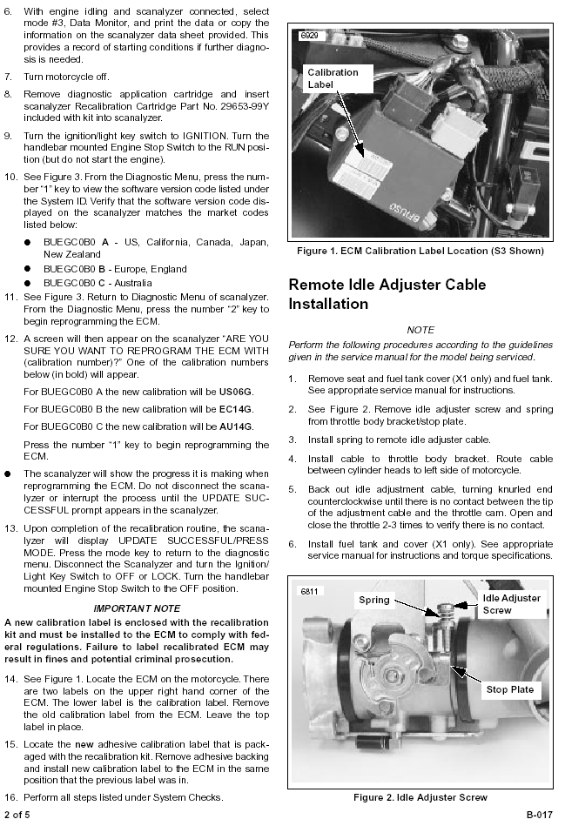

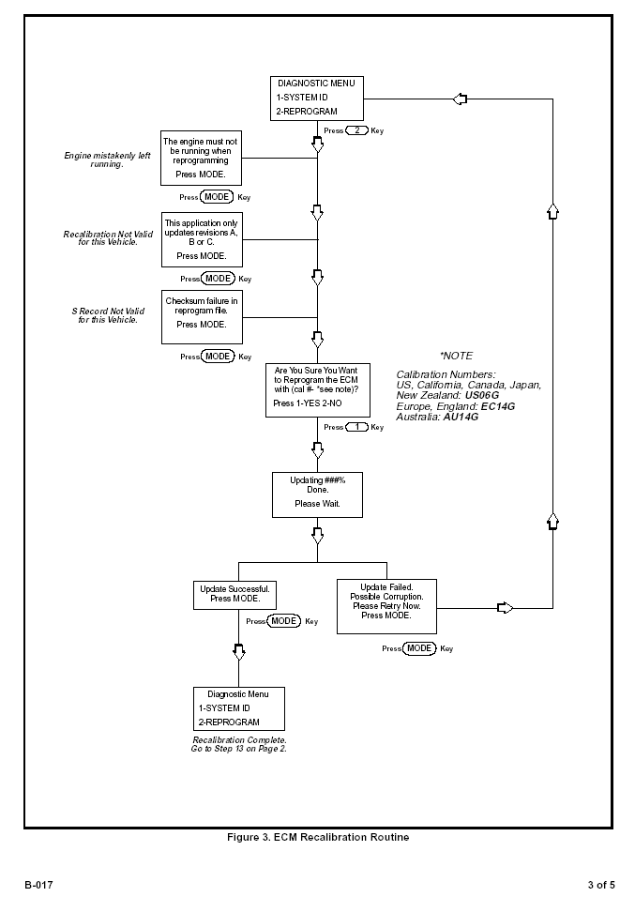

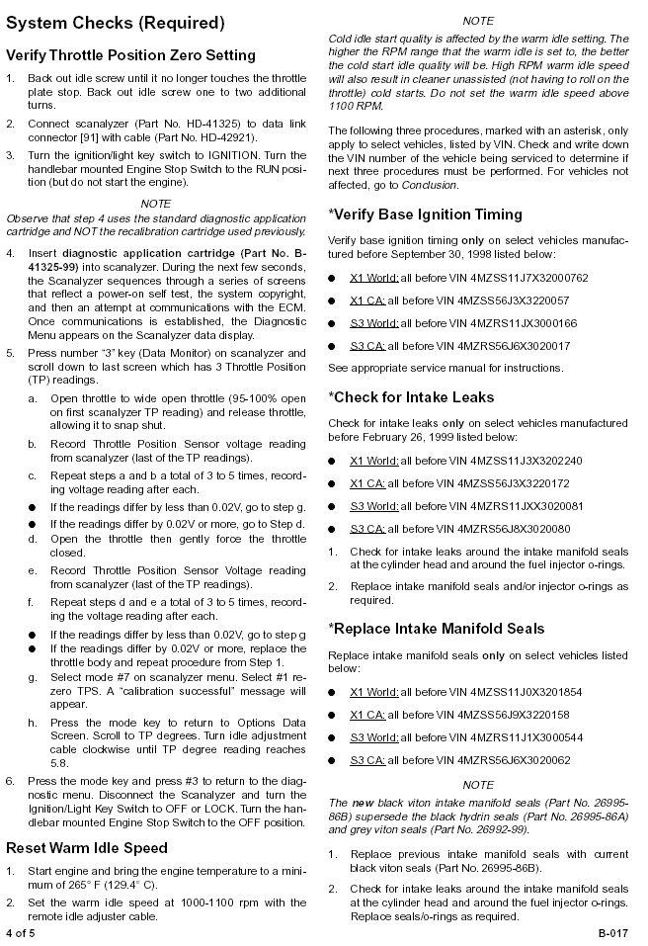

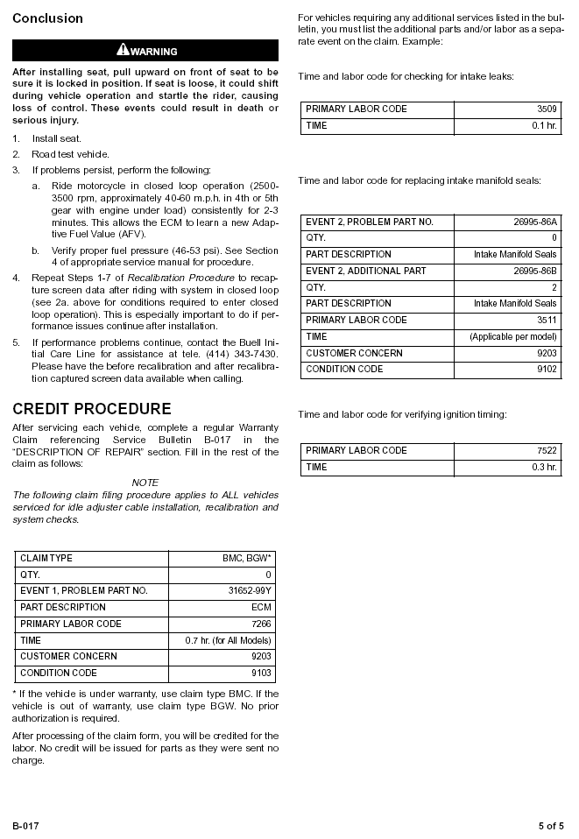

Rear shock locknut tightening procedure

Revised torque specification and additional instructions required for proper tightening of rear shock adjusting locknuts.
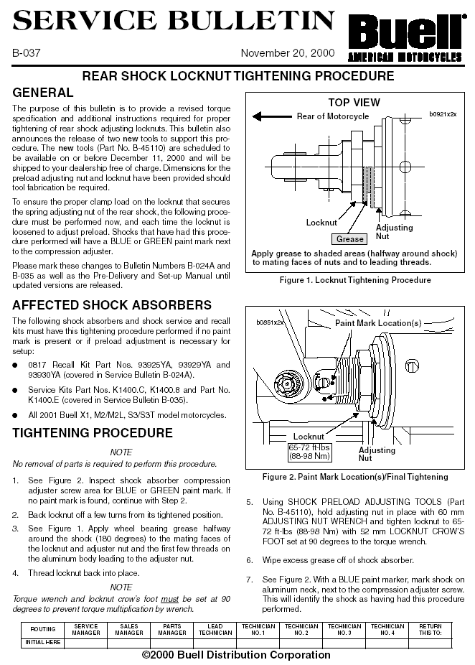

The fuel filter can leak

Fuel leakage in the presence of an ignition source could result in a fire. Dealers will replace the fuel filter. Owner notification began March 20, 2000.

Bad Sidestand Switch

These motorcycles were built with a sidestand switch that could become inoperative. This condition can cause the engine to stall/quit when riding. Dealers will replace the sidestand switch. Owner notification began June 24, 1999.

Fuel Tank Vent

These motorcycles were built with a fuel tank vent valve assembly that could become plugged. Under certain conditions, this could cause the carburetor to overflow fuel which could result in a fire. This condition could also prevent sufficient fuel flow, which could cause the engine to misfire or stall. Dealers will replace the fuel tank vent valve assembly. Owner notification began June 15, 1999.

2002 Shock Mount

Models: Buell M2L Year: 2002 Buell S3T Year: 2002 Buell M2 Year: 2002 Buell X1 Year: 2002 Number Involved: 387 Dates of Manufacture: September – November 2001 Defect: These motorcycles were built with a front shock mount that is cracked and could break, allowing the suspension to drop unexpectedly. This could cause a loss of control of the motorcycle. Remedy: Dealers will replace the broken shock mount. The manufacturer reported that owner notification was expected to begin during February 2002. Owners who do not receive the free remedy within a reasonable time should contact Buell at 1-414-342-4680.

It applies ONLY to bikes manufactured between September and November of 2001, and only a certain few within that time frame, a total of 387 bikes.

Battery Cable

The positive battery cable can contact the battery carrier. Should this occur, the motorcycle could stall or quit. Dealers will inspect the positive battery cable routing and correct it if there is any sign of contact. Owner notification began May 28, 1999.

New Shock

A new shock is available for all Buells 95-00 requiring shock servicing. Here's a summary of the confusing situation...

'95 through '98 (all models): Original WP shock is under recall. If the recall service has not been performed, the new '01 style shock will be put on at no charge. If the recall has been performed, and the replacement Showa shock has failed after being in place for less than one year, a new '01 shock will be provided free of charge. If however the replacement Showa failed after more than one year in service, the customer will be charged $100 for the replacement '01 style shock.

'99 X1 & S3 models: Original Showa shock is not under recall. A failure within the first year of service is covered by the factory warranty, and a new '01 style shock will be used. A failure after the warranty expires will incur a $100 charge to the customer and the shock will be replaced with a new '01 style shock.

'99 M2 and '00 all models: Original Showa shock is under recall. Will be replaced with new '01 style shock at no charge. This is true even if the shock is already equipped with the SRP, if the owner objects to the SRP’s appearance.

Some deviations from the above have occurred, primarily because the policy was evolving, but this is the latest BMC policy, until it changes.

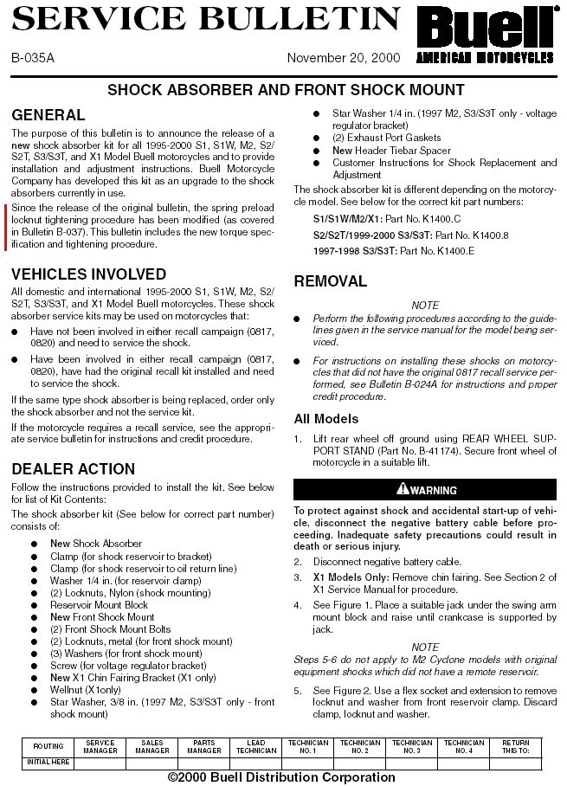

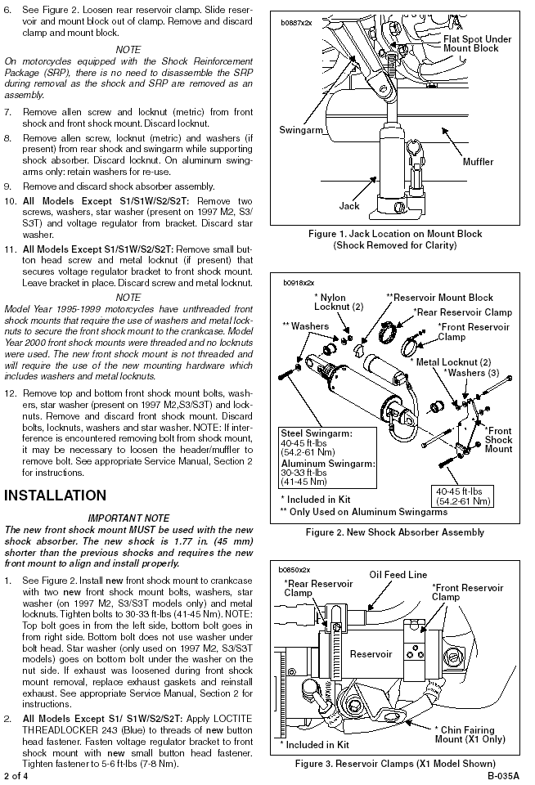

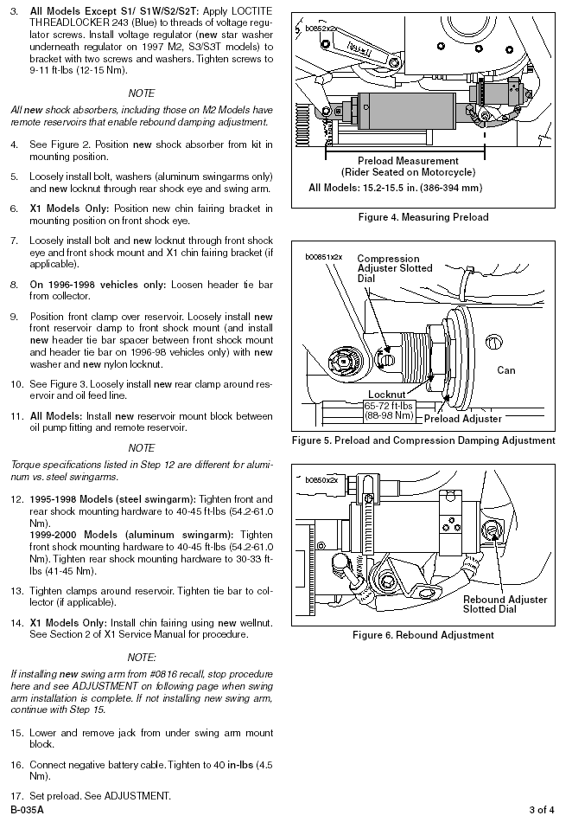

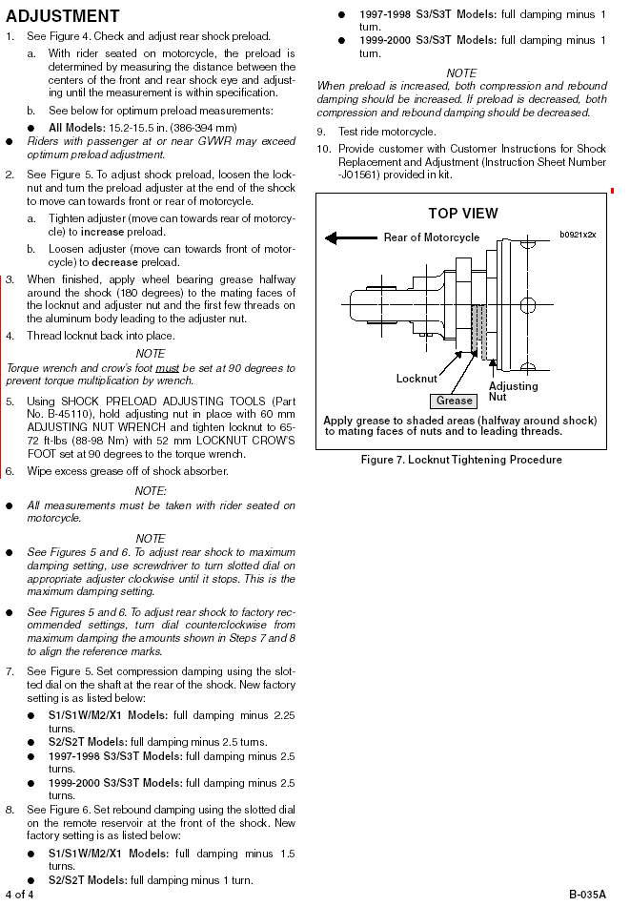

Shock Recall

Certain 1999 and 2000 Buells were built with a rear shock absorber that could break If the shock should break, the underside of the vehicle could drag on the ground, which may adversely affect handling and cause an accident.
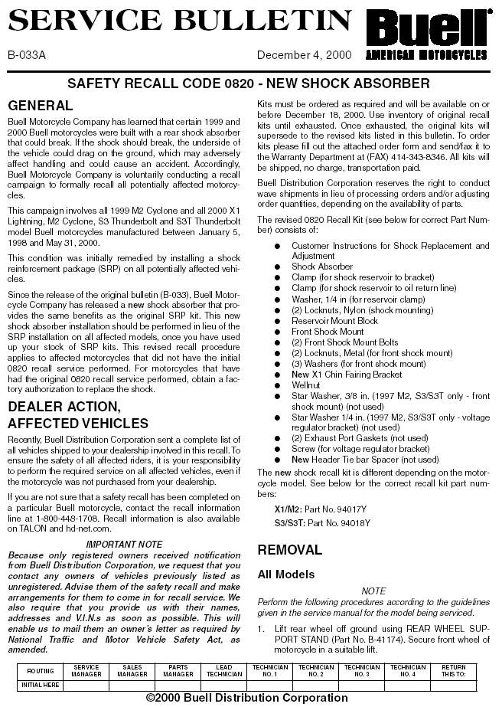

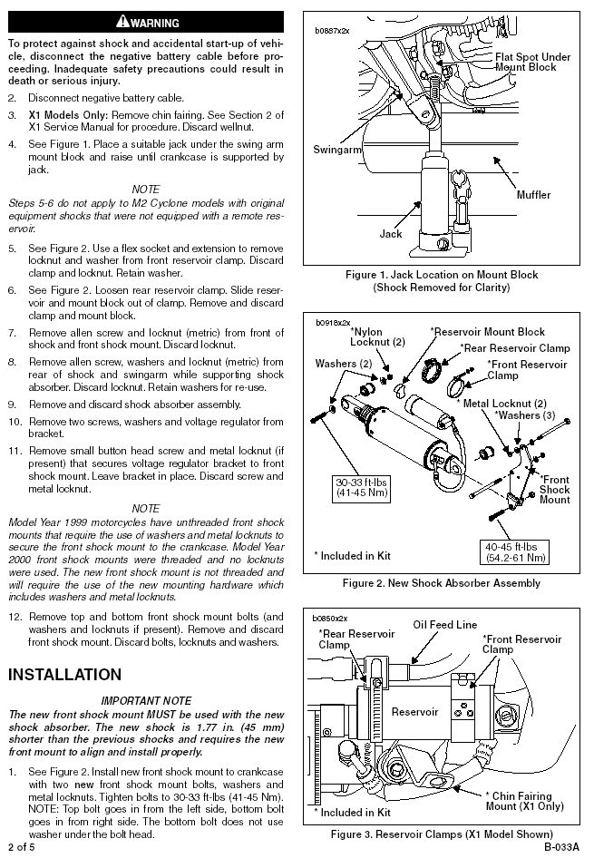

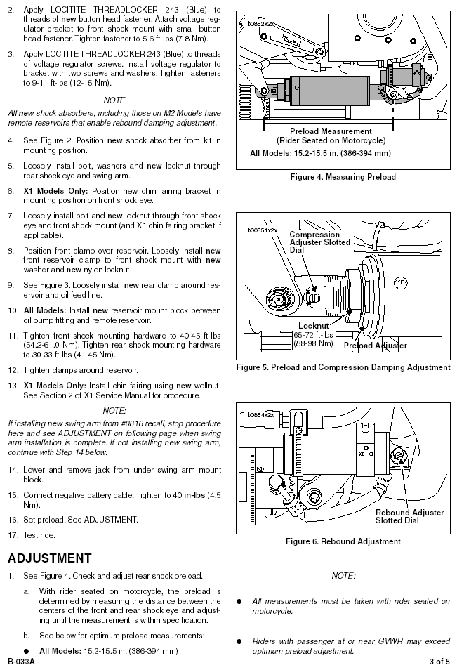

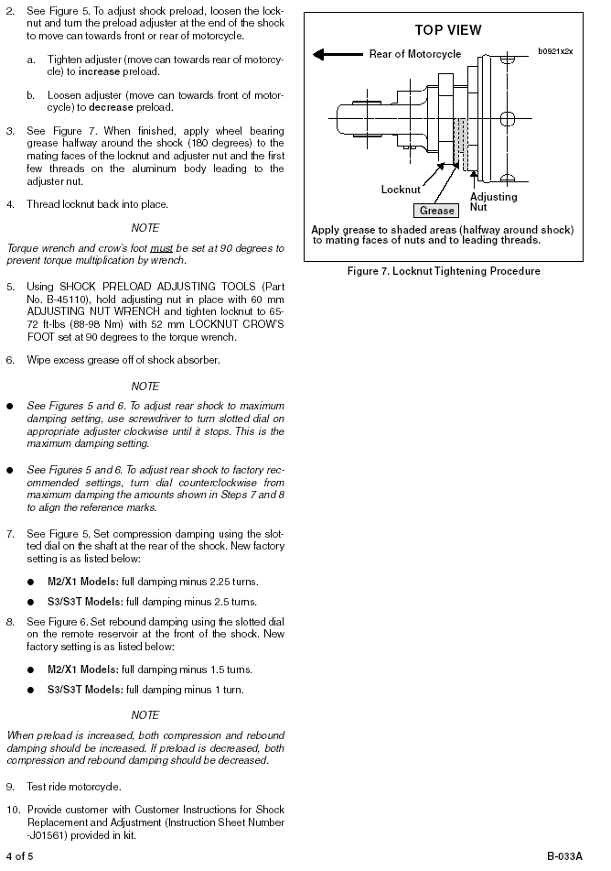

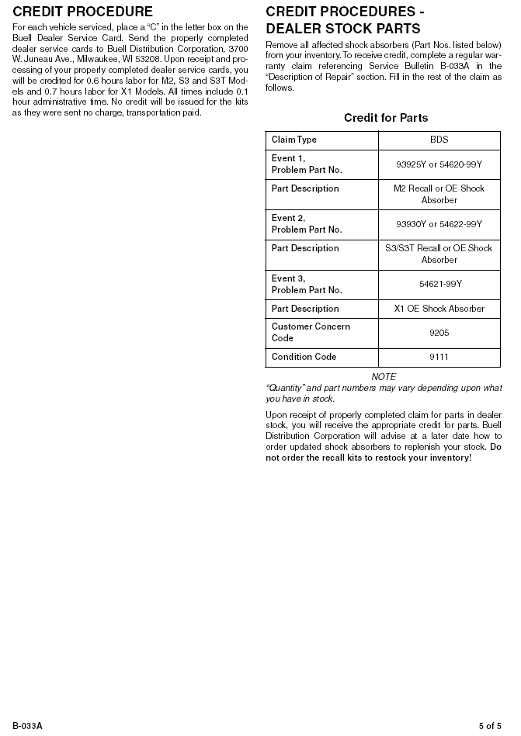

Buell Race Muffler (Old)

This system no longer available as it is under recall.
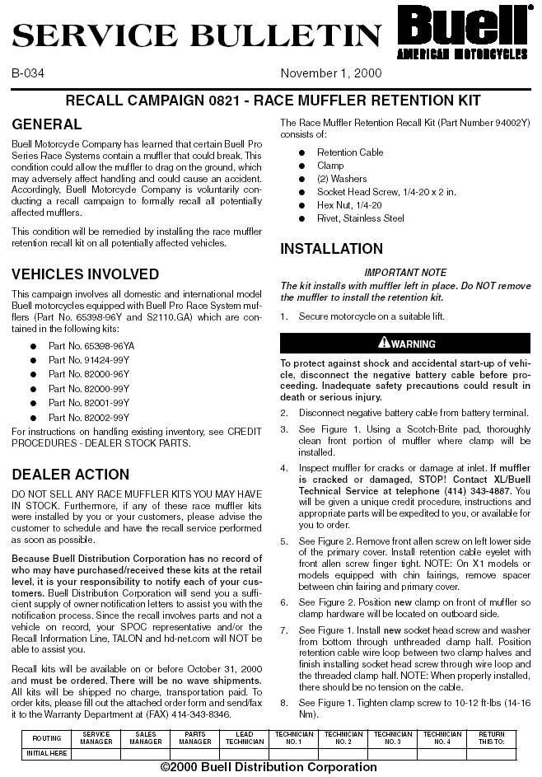

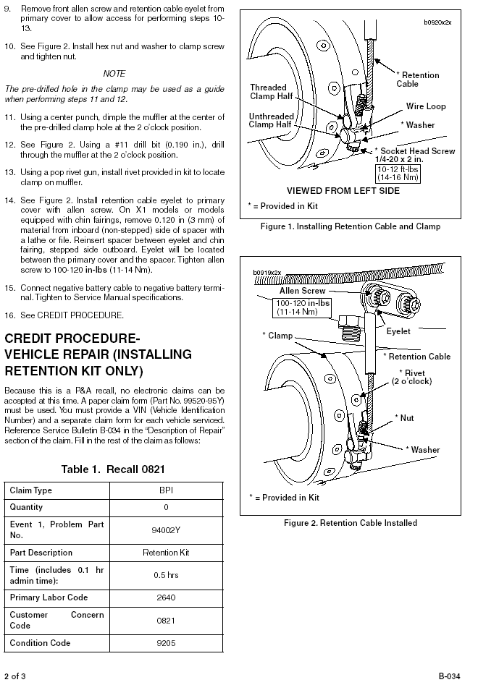

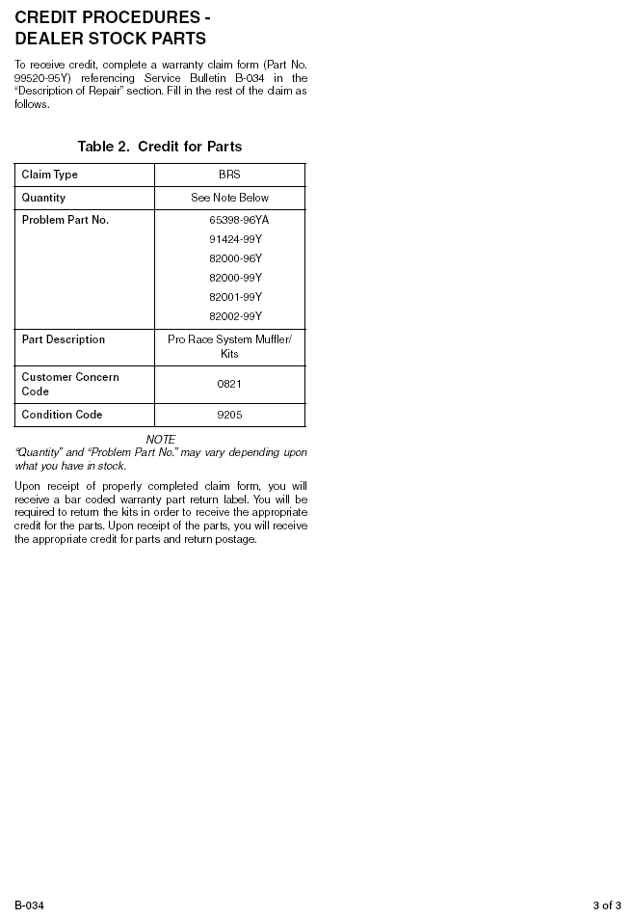

Recommended Dealers (Buell Customer Service (414) 343-8400)
Topeka HD/Buell¹ has every last little part for these bikes. They will gladly UPS them to your door. All of the parts people know these bikes and ride them... call 1-785-234-6174.

¹) http://www.topekaharleydavidson.com/

Mankato Harley-Davidson/Buell² in Minnesota is wonderful to work with. They are very knowledgeable and understanding of extenuating circumstances. All the employees and the owner ride cycles, and genuinely care for their customers. Mankato Harley-Davidson / Buell 1200 N. River Drive Mankato, MN 56001 1-888-290-3149.

²) http://www.mankatoharley-davidson.com/

Valley Harley/Buell³ in Morristown, Ohio, 740-695-9591. They will bend over backward to help you with anything you need. Bob is the head mechanic and really knows his @#@$! I have had extensive dealings with them and have never left unsatisfied

³) http://www.valleyharley-buell.com/index.htm

San Diego Harley Davidson³ They have a Buell race team there and are by far the most knowledgeable Buell dealer in San Diego County. Their lead Buell salesman, and race bike rider, is Fread (like bread) Finerty. His bother works there as well and between them they have some 9 Buells. One of their service writers, Andy, rides an S1 White Lightning. For a person who is looking for a Buell, you can't do better than this shop for knowledge. The team there has been wonderful through the teething period of my new 00 X1. I've never left there unsatisfied.

³) http://www.sandiegoharley.com

Atlantic County HD/Buell⁴ in Absecon/Atlantic City should be on this list. I have had numerous upgrades and modifications to my 99 X1. This dealer is excellent, all work done well and very reasonably priced. They know Buells!

⁴) http://www.acharley.com

Eastside HD/Buell⁵ in Bellevue, WA. Their Buell-friendly front has been championed by salesman/racer Scott Moon, and the whole dealer is now much more Buell friendly because of his efforts. Last year their veteran Buell mechanic left, and they got a new one -- Kurt -- who was a fighter-jet mechanic for Boeing; pretty good basics.

⁵) http://www.eastsideharley.com/

Redwood Harley Davidson / Buell , Eureka California, 707-444-0111 Awesome Owner and experienced staff. Feel like part of the family. The repair department is super clean and fully equipped. Brilliant Buell technician and superb customer service. Have had friends buy a pair of Blasts they where impressed by the entire experience. Sponsor of local BRAG chapter providing excellent support to members.

Illinois H-D/Buell. Their service dept is on top of their game (90%) They are very forthcoming with tech help and advice. Not only that they have a stand alone showroom of just Buell products. Their salesman Sam is very knowledgeable about their product. They also are setting up, maybe completed by now, a dedicated speed shop portion of their service dept. They have recently recruited Jim Egizio from S&S This guy knows his shit. They are located in Berwyn Illinois, a Chicago suburb.

Modesto Buell 1408 Carpenter Rd. Modesto, CA 95357 209 578-1330 Ask for Danny or Deanna.

Marty Hunt⁶ at Sauk Prairie H-D/Buell⁷ Sauk City, WI 53555 welcomes 'net biz! Or, phone 1-608-643-3735.

⁶) spbuell@hotmail.com?Subject=Inquiry from TheX1Files.com ⁷) http://www.spharley.com

Chicago Harley⁸ offers 20% off all Genuine Harley-Davidson Parts, Accessories, and Clothing, all the time. Place your order online, or call it in Toll Free at 1-888-338-6868 or Fax it in to 773-338-8868 Also FREE SHIPPING* (*Minimum handling charge) and NO SALES TAX out of state.

⁸) https://www.chicagoharley.com/porder.html

Ray and Gail Lytle, Gainesville Harley-Davidson & Buell, Inc.⁹ 4125 NW 97th Blvd. Gainesville, Fl 32606 352-331-6363 FAX 352-331-6609 email: mailto:gnvhd@earthlink.net?Subject=Inquiry from TheX1Files.com.

⁹) http://www.gainesvilleh-d.com

Destination Beaverton HD/Buell¹, Beaverton Oregon, 503-643-7111 Ed Wallice Jr², owner, takes care of his customers, stocks mass factory and aftermarket stuff, has competent service department whom race and know their machines.

¹) http://www.beavertonharley.com ²) ed@beavertonharley.com?Subject=Inquiry from TheX1Files.com

Bumpus HD/Buell³ of Murfreesboro, TN. The service, parts, and sales staff have been no less than excellent. The sales people call me by name (it's one of those little things that make you feel like a friend instead of a customer), the service manager gave me his airbox cover when I cracked mine open (lowsided, ooops!), and 3 of the employees ride Buells (service manager, & 2 techs). I would definitely recommend to anyone looking for a Buell or HD to check them out.

³) http://www.bumpusharleydavidson.com

H-D/Buell of Edison, NJ⁴. These guys are fantastic! They are friendly, treat Buell customers as first-class citizens, and really take the time you need to make the right decision. The service and parts department is also first-rate. We have bought 2 M2 Cyclones there and will continue to use them for all of our needs. They also sponsor an active BRAG club.

⁴) http://www.harleyofedison.com

Calgary Alberta's Southern Alberta Harley Davidson & Buell deserves to be on your list of great dealers and service centers. Buell tech, Jeff Holsey is second to none in the service dept. While the Sales and Parts Staff are nothing but the best!

At Twin City Harley and Buell, Lakeville MN, there is a guy named Andy Long who is a mastermind when it comes to Buells ( he owns an X1 ) People have called out of state for his services!! I won't let ANYONE touch my bike except him!!!

"The Harley Davidson Store" on U.S. Rt. r0 to the east of Baltimore, MD. needs to be on the "good to know/good to go" list. Jason of their service department knows far more than the average Buell guy, and is willing to call b.s. on ill-advised choices or directions you might be inclined to take. Besides, the actual place itself is way sano...and the Buells are what you see when you walk in the door, how 'bout that?

HCS Zoetermeer⁵

⁵)http://www.hcsmotor.com/

Westcoast Motors⁶

⁶) http://www.westcoastmotors.nl/

Motoplaza Eindhoven⁷

⁷) http://www.motoplaza-eindhoven.com/index.php?cat=12

HD-Point Leeuwarden, de Friese Harley-Davidson en Buell deal⁸

⁸) http://www.hdpoint.nl/

SAFE Rotterdam⁹

⁹) http://www.safe.nl/

Distributors
American Sportbike¹⁰
My experience with ASB has been fantastic. Great availability, quick delivery, decent prices. Because of their great inventory, ASB has helped me get my 99 S3T back on the road quicker than my local dealer, first with a ceramic coated header pipe (much better looking than stock) and then with an upgraded bushing for the front muffler hanger. Most recently, they helped my wife and son surprise me with a carbon fiber rear fender. I met Tat and Maria at Daytona in 99, found both of them to be really nice people who took a helluva risk giving up their "day jobs" to create a company dedicated to serving Buell owners. I won't say if I'm biased just because Maria happens to be very attractive lady, also, but she does give great overnight shipping!

¹⁰) http://www.americansportbike.com/

Eurocomponents¹
Quality issues, fit & finish, reported... I purchased Eurocomponents fender eliminator kit and seat cowl, they both fit very poorly. I took them to the body shop for painting, and the painter said flat-out that these pieces needed extensive finish work. I sent them both back and got the same parts back with a little more finish work but they still fit only fair. I installed them only to have the turn signal set-up not work properly (they flash way too fast). I am not trashing this company, but I think this stuff costs too much to have such a bad fit. I would suggest you talk to Tat at American Sportsbike, he sold this stuff at one time, while he never said anything bad about the stuff he didn't seem to endorse it either.
¹) http://www.eurocomponentsusa.com/buells.html

PlanetBuell²
A new site by Milwaukee Twin, the largest Buell dealer in France, where one can participate in a local forum or buy stuff on their on-line store. The site is in French as well as the forum.

²) http://www.planetbuell.com/

Force Motor Products³ Twin Performance⁴

³) http://forcemotorproduct.com/index2.html ⁴) http:// www.twin-performance.nl/buell_specialist.htm

Joker Machine⁵ Bike Hospital⁶

⁵) http://www.jokermachine.com/catalog.htm ⁶) http://www.bikehospital.nl/

R&R Customizing⁷ O.I.T. Breda⁸

⁷) http://www.r-r-customizing.de/ ⁸) http://www.oit-harley-davidson.com/

Trojan Horse Products⁹ Harley World Apeldoorn¹⁰

⁹) http://www.trojan-horse.co.uk/ ¹⁰) http://www.harleyworld.nl/

Banke Performance¹¹ Harley World Amsterdam¹²

¹¹) http://www.bankeperformance.com/index.html ¹²) http://www.harleyworld.nl/index.php?id=9

Zipper's Performance¹³ House of Harley¹⁴

¹³) http://www.zippersperformance.com/catalogue/default.asp ¹⁴) http://www.proximedia.com/web/harley.html

Hyperformance¹⁵ Service and tuning¹⁶

¹⁵) http://www.kingofcubes.com/ ¹⁶) http://www.sent-harley-davidson.com/

S & S Cycle¹⁷ H-D Point¹⁸

¹⁷) http://www.sscycle.com/ ¹⁸) http://www.hdpoint.nl/

Crossroads¹⁹ Dreamcycles²⁰

¹⁹) http://www.nvo.com/crossroads/displayroom/category.nhtml? ²⁰) http://www.dream-cycles.com/
catuid=10039

Storz Performance²¹ American Bike Shop²²

²¹) http://www.storzperf.com/buell.html ²²) http://www.americanbikeshop.com/

Bartels' Performance²³ Zodiac²⁴

²³) http://motorcycle.com/mo/mcads/mcbartels/bpp/ ²⁴) http://www.zodiac.nl/

Airtech Streamlining²⁵ Suburban Harley²⁶

²⁵) http://www.airtech-streamlining.com/prodbuell.htm ²⁶) http://www.suburbanharley.com/

Lockhart Phillips USA²⁷ Centennial Park Harley-Davidson & Buell Online Shopping²⁸

²⁷) http://www.lockhartphillipsusa.com/cwbodywork.html ²⁸) http://www.centennial-park.com/

ART Exotic Motorcycle Accessories²⁹ AML enterprices³⁰

²⁹) http://www.artexhausts.co.uk/cgi-bin/browse-no-frames.pl? ³⁰) http://www.motocyclestore.com/index.asp?PageAction=
session=4455677&view=group&group=buell VIEWPROD&ProdID=

Champion Motorräder¹ Deeley's House of Buell²

¹) http://www.champion-motorraeder.de/ ²) http://buell.trevdeeley.com/

Force Air Cleaner for Buell Motorcycles³ Motorcycle Storehouse Harley-Davidson⁴

³) http://www.cas4.com/Force/Intake/AirCleaners/Buell%20Air ⁴) http://www.mcseurope.nl/
%20Cleaner%20by%20Force.htm

H&M Harley-Davidson oiltanks⁵ Bartels' Harley-Davidson⁶

⁵) http://www.hmhd.com/webstore/viewprod.asp?PID=oiltanks ⁶) http://www.bartelsharley.com/
&SUBPID=oilcoolers

Products (Not found elsewhere on this site)
Buell on Trader Online⁷

⁷) http://www.traderonline.com/cgi-bin/cycle/ads3/search/cSearch.html?iteration=0&beginYear=&endYear=&lowPrice=&hiPrice=&keyword=buell&areacode1=&areacode2=&areacode3=&state=&region=0

Buell on eBay⁸

⁸) http://search-desc.ebay.com/search/search.dll?MfcISAPICommand=GetResult&ebaytag1=ebayreg&ht=1&query=buell&ebaytag1code=0&srchdesc=y&SortProperty=MetaEndSort

JMC Swingarms⁹ Classic Coatings¹⁰

⁹) http://www.swingarm.com/ ¹⁰) http://www.classiccoatings.com/

Hell Fire Nitrous Systems¹¹ Signal Dynamics¹²

¹¹) http://www.geocities.com/hellfirenitrous/page2.html ¹²) http://12.6.109.157/

Ferodo Brake Pads¹³ Aerocharger Turbo System¹⁴

¹³) http://www.ferodobraketech.com/cp911.html ¹⁴) http://www.aerocharger.com/sptsbu.htm

Lyndall Racing Brakes¹⁵ Automatic Chain Tensioner¹⁶

¹⁵) http://www.lyndallracingbrakes.com/home.htm ¹⁶) http://www.sohotbikes.com/tension.html

Rizoma... Buell parts made in Italy¹⁷ Max T Engines - 4 valve heads¹⁸

¹⁷) http://www.rizoma.com/ ¹⁸) http://www.maxtengines.com/

Engraveyard¹⁹ Goodridge Benelux²⁰

¹⁹) http://www.engraveyard.com/ ²⁰) http://www.goodridge.nl/

X1 Articles Online
TexMoto - Dancing with Buells²¹ TheAutoChannel – Review²²

²¹) http://www.texmoto.com/testrides/2000BuellX1TestRide.htm ²²) http://www.theautochannel.com/vehicles/new/reviews/motorcycles/
2000/abachofen_buell_x1_lightning.html?FEATURES

Motorcycle Online - A Different Way to Dance²³ Canadian Biker - The X1 Files²⁴

²³) http://www.motorcycle.com/mo/mcbuell/99x1.html ²⁴) http://canadianbiker.com/features/x1.html

TheAutoChannel - X1 vs Ducati²⁵ Buell Nederland²⁶

²⁵) http://www.theautochannel.com/vehicles/new/reviews/ ²⁶) http://www.buell.nl/
motorcycles/2000/abachofen_buell_or_ducati.html

MCN - Buell Articles²⁷

²⁷) http://www.motorcyclenews.com/bikes/makes?letter=B

Personal Pages / Forums
American Thunderbike Club¹ Dutch Buell Forum²

¹) http://www.americanthunderbike.org/ ²) http://buell.qweb.nl/ikonboard.cgi?act=Portal

TheS3Files³ Motormaniacs Buell Forum⁴

³) http://www.dcbrag.org/FAQ2.htm ⁴) http://www.motormaniacs.nl/cgi-bin/ikonboard/forums.cgi?forum=6

Sac BORG⁵ Buell Forum⁶

⁵) http://www.sacborg.com/ ⁶) http://www.buellforum.nl

PACBOG⁷ X1-files⁸

⁷) http://members.aol.com/pacbog/index.html ⁸) http://www.saintjohn.nbcc.nb.ca/Marriott/x1/

DC Brag⁹ Buellblast¹⁰

⁹) http://www.dcbrag.org/ ¹⁰) http://www.buellblast.com/

Bikernet Buell Report¹¹ Buell World¹²

¹¹) http://www.bikernet.com/buell/ ¹²) http://www.buellworld.com/

Juergen Moser¹³ UK Buell Entusiasts¹⁴

¹³) http://home.surf24.de/~moser/buell.html ¹⁴) http://www.ukbeg.org.uk/index.htm

Neil S Schwartz¹⁵ B.O.R.G.¹⁶

¹⁵) http://members.sigecom.net/neils/ ¹⁶) http://www.grabo.de/forum/#post

Bad Weather Biker's BBS¹⁷ Pitt Bull¹⁸

¹⁷) http://www.badweatherbikers.com/ ¹⁸) http://www.pitt-biull.com/

UK Buell Enthusiasts On-Line¹⁹ Buell Planet²⁰

¹⁹) http://www.ukbeg.com/ ²⁰) http://www.planetbuell.com/

Sport Twin²¹ Hillbilly motors²²

²¹) http://www.sporttwin.com/ ²²) http://www.hillbilly-motors.de/portal.html

Buelligans²³ harley-davidson.startkabel.nl²⁴

²³) http://www.buelligans.com/ ²⁴) http://www.harley-davidson.startkabel.nl/

Battletwins²⁵ Rocky Mountain Harley Davidson and Buell²⁶

²⁵) http://www.battletwins.com/ ²⁶) http://rmh-d.com

Jim Armstrong²⁷ V-twin forum (U.S.)²⁸

²⁷) http://caferacers.editthispage.com/ ²⁸) http://www.v-twinforum.com

Stein Åge Moen²⁹ John-Marc Hamilton³⁰

²⁹) http://home.online.no/~sa-moen/index.htm ³⁰) http://www.lightningx1.com/

